# **Power BI Certification (PL-300) Dumps**

**[QUESTION: 1](https://free-braindumps.com/microsoft/free-pl-300-braindumps/page-2" \l "collapse_1)**

HOTSPOT (Drag and Drop is not supported)  
You plan to create the Power BI model shown in the exhibit. (Click the Exhibit tab.)  
The data has the following refresh requirements:  
-Customer must be refreshed daily.  
-Date must be refreshed once every three years.  
-Sales must be refreshed in near real time.  
-SalesAggregate must be refreshed once per week.  
You need to select the storage modes for the tables. The solution must meet the following requirements:  
-Minimize the load times of visuals.  
-Ensure that the data is loaded to the model based on the refresh requirements.  
Which storage mode should you select for each table? To answer, select the appropriate options in the answer area.  
NOTE: Each correct selection is worth one point.  
Hot Area: 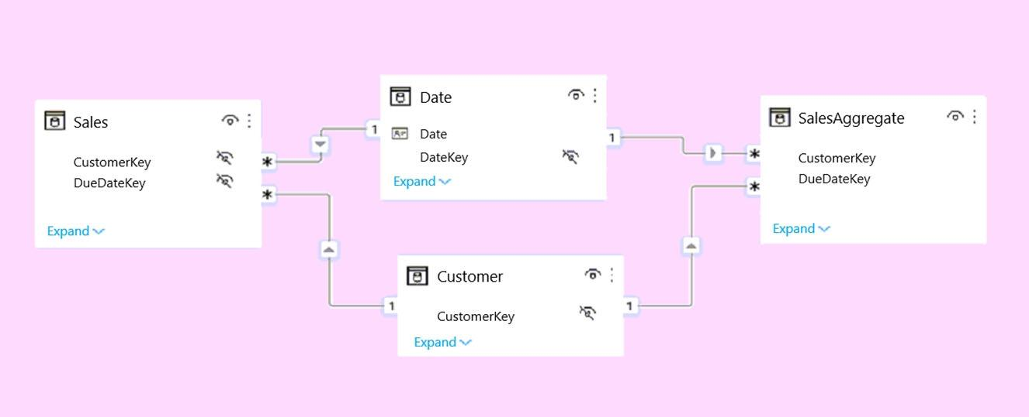

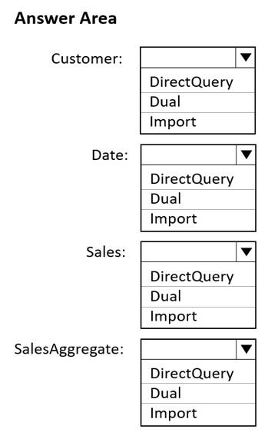

**Answer(s):** A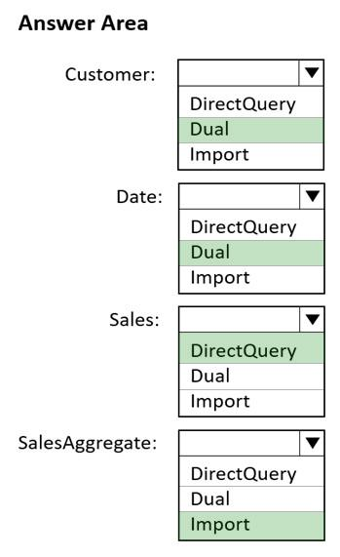

**[QUESTION: 2](https://free-braindumps.com/microsoft/free-pl-300-braindumps/page-2" \l "collapse_226)**

You have a project management app that is fully hosted in Microsoft Teams. The app was developed by using Microsoft Power Apps.  
You need to create a Power BI report that connects to the project management app.  
Which connector should you select?

1. Microsoft Teams Personal Analytics
2. SQL Server database
3. Dataverse
4. Dataflows

**Answer(s):** C

QUESTION: 3

For the sales department at your company, you publish a Power BI report that imports data from a Microsoft Excel file located in a Microsoft SharePoint folder.  
The data model contains several measures.  
You need to create a Power BI report from the existing data. The solution must minimize development effort.  
Which type of data source should you use?

1. Power BI dataset
2. a SharePoint folder
3. Power BI dataflows
4. an Excel workbook

**Answer(s):** A

**[QUESTION: 4](https://free-braindumps.com/microsoft/free-pl-300-braindumps/page-2" \l "collapse_224)**

You import two Microsoft Excel tables named Customer and Address into Power Query. Customer contains the following columns:  
-Customer ID  
-Customer Name  
-Phone  
-Email Address  
-Address ID  
Address contains the following columns:  
-Address ID  
-Address Line 1  
-Address Line 2  
-City  
-State/Region  
-Country  
-Postal Code  
Each Customer ID represents a unique customer in the Customer table. Each Address ID represents a unique address in the Address table.  
You need to create a query that has one row per customer. Each row must contain City, State/Region, and Country for each customer.  
What should you do?

1. Merge the Customer and Address tables.
2. Group the Customer and Address tables by the Address ID column.
3. Transpose the Customer and Address tables.
4. Append the Customer and Address tables.

**Answer(s):** A

**[QUESTION: 5](https://free-braindumps.com/microsoft/free-pl-300-braindumps/page-3" \l "collapse_223)**

HOTSPOT (Drag and Drop is not supported)  
You have two Azure SQL databases that contain the same tables and columns.  
For each database, you create a query that retrieves data from a table named Customer.  
You need to combine the Customer tables into a single table. The solution must minimize the size of the data model and support scheduled refresh in powerbi.com.  
What should you do? To answer, select the appropriate options in the answer area.  
NOTE: Each correct selection is worth one point.  
Hot Area:

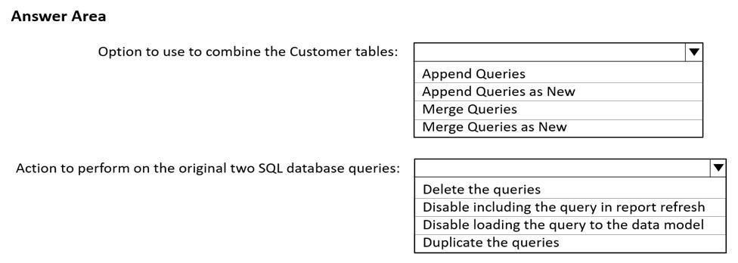

Answer

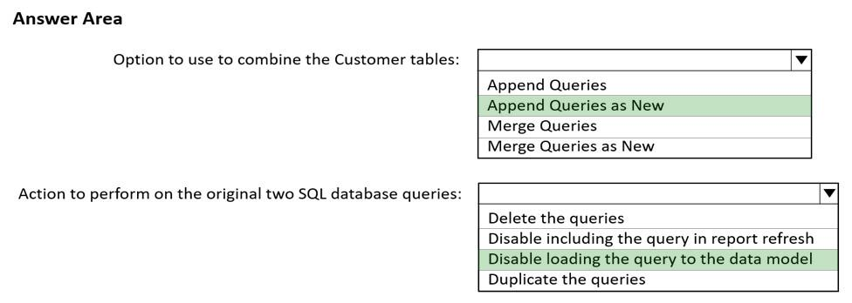

**[QUESTION: 6](https://free-braindumps.com/microsoft/free-pl-300-braindumps/page-3" \l "collapse_222)**

DRAG DROP (Drag and Drop is not supported)  
In Power Query Editor, you have three queries named ProductCategory, ProductSubCategory, and Product.  
Every Product has a ProductSubCategory.  
Not every ProductsubCategory has a parent ProductCategory.  
You need to merge the three queries into a single query. The solution must ensure the best performance in Power Query.  
How should you merge the tables? To answer, drag the appropriate merge types to the correct queries. Each merge type may be used once, more than once, or not at all. You may need to drag the split bar between panes or scroll to view content.  
NOTE: Each correct selection is worth one point.

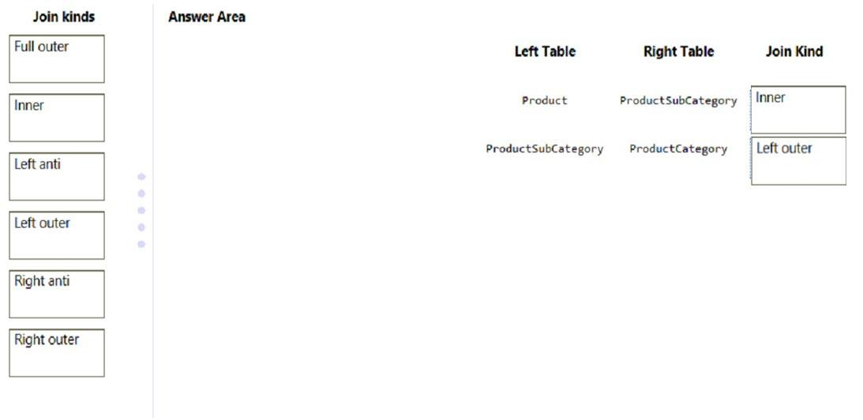

**[QUESTION: 7](https://free-braindumps.com/microsoft/free-pl-300-braindumps/page-3" \l "collapse_221)**

You are building a Power BI report that uses data from an Azure SQL database named erp1.  
You import the following tables.  
You need to perform the following analyses:  
-Orders sold over time that include a measure of the total order value  
Orders by attributes of products sold  
The solution must minimize update times when interacting with visuals in the report.  
What should you do first?  
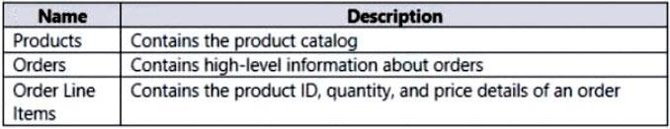

1. From Power Query, merge the Order Line Items query and the Products query.
2. Create a calculated column that adds a list of product categories to the Orders table by using a DAX function.
3. Calculate the count of orders per product by using a DAX function.
4. From Power Query, merge the Orders query and the Order Line Items query.

**Answer(s):** D

**[QUESTION: 8](https://free-braindumps.com/microsoft/free-pl-300-braindumps/page-3" \l "collapse_220)**

You have a Microsoft SharePoint Online site that contains several document libraries.  
One of the document libraries contains manufacturing reports saved as Microsoft Excel files. All the manufacturing reports have the same data structure.  
You need to use Power BI Desktop to load only the manufacturing reports to a table for analysis.  
What should you do?

1. Get data from a SharePoint folder and enter the site URL Select Transform, then filter by the folder path to the manufacturing reports library.
   1. Get data from a SharePoint list and enter the site URL. Select Combine & Transform, then filter by the folder path to the manufacturing reports library.
2. Get data from a SharePoint folder, enter the site URL, and then select Combine & Load.
3. Get data from a SharePoint list, enter the site URL, and then select Combine & Load.

**[QUESTION: 9](https://free-braindumps.com/microsoft/free-pl-300-braindumps/page-4" \l "collapse_219)**

DRAG DROP (Drag and Drop is not supported)  
You have a Microsoft Excel workbook that contains two sheets named Sheet1 and Sheet2.  
Sheet1 contains the following table named Table1.  
Sheet2 contains the following table named Table2.  
You need to use Power Query Editor to combine the products from Table1 and Table2 into the following table that has one column containing no duplicate values.  
Which three actions should you perform in sequence? To answer, move the appropriate actions from the list of actions to the answer area and arrange them in the correct order.  
Select and Place:

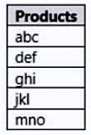 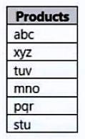 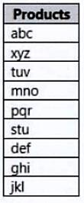

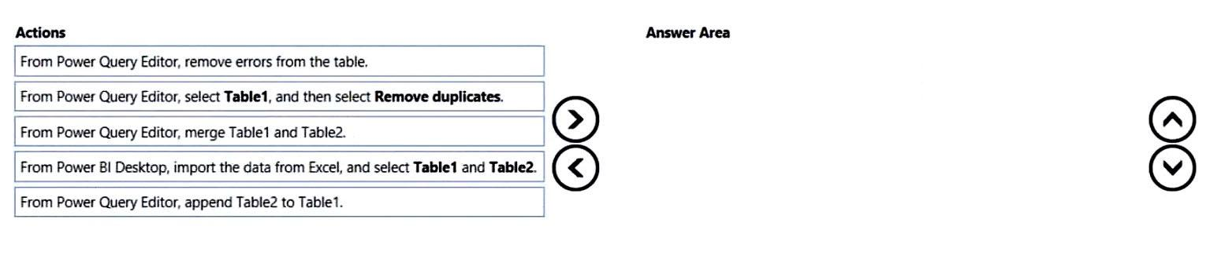

**Answer(s):** A 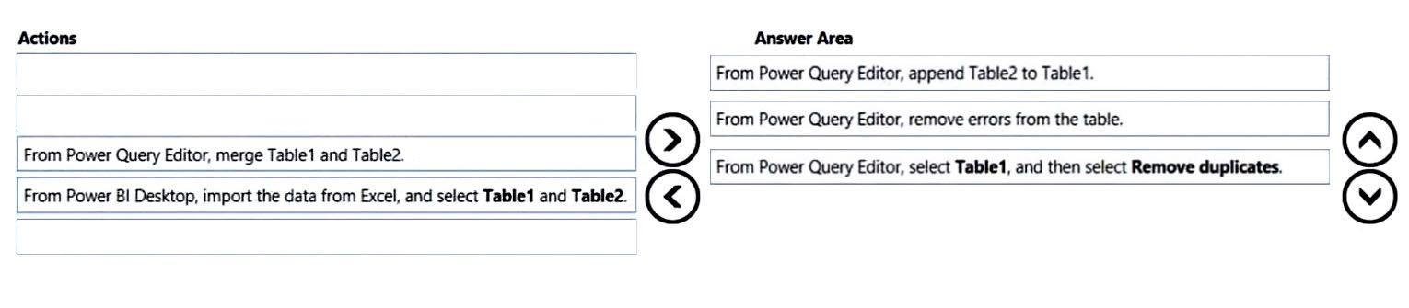

**[QUESTION: 10](https://free-braindumps.com/microsoft/free-pl-300-braindumps/page-4" \l "collapse_218)**

You have a CSV file that contains user complaints. The file contains a column named Logged. Logged contains the date and time each complaint occurred. The data in Logged is in the following format: 2018-12-31 at 08:59.  
You need to be able to analyze the complaints by the logged date and use a built-in date hierarchy.  
What should you do?

1. Apply a transformation to extract the last 11 characters of the Logged column and set the data type of the new column to Date.
2. Change the data type of the Logged column to Date.
3. Split the Logged column by using at as the delimiter.
4. Apply a transformation to extract the first 11 characters of the Logged column.

**Answer(s):** C

**[QUESTION: 11](https://free-braindumps.com/microsoft/free-pl-300-braindumps/page-4" \l "collapse_217)**

You have a Microsoft Excel file in a Microsoft OneDrive folder.  
The file must be imported to a Power BI dataset.  
You need to ensure that the dataset can be refreshed in powerbi.com.  
Which two connectors can you use to connect to the file? Each correct answer presents a complete solution.  
NOTE: Each correct selection is worth one point.

1. Excel Workbook
2. Text/CSV
3. Folder
4. SharePoint folder
5. Web

**Answer(s):** D,E

**[QUESTION: 12](https://free-braindumps.com/microsoft/free-pl-300-braindumps/page-4" \l "collapse_216)**

HOTSPOT (Drag and Drop is not supported)  
You are profiling data by using Power Query Editor.  
You have a table named Reports that contains a column named State. The distribution and quality data metrics for the data in State is shown in the following exhibit.  
Use the drop-down menus to select the answer choice that completes each statement based on the information presented in the graphic.  
NOTE: Each correct selection is worth one point.  
Hot Area:

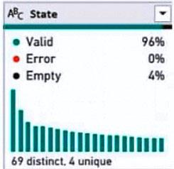 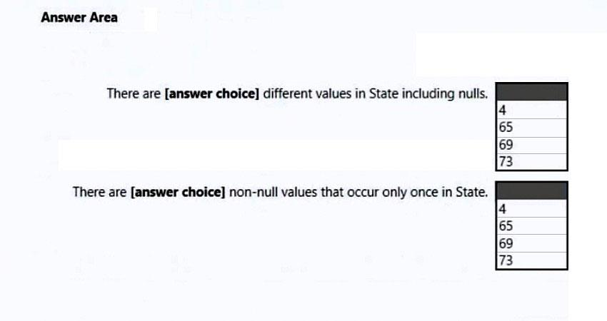

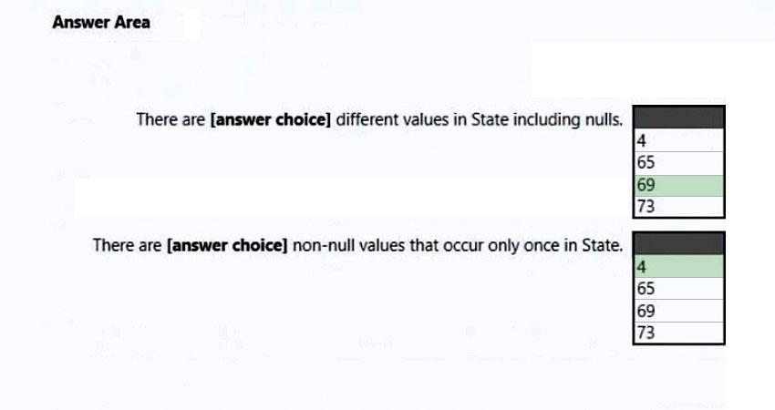

**[QUESTION: 13](https://free-braindumps.com/microsoft/free-pl-300-braindumps/page-5" \l "collapse_215)**

HOTSPOT (Drag and Drop is not supported)  
You have two CSV files named Products and Categories.  
The Products file contains the following columns:  
-ProductID  
-ProductName  
-SupplierID  
-CategoryID  
The Categories file contains the following columns:  
-CategoryID  
-CategoryName  
-CategoryDescription  
From Power BI Desktop, you import the files into Power Query Editor.  
You need to create a Power BI dataset that will contain a single table named Product. The Product will table includes the following columns:  
-ProductID  
-ProductName  
-SupplierID  
-CategoryID  
-CategoryName  
-CategoryDescription  
How should you combine the queries, and what should you do on the Categories query? To answer, select the appropriate options in the answer area.  
NOTE: Each correct selection is worth one point.  
Hot Area:

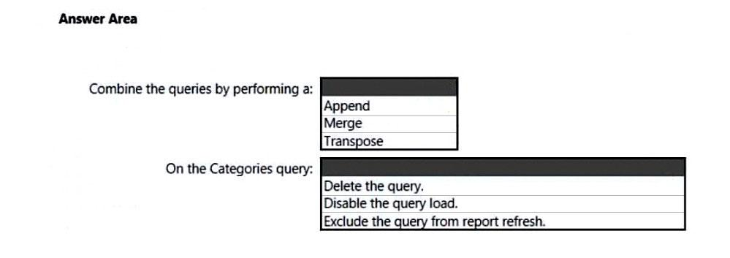 **Answer(s):** A

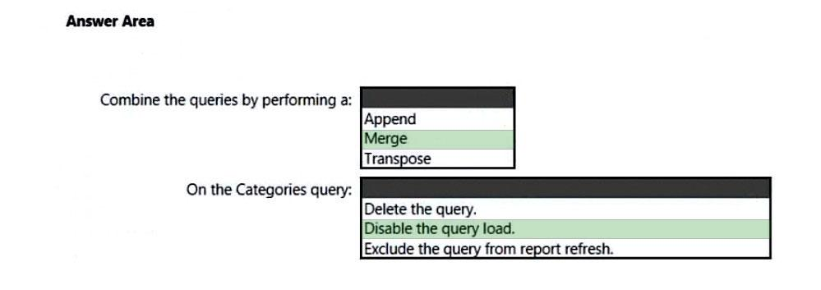

**[QUESTION: 14](https://free-braindumps.com/microsoft/free-pl-300-braindumps/page-5" \l "collapse_214)**

You have an Azure SQL database that contains sales transactions. The database is updated frequently.  
You need to generate reports from the data to detect fraudulent transactions. The data must be visible within five minutes of an update.  
How should you configure the data connection?

1. Add a SQL statement.
2. Set the Command timeout in minutes setting.
3. Set Data Connectivity mode to Import.
4. Set Data Connectivity mode to DirectQuery.

**Answer(s):** D

**[QUESTION: 15](https://free-braindumps.com/microsoft/free-pl-300-braindumps/page-5" \l "collapse_213)**

DRAG DROP (Drag and Drop is not supported)  
You have a folder that contains 100 CSV files.  
You need to make the file metadata available as a single dataset by using Power BI. The solution must NOT store the data of the CSV files.  
Which three actions should you perform in sequence. To answer, move the appropriate actions from the list of actions to the answer area and arrange them in the correct order.  
Select and Place:

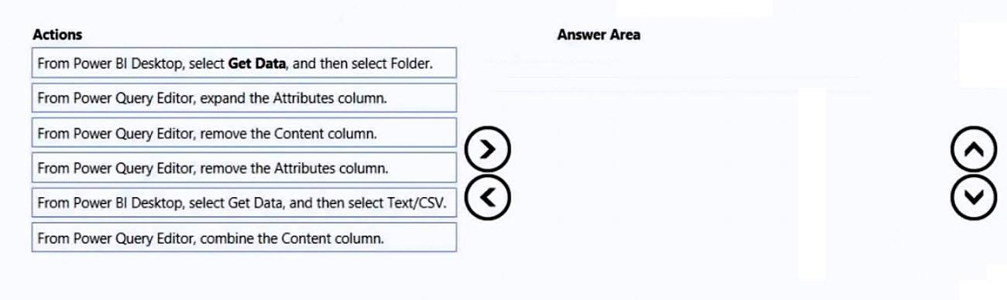 **Answer(s):** A

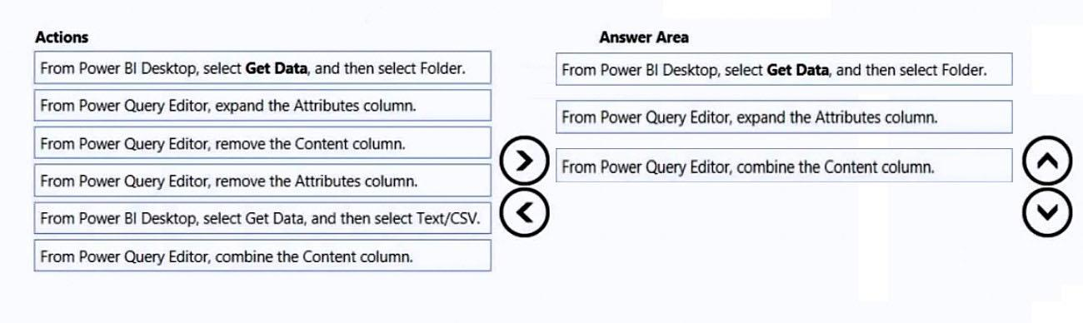

**[QUESTION: 16](https://free-braindumps.com/microsoft/free-pl-300-braindumps/page-5" \l "collapse_212)**

A business intelligence (BI) developer creates a dataflow in Power BI that uses DirectQuery to access tables from an on-premises Microsoft SQL server. The  
Enhanced Dataflows Compute Engine is turned on for the dataflow.  
You need to use the dataflow in a report. The solution must meet the following requirements:  
-Minimize online processing operations.  
-Minimize calculation times and render times for visuals.  
-Include data from the current year, up to and including the previous day.  
What should you do?

1. Create a dataflows connection that has DirectQuery mode selected.
2. Create a dataflows connection that has DirectQuery mode selected and configure a gateway connection for the dataset.
3. Create a dataflows connection that has Import mode selected and schedule a daily refresh.
   1. Create a dataflows connection that has Import mode selected and create a Microsoft Power Automate solution to refresh the data hourly.

**Answer(s):** C

**[QUESTION: 17](https://free-braindumps.com/microsoft/free-pl-300-braindumps/page-6" \l "collapse_211)**

DRAG DROP (Drag and Drop is not supported)  
You publish a dataset that contains data from an on-premises Microsoft SQL Server database.  
The dataset must be refreshed daily.  
You need to ensure that the Power BI service can connect to the database and refresh the dataset.  
Which four actions should you perform in sequence? To answer, move the appropriate actions from the list of actions to the answer area and arrange them in the correct order.

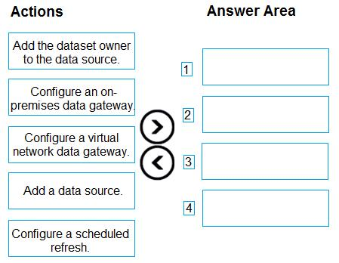

**Answer(s):** A 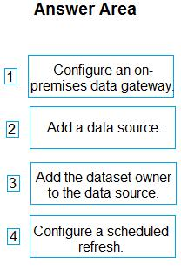

**[QUESTION: 18](https://free-braindumps.com/microsoft/free-pl-300-braindumps/page-6" \l "collapse_210)**

You attempt to connect Power BI Desktop to a Cassandra database.  
From the Get Data connector list, you discover that there is no specific connector for the Cassandra database.  
You need to select an alternate data connector that will connect to the database.  
Which type of connector should you choose?

1. Microsoft SQL Server database
2. ODBC
3. OLE DB
4. OData

#### **[QUESTION: 19](https://free-braindumps.com/microsoft/free-pl-300-braindumps/page-6" \l "collapse_227)**

DRAG DROP (Drag and Drop is not supported)  
You receive annual sales data that must be included in Power BI reports.  
From Power Query Editor, you connect to the Microsoft Excel source shown in the following exhibit.  
You need to create a report that meets the following requirements:  
• Visualizes the Sales value over a period of years and months  
• Adds a slicer for the month  
• Adds a slicer for the year  
Which three actions should you perform in sequence? To answer, move the appropriate actions from the list of actions to the answer area and arrange them in the correct order.

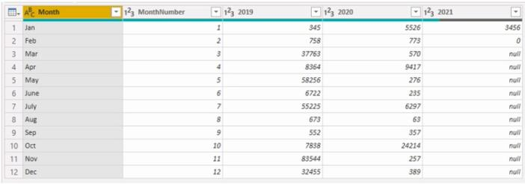

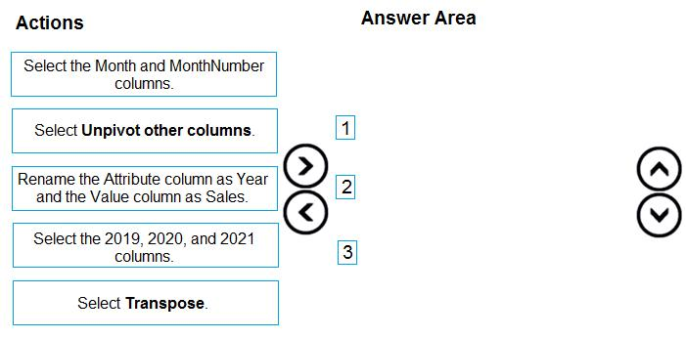

**Answer(s):** A 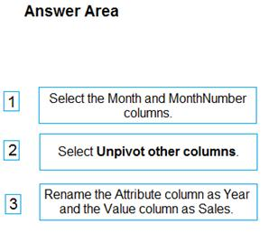

**[QUESTION: 20](https://free-braindumps.com/microsoft/free-pl-300-braindumps/page-6" \l "collapse_229)**

HOTSPOT (Drag and Drop is not supported)  
You are using Power BI Desktop to connect to an Azure SQL database.  
The connection is configured as shown in the following exhibit.  
Use the drop-down menus to select the answer choice that completes each statement based on the information presented in the graphic.  
NOTE: Each correct solution is worth one point.  
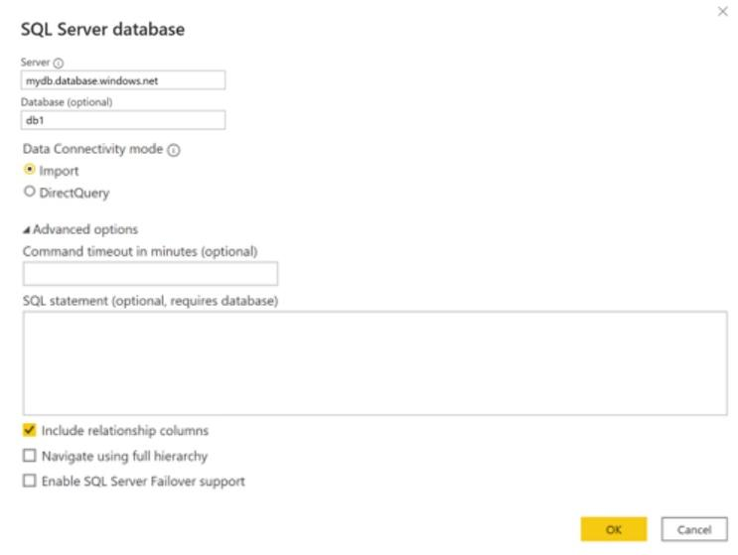  
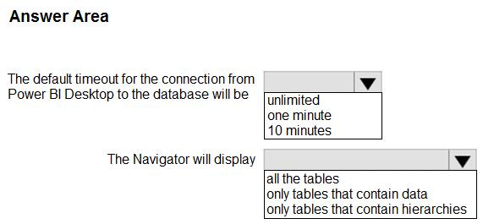

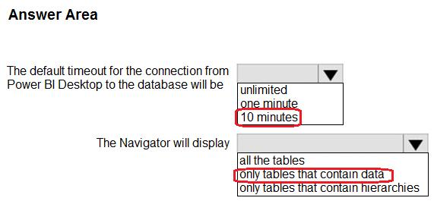

**[QUESTION: 21](https://free-braindumps.com/microsoft/free-pl-300-braindumps/page-7" \l "collapse_248)**

HOTSPOT (Drag and Drop is not supported)  
You have the Azure SQL databases shown in the following table.  
You plan to build a single PBIX file to meet the following requirements:  
• Data must be consumed from the database that corresponds to each stage of the development lifecycle.  
• Power BI deployment pipelines must NOT be used.  
• The solution must minimize administrative effort.  
What should you do? To answer, select the appropriate options in the answer area.  
NOTE: Each correct selection is worth one point.  
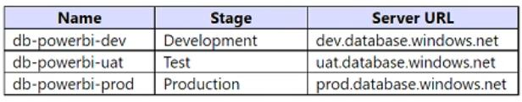  
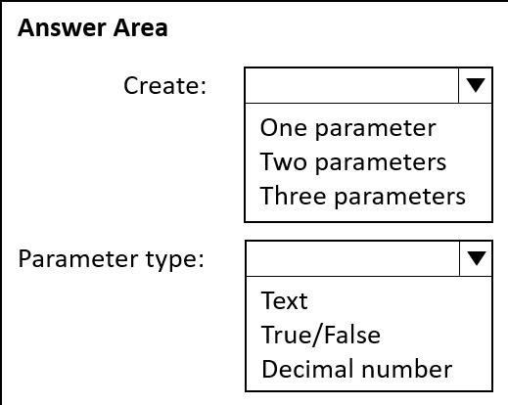

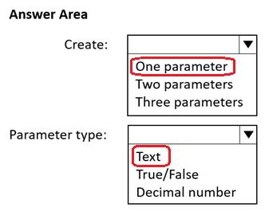

**[QUESTION: 22](https://free-braindumps.com/microsoft/free-pl-300-braindumps/page-7" \l "collapse_230)**

You are creating a query to be used as a Country dimension in a star schema.  
A snapshot of the source data is shown in the following table.  
You need to create the dimension. The dimension must contain a list of unique countries.  
Which two actions should you perform? Each correct answer presents part of the solution.  
NOTE: Each correct selection is worth one point.  
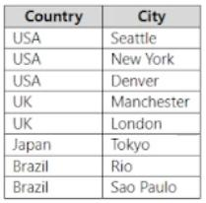

1. Delete the Country column.
2. Remove duplicates from the table.
3. Remove duplicates from the City column.
4. Delete the City column.
5. Remove duplicates from the Country column.

**Answer(s):** D,E

**[QUESTION: 23](https://free-braindumps.com/microsoft/free-pl-300-braindumps/page-7" \l "collapse_247)**

DRAG DROP (Drag and Drop is not supported)  
You use Power Query Editor to preview the data shown in the following exhibit.  
You need to clean and transform the query so that all the rows of data are maintained, and error values in the discount column are replaced with a discount of 0.05. The solution must minimize administrative effort.  
Which three actions should you perform in sequence? To answer, move the appropriate actions from the list of actions to the answer area and arrange them in the correct order.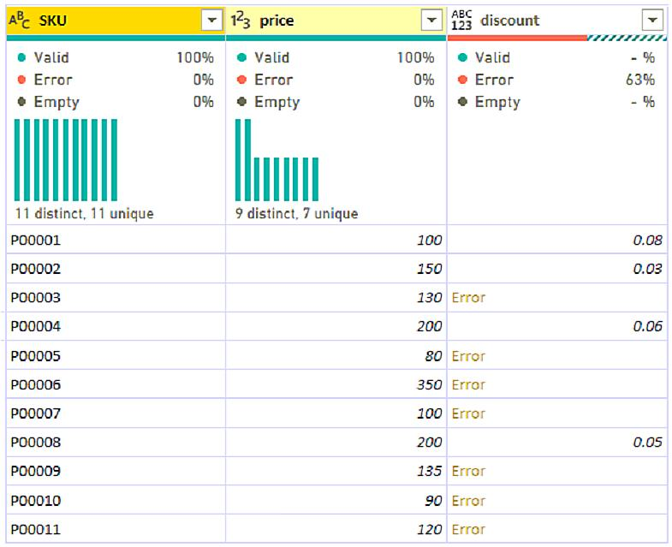  
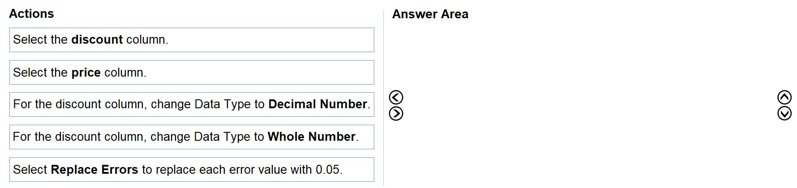

**Answer(s):** A 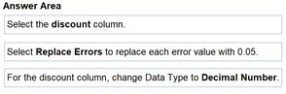

**[QUESTION: 24](https://free-braindumps.com/microsoft/free-pl-300-braindumps/page-7" \l "collapse_246)**

HOTSPOT (Drag and Drop is not supported)  
You attempt to use Power Query Editor to create a custom column and receive the error message shown in the following exhibit.  
Use the drop-down menus to select the answer choice that completes each statement based on the information presented in the graphic.  
NOTE: Each correct selection is worth one point.

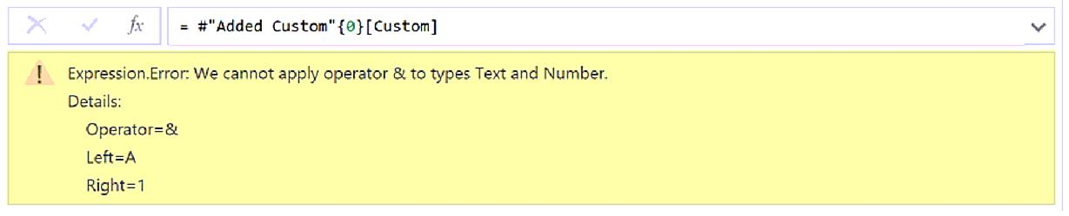 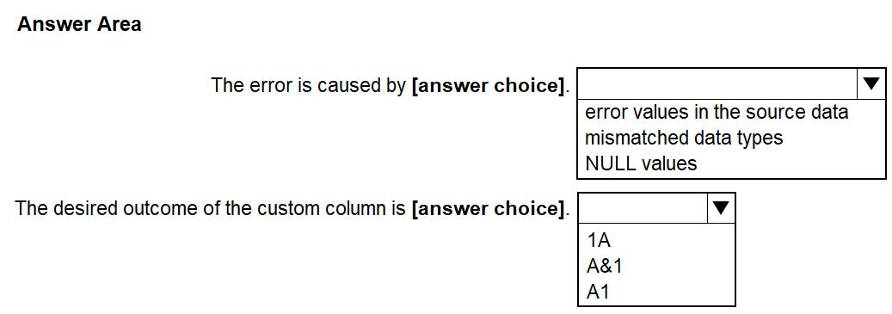

**Answer(s):** A

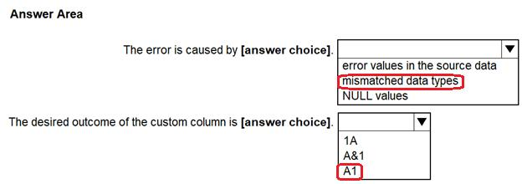

**[QUESTION: 25](https://free-braindumps.com/microsoft/free-pl-300-braindumps/page-8" \l "collapse_245)**

From Power Query Editor, you attempt to execute a query and receive the following error message.  
Datasource.Error: Could not find file.  
What are two possible causes of the error? Each correct answer presents a complete solution.  
NOTE: Each correct selection is worth one point.

1. You do not have permissions to the file.
2. An incorrect privacy level was used for the data source.
3. The file is locked.
4. The referenced file was moved to a new location.

**Answer(s):** A,D

**[QUESTION: 26](https://free-braindumps.com/microsoft/free-pl-300-braindumps/page-8" \l "collapse_244)**

You have data in a Microsoft Excel worksheet as shown in the following table.  
You need to use Power Query to clean and transform the dataset. The solution must meet the following requirements:  
• If the discount column returns an error, a discount of 0.05 must be used.  
• All the rows of data must be maintained.  
• Administrative effort must be minimized.  
What should you do in Power Query Editor?  
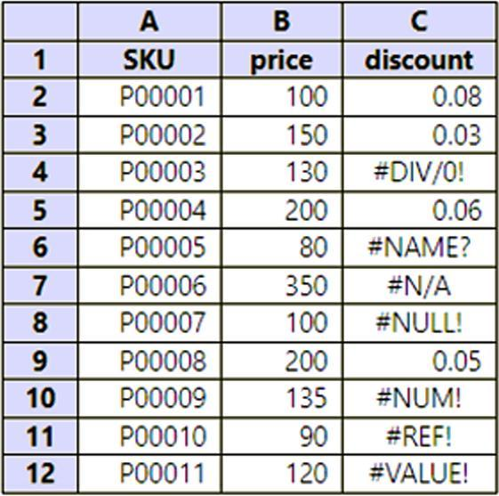

1. Select Replace Errors.
2. Edit the query in the Query Errors group.
3. Select Remove Errors.
4. Select Keep Errors.

**Answer(s):** A

**[QUESTION: 27](https://free-braindumps.com/microsoft/free-pl-300-braindumps/page-8" \l "collapse_243)**

You have a CSV file that contains user complaints. The file contains a column named Logged. Logged contains the date and time each complaint occurred. The data in Logged is in the following format: 2018-12-31 at 08:59.  
You need to be able to analyze the complaints by the logged date and use a built-in date hierarchy.  
What should you do?

1. Apply the Parse function from the Data transformations options to the Logged column.
2. Change the data type of the Logged column to Date.
3. Split the Logged column by using at as the delimiter.
4. Create a column by example that starts with 2018-12-31.

**Answer(s):** C

**[QUESTION: 28](https://free-braindumps.com/microsoft/free-pl-300-braindumps/page-8" \l "collapse_242)**

DRAG DROP (Drag and Drop is not supported)  
You have two Microsoft Excel workbooks in a Microsoft OneDrive folder.  
Each workbook contains a table named Sales. The tables have the same data structure in both workbooks.  
You plan to use Power BI to combine both Sales tables into a single table and create visuals based on the data in the table. The solution must ensure that you can publish a separate report and dataset.  
Which storage mode should you use for the report file and the dataset file? To answer, drag the appropriate modes to the correct files. Each mode may be used once, more than once, or not at all. You may need to drag the split bar between panes or scroll to view content.  
NOTE: Each correct selection is worth one point.  
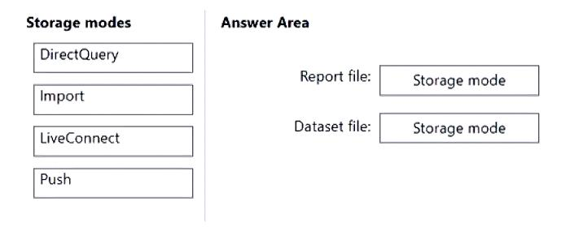

1. See Explanation section for answer.

**Answer(s):** A

**Explanation:**

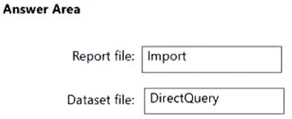

**[QUESTION: 29](https://free-braindumps.com/microsoft/free-pl-300-braindumps/page-9" \l "collapse_241)**

You use Power Query to import two tables named Order Header and Order Details from an Azure SQL database. The Order Header table relates to the Order Details table by using a column named Order ID in each table.  
You need to combine the tables into a single query that contains the unique columns of each table.  
What should you select in Power Query Editor?

1. Merge queries
2. Combine files
3. Append queries

**Answer(s):** A

**[QUESTION: 30](https://free-braindumps.com/microsoft/free-pl-300-braindumps/page-9" \l "collapse_240)**

You have a PBIX file that imports data from a Microsoft Excel data source stored in a file share on a local network.  
You are notified that the Excel data source was moved to a new location.  
You need to update the PBIX file to use the new location.  
What are three ways to achieve the goal? Each correct answer presents a complete solution.  
NOTE: Each correct selection is worth one point.

1. From the Datasets settings of the Power BI service, configure the data source credentials.
2. From the Data source settings in Power BI Desktop, configure the file path.
3. From Current File in Power BI Desktop, configure the Data Load settings.
4. From Power Query Editor, use the formula bar to configure the file path for the applied step.
5. From Advanced Editor in Power Query Editor, configure the file path in the M code.

**Answer(s):** B,D,E

**[QUESTION: 31](https://free-braindumps.com/microsoft/free-pl-300-braindumps/page-9" \l "collapse_239)**

HOTSPOT (Drag and Drop is not supported)  
You have a folder that contains 50 JSON files.  
You need to use Power BI Desktop to make the metadata of the files available as a single dataset. The solution must NOT store the data of the JSON files.  
Which type of data source should you use, and which transformation should you perform? To answer, select the appropriate options in the answer area.  
NOTE: Each correct selection is worth one point.  
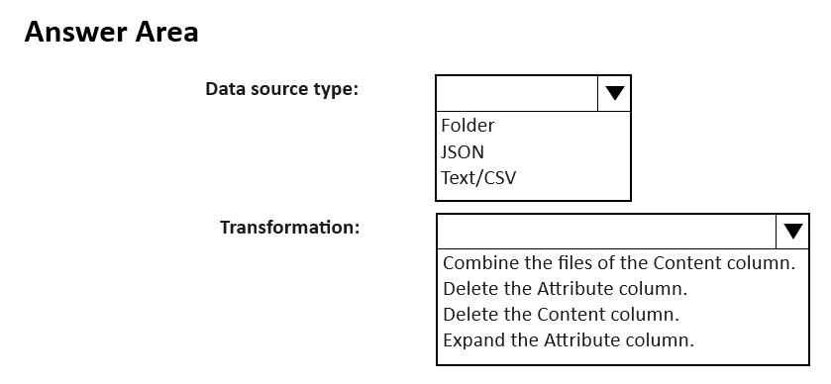

**Answer(s):** A 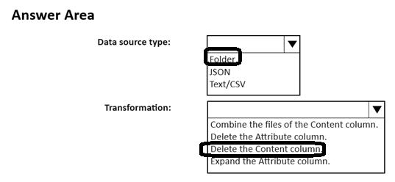

**[QUESTION: 32](https://free-braindumps.com/microsoft/free-pl-300-braindumps/page-9" \l "collapse_238)**

Case Study  
This is a case study. Case studies are not timed separately. You can use as much exam time as you would like to complete each case. However, there may be additional case studies and sections on this exam. You must manage your time to ensure that you are able to complete all questions included on this exam in the time provided.  
To answer the questions included in a case study, you will need to reference information that is provided in the case study. Case studies might contain exhibits and other resources that provide more information about the scenario that is described in the case study. Each question is independent of the other questions in this case study.  
At the end of this case study, a review screen will appear. This screen allows you to review your answers and to make changes before you move to the next section of the exam. After you begin a new section, you cannot return to this section.  
To start the case study  
To display the first question in this case study, click the Next button. Use the buttons in the left pane to explore the content of the case study before you answer the questions. Clicking these buttons displays information such as business requirements, existing environment and problem statements. If the case study has an All Information tab, note that the information displayed is identical to the information displayed on the subsequent tabs. When you are ready to answer a question, click the Question button to return to the question.  
General Overview  
Northwind Traders is a specialty food import company.  
The company recently implemented Power BI to better understand its top customers, products, and suppliers.  
Business Issues  
The sales department relies on the IT department to generate reports in Microsoft SQL Server Reporting Services (SSRS). The IT department takes too long to generate the reports and often misunderstands the report requirements.  
Existing Environment. Data Sources  
Northwind Traders uses the data sources shown in the following table.  
Source2 is exported daily from a third-party system and stored in Microsoft SharePoint Online.  
Existing Environment. Customer Worksheet  
Source2 contains a single worksheet named Customer Details. The first 11 rows of the worksheet are shown in the following table.  
All the fields in Source2 are mandatory.  
The Address column in Customer Details is the billing address, which can differ from the shipping address.  
Existing Environment. Azure SQL Database  
Source1 contains the following tables:  
• Orders  
• Products  
• Suppliers  
• Categories  
• Order Details  
• Sales Employees  
The Orders table contains the following columns.  
The Order Details table contains the following columns.  
The address in the Orders table is the shipping address, which can differ from the billing address.  
The Products table contains the following columns.  
The Categories table contains the following columns.  
The Suppliers table contains the following columns.  
The Sales Employees table contains the following columns.  
Each employee in the Sales Employees table is assigned to one sales region. Multiple employees can be assigned to each region.  
Requirements. Report Requirements  
Northwind Traders requires the following reports:  
• Top Products  
• Top Customers  
• On-Time Shipping  
The Top Customers report will show the top 20 customers based on the highest sales amounts in a selected order month or quarter, product category, and sales region.  
The Top Products report will show the top 20 products based on the highest sales amounts sold in a selected order month or quarter, sales region, and product category. The report must also show which suppliers provide the top products.  
The On-Time Shipping report will show the following metrics for a selected shipping month or quarter:  
• The percentage of orders that were shipped late by country and shipping region  
• Customers that had multiple late shipments during the last quarter  
Northwind Traders defines late orders as those shipped after the required shipping date.  
The warehouse shipping department must be notified if the percentage of late orders within the current month exceeds 5%.  
The reports must show historical data for the current calendar year and the last three calendar years.  
Requirements. Technical Requirements  
Northwind Traders identifies the following technical requirements:  
• A single dataset must support all three reports.  
• The reports must be stored in a single Power BI workspace.  
• Report data must be current as of 7 AM Pacific Time each day.  
• The reports must provide fast response times when users interact with a visualization.  
• The data model must minimize the size of the dataset as much as possible, while meeting the report requirements and the technical requirements.  
Requirements. Security Requirements  
Access to the reports must be granted to Azure Active Directory (Azure AD) security groups only. An Azure AD security group exists for each department.  
The sales department must be able to perform the following tasks in Power BI:  
• Create, edit, and delete content in the reports.  
• Manage permissions for workspaces, datasets, and reports.  
• Publish, unpublish, update, and change the permissions for an app.  
• Assign Azure AD groups role-based access to the reports workspace.  
Users in the sales department must be able to access only the data of the sales region to which they are assigned in the Sales Employees table.  
Power BI has the following row-level security (RLS) Table filter DAX expression for the Sales Employees table.  
[EmailAddress] = USERNAME()  
RLS will be applied only to the sales department users. Users in all other departments must be able to view all the data.  
You need to create the semantic model.  
Which storage mode should you use for the tables in the semantic model?  
  
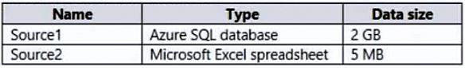  
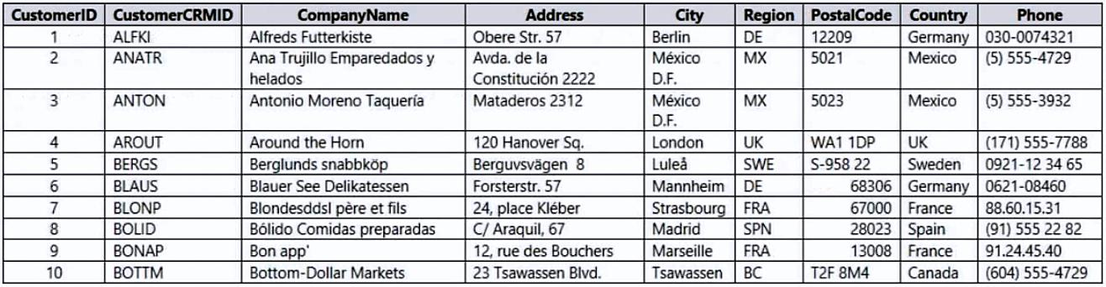  
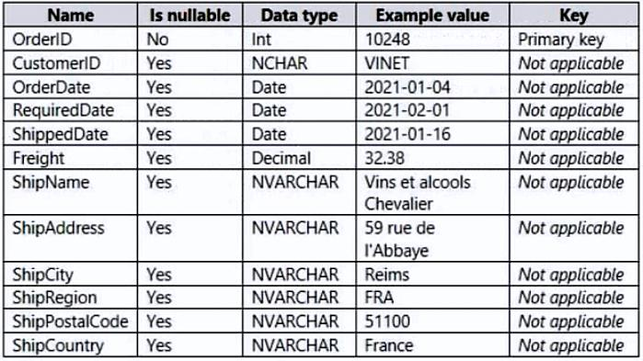  
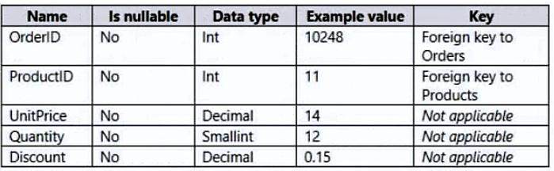  
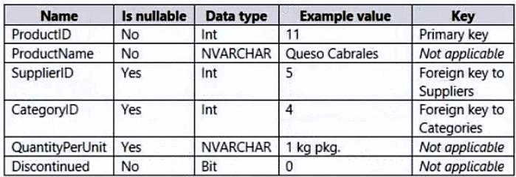  
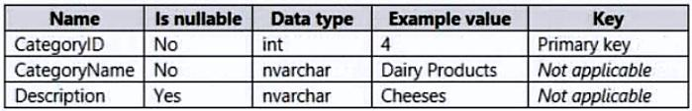  
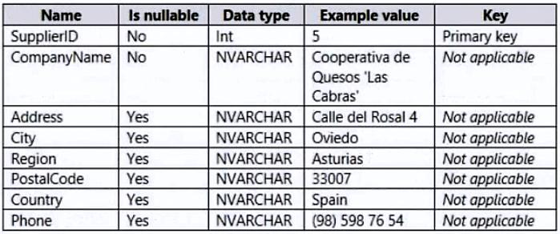  
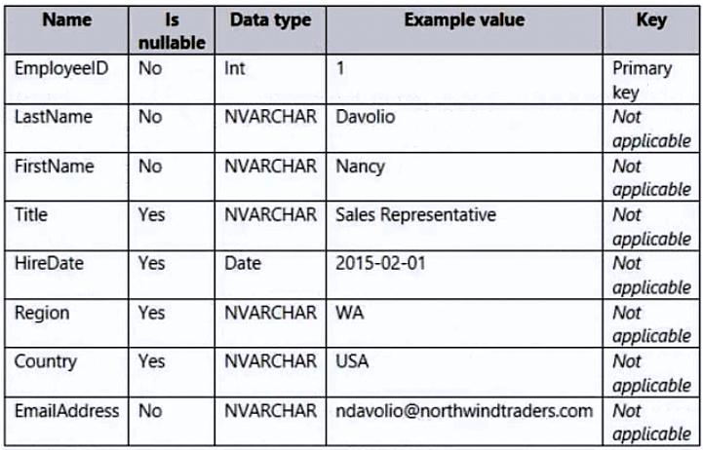

1. DirectQuery
2. Dual
3. Import
4. live connection

**[QUESTION: 33](https://free-braindumps.com/microsoft/free-pl-300-braindumps/page-10" \l "collapse_237)**

HOTSPOT (Drag and Drop is not supported)  
You have a Power BI semantic model that contains the data sources shown in the following table.  
You need to configure the privacy level s of the data sources.  
What should you configure for each data source? To answer, select the appropriate options in the answer area.  
NOTE: Each correct answer is worth one point.  
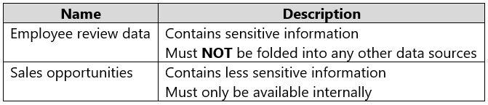  
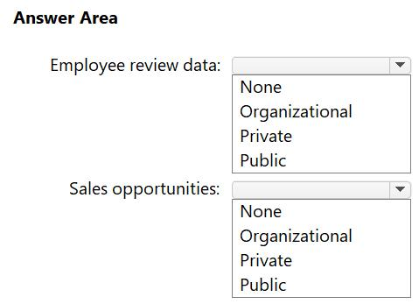

**Answer(s):** A

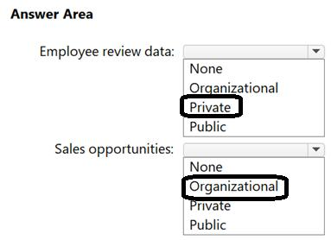

**[QUESTION: 34](https://free-braindumps.com/microsoft/free-pl-300-braindumps/page-10" \l "collapse_236)**

You plan to use Power BI Desktop to create a bug tracking dashboard that will pull data from Analytics in Azure DevOps.  
From Power BI Desktop, you need to configure a data connector to authenticate to Azure DevOps. The solution must meet the following requirements:  
• Use Analytics views.  
• Filter data from the cloud.  
Which connector should you use?

1. OData queries
2. Azure DevOps (Boards only)
3. Azure DevOps Server (Boards only)
4. OData Feed

#### **[QUESTION: 35](https://free-braindumps.com/microsoft/free-pl-300-braindumps/page-10" \l "collapse_235)**

HOTSPOT (Drag and Drop is not supported)  
You use Power Query Editor to preview the data shown in the following exhibit.  
You confirm that the data will always start on row 3, and row 3 will always contain the column names.  
How should you shape the query? To answer, select the appropriate options in the answer area.  
NOTE: Each correct selection is worth one point.  
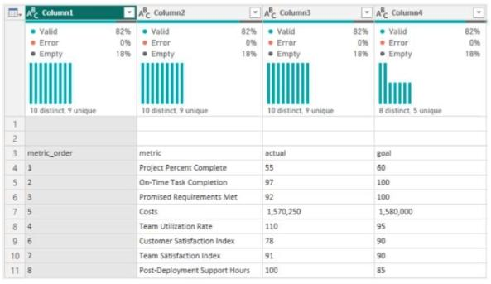  
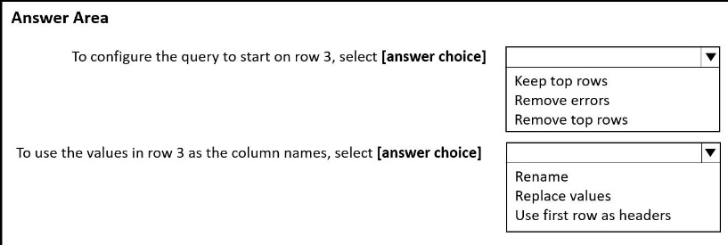

1. See Explanation section for answer.

**Answer(s):** A

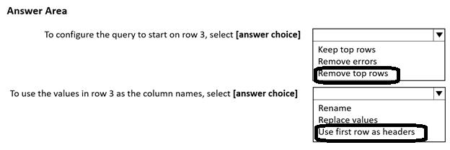

**[QUESTION: 36](https://free-braindumps.com/microsoft/free-pl-300-braindumps/page-10" \l "collapse_234)**

Note: This question is part of a series of questions that present the same scenario. Each question in the series contains a unique solution that might meet the stated goals. Some question sets might have more than one correct solution, while others might not have a correct solution.  
After you answer a question in this section, you will NOT be able to return to it. As a result, these questions will not appear in the review screen.  
You have a data source that contains a column. The column contains case sensitive data.  
You have a Power BI semantic model in DirectQuery mode.  
You connect to the model and discover that it contains undefined values and errors.  
You need to resolve the issue.  
Solution: You implicitly convert the values into the required type.  
Does this meet the goal?

1. Yes
2. No

**Answer(s):** B

**[QUESTION: 37](https://free-braindumps.com/microsoft/free-pl-300-braindumps/page-11" \l "collapse_233)**

You have a data source that contains a column. The column contains case sensitive data.  
You have a Power BI semantic model in DirectQuery mode.  
You connect to the model and discover that it contains undefined values and errors.  
You need to resolve the issue.  
Solution: You change the semantic model mode.  
Does this meet the goal?

1. Yes
2. No

**Answer(s):** B

**[QUESTION: 38](https://free-braindumps.com/microsoft/free-pl-300-braindumps/page-11" \l "collapse_232)**

You have a data source that contains a column. The column contains case sensitive data.  
You have a Power BI semantic model in DirectQuery mode.  
You connect to the model and discover that it contains undefined values and errors.  
You need to resolve the issue.  
Solution: You normalize casing in the source query or Power Query Editor.  
Does this meet the goal?

1. Yes
2. No

**Answer(s):** A

**[QUESTION: 39](https://free-braindumps.com/microsoft/free-pl-300-braindumps/page-11" \l "collapse_231)**

You have a data source that contains a column. The column contains case sensitive data.  
You have a Power BI semantic model in DirectQuery mode.  
You connect to the model and discover that it contains undefined values and errors.  
You need to resolve the issue.  
Solution: You add an index key and normalize casing in the data source.  
Does this meet the goal?

1. Yes
2. No

**Answer(s):** A

**[QUESTION: 40](https://free-braindumps.com/microsoft/free-pl-300-braindumps/page-11" \l "collapse_209)**

You have a Microsoft Excel file in a Microsoft OneDrive folder.  
The file must be imported to a Power BI semantic model.  
You need to ensure that the semantic model can be refreshed in PowerBi.com.  
Which two connectors can you use to connect to the file? Each correct answer presents a complete solution.  
NOTE: Each correct selection is worth one point.

1. Web
2. Excel Workbook
3. Folder
4. Text/CSV
5. SharePoint folder

**Answer(s):** A,E

**[QUESTION: 41](https://free-braindumps.com/microsoft/free-pl-300-braindumps/page-12" \l "collapse_208)**

You use Power Query Editor to preview a column named Date as shown in the following exhibit.  
You need to change the Date column to contain only the year. The solution must minimize administrative effort.  
What should you do?  
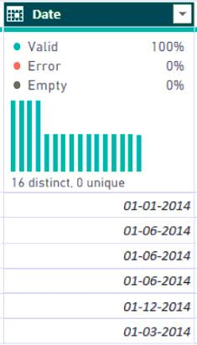

1. Split the column by delimiter.
2. Split the column by number of characters.
3. Extract the text after the delimiter.
4. Transform the column to contain only the year.

**Answer(s):** D

**[QUESTION: 42](https://free-braindumps.com/microsoft/free-pl-300-braindumps/page-12" \l "collapse_207)**

HOTSPOT (Drag and Drop is not supported)  
You are designing the data model for a Power BI semantic model.  
You have the following tables in the star schema.  
Which table is the fact table of the star schema, and which column in the Patient table is the surrogate key of the star schema? To answer, select the appropriate options in the answer area.  
NOTE: Each correct selection is worth one point.  
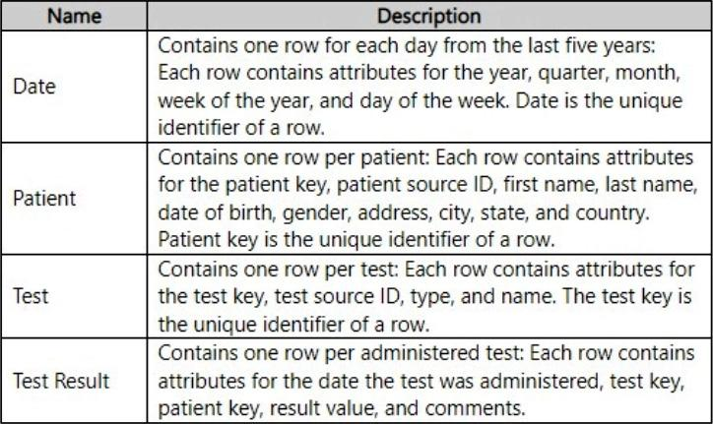  
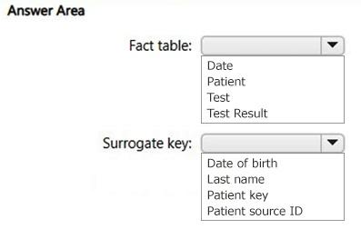

**Answer(s):** A

**Explanation:**

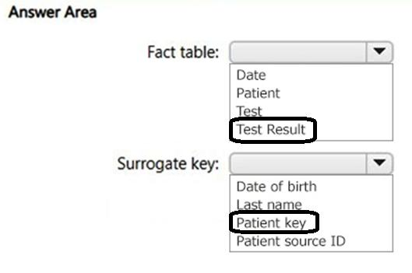

**[QUESTION: 43](https://free-braindumps.com/microsoft/free-pl-300-braindumps/page-12" \l "collapse_206)**

You use Power BI Desktop to import two tables named Customer and Contacts.  
The Customer table contains the following columns:  
• Customer\_Name  
• Customer ID

• Website  
The Contacts table contains the following columns:  
• Contact ID  
• Contact Email  
• Contact Name  
• Customer Name  
A web-based contact form is used to fill the Contacts table. The data is not sanitized.  
You need to create a merge for the Customer and Contacts tables.  
What should you do?

1. Disable fuzzy matching.
2. Enable fuzzy matching.
3. Set Join Kind to Left Outer.

**Answer(s):** B

**[QUESTION: 44](https://free-braindumps.com/microsoft/free-pl-300-braindumps/page-12" \l "collapse_184)**

HOTSPOT (Drag and Drop is not supported)  
You are using Microsoft Power BI Desktop to profile data in Power Query Editor.  
Table data is displayed as shown in the following exhibit.  
Use the drop-down menus to select the answer choice that completes each statement based on the information presented in the graphic.  
NOTE: Each correct selection is worth one point.  
  
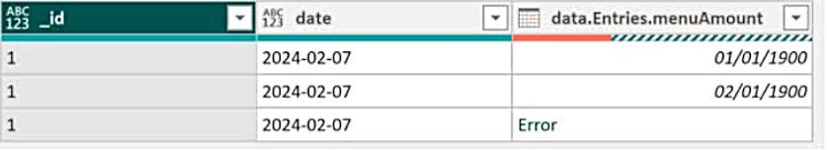  
  
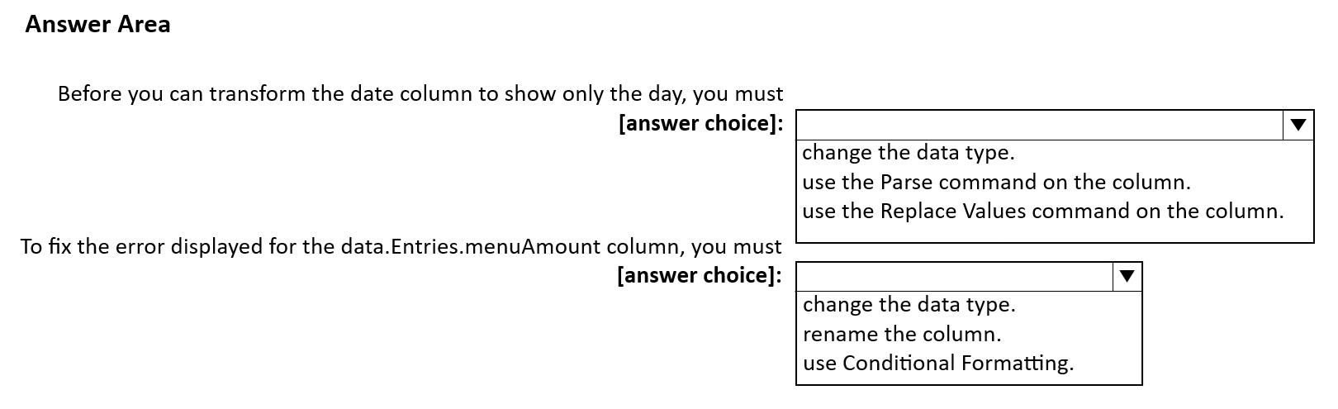

1. See Explanation section for answer.

**Answer(s):** A

**Explanation:**

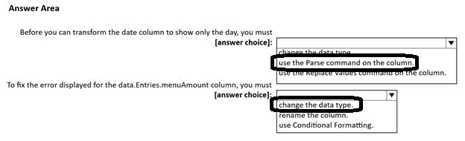

**[QUESTION: 45](https://free-braindumps.com/microsoft/free-pl-300-braindumps/page-13" \l "collapse_183)**

HOTSPOT (Drag and Drop is not supported)  
You have a Power BI semantic model named Model1 that contains a table named Sales.  
Sales contains 10 million records and the following data.  
The related report displays the weekly sales per region.  
You need to minimize the size of Model1.  
How should you modify the CustomerID column and the PurchaseDateTime column? To answer, select the appropriate options in the answer area.  
NOTE: Each correct selection is worth one point.  
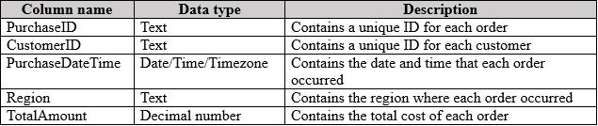  
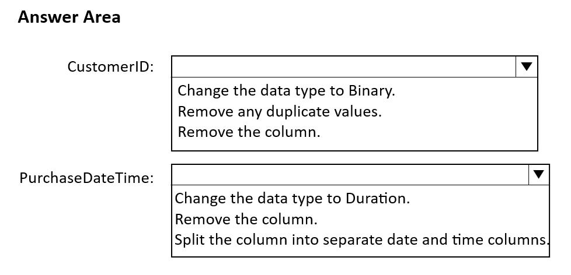

1. See Explanation section for answer.

**Answer(s):** A

**Explanation:**

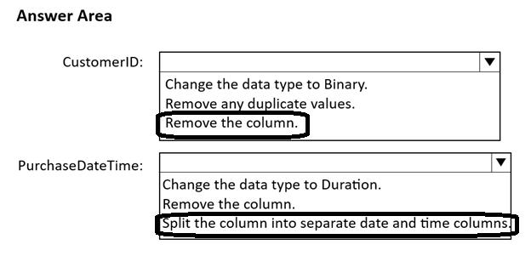

**[QUESTION: 46](https://free-braindumps.com/microsoft/free-pl-300-braindumps/page-13" \l "collapse_182)**

You have a Microsoft Power BI Desktop report named Report1 that uses an Azure SQL database as a data source.  
A user named User1 plans to create a report by using the same data source as Report1.  
You need to simplify the connection to the data source for User1.  
Which type of file should you create?

1. PBIDS
2. XLSX
3. PBIT
4. PBIX

**Answer(s):** A

**[QUESTION: 47](https://free-braindumps.com/microsoft/free-pl-300-braindumps/page-13" \l "collapse_181)**

HOTSPOT (Drag and Drop is not supported)  
You have a Power BI semantic model.  
You discover that the semantic model contains values that display as errors.  
You need to use data profiling features in Power Query to preview the data and identify the issues.  
What should you select to gain insight into the number of errors in the model, and what should you select to resolve the errors? To answer, select the appropriate options in the answer area.  
NOTE: Each correct answer is worth one point.  
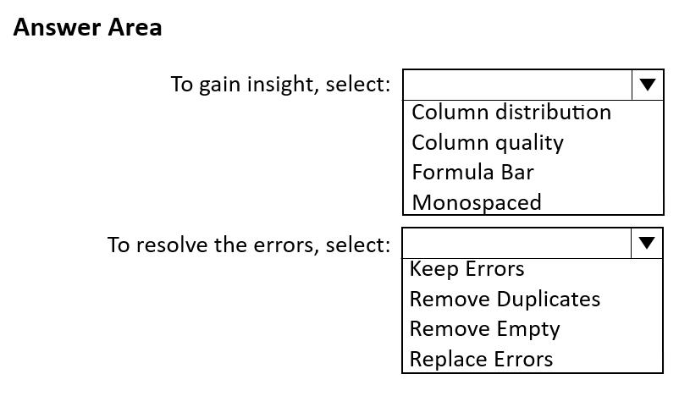

1. See Explanation section for answer.

**Answer(s):** A

**Explanation:**

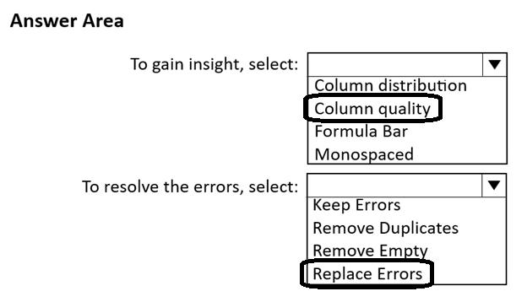

**[QUESTION: 48](https://free-braindumps.com/microsoft/free-pl-300-braindumps/page-13" \l "collapse_180)**

You plan to create a Power BI semantic model named Model1 that will contain data from an Azure SQL database named DB1.  
Model1 must show updated data within two minutes of the data being updated in DB1.  
You need to select a connectivity mode for the connection to DB1.  
What should you choose?

1. DirectQuery
2. live connection
3. import

**Answer(s):** A

**[QUESTION: 49](https://free-braindumps.com/microsoft/free-pl-300-braindumps/page-14" \l "collapse_179)**

You need to create a semantic model in Power BI Desktop. The solution must meet the following requirements:  
• The model must contain a table named Orders that has one row per order. Each row will contain the total amount per order.  
• The orders must be filtered to the selected CustomerID value.  
• Users must select the CustomerID value from a list.  
• The list of customers must come from an OData source.  
Which three objects should you create in Power Query Editor? Each correct answer presents part of the solution.  
NOTE: Each correct selection is worth one point.

1. an Orders query that has a filter on CustomerID
2. a Customers query that has a filter on CustomerID
3. an Orders query that has a single column containing a list of customers
4. a Customers query that has a single column containing a list of customer IDs
5. a parameter for CustomerID that uses a query to populate the suggested values
6. a parameter for CustomerID that uses manually entered values to populate the suggested values

**Answer(s):** A,D,E

**[QUESTION: 50](https://free-braindumps.com/microsoft/free-pl-300-braindumps/page-14" \l "collapse_178)**

You are creating a report in Power BI Desktop.  
You load a data extract that includes a free text field named coll.  
You need to analyze the frequency distribution of the string lengths in col1. The solution must not affect the size of the model.  
What should you do?

1. In the report, add a DAX calculated column that calculates the length of col1
2. In the report, add a DAX function that calculates the average length of col1
3. From Power Query Editor, add a column that calculates the length of col1
4. From Power Query Editor, change the distribution for the Column profile to group by length for col1

**Answer(s):** D

**[QUESTION: 51](https://free-braindumps.com/microsoft/free-pl-300-braindumps/page-14" \l "collapse_185)**

You have a collection of reports for the HR department of your company. The datasets use row-level security (RLS). The company has multiple sales regions.  
Each sales region has an HR manager.  
You need to ensure that the HR managers can interact with the data from their region only. The HR managers must be prevented from changing the layout of the reports.  
How should you provision access to the reports for the HR managers?

1. Publish the reports in an app and grant the HR managers access permission.
2. Create a new workspace, copy the datasets and reports, and add the HR managers as members of the workspace.
3. Publish the reports to a different workspace other than the one hosting the datasets.
4. Add the HR managers as members of the existing workspace that hosts the reports and the datasets.

**Answer(s):** A

**[QUESTION: 52](https://free-braindumps.com/microsoft/free-pl-300-braindumps/page-14" \l "collapse_177)**

You need to provide a user with the ability to add members to a workspace. The solution must use the principle of least privilege.  
Which role should you assign to the user?

1. Viewer
2. Admin
3. Contributor
4. Member

**Answer(s):** D

**[QUESTION: 53](https://free-braindumps.com/microsoft/free-pl-300-braindumps/page-15" \l "collapse_175)**

You have a Power BI query named Sales that imports the columns shown in the following table.  
Users only use the date part of the Sales\_Date field. Only rows with a Status of Finished are used in analysis.  
You need to reduce the load times of the query without affecting the analysis.  
Which two actions achieve this goal? Each correct answer presents a complete solution.  
NOTE: Each correct selection is worth one point.

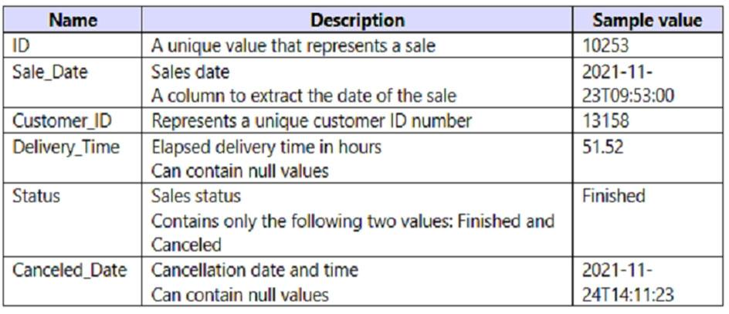

1. Remove the rows in which Sales[Status] has a value of Canceled.
2. Remove Sales[Sales\_Date].
3. Change the data type of Sale[Delivery\_Time] to Integer.
4. Split Sales[Sale\_Date] into separate date and time columns.
5. Remove Sales[Canceled Date].

**Answer(s):** A,E

**[QUESTION: 54](https://free-braindumps.com/microsoft/free-pl-300-braindumps/page-15" \l "collapse_174)**

You build a report to analyze customer transactions from a database that contains the tables shown in the following table.  
You import the tables.  
Which relationship should you use to link the tables?  
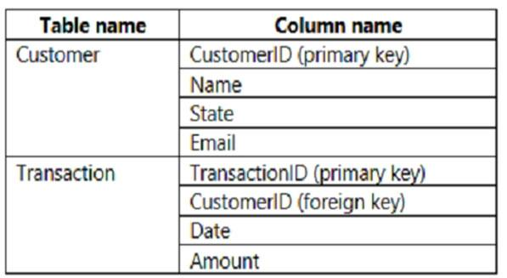

1. one-to-many from Transaction to Customer
2. one-to-one between Customer and Transaction
3. many-to-many between Customer and Transaction
4. one-to-many from Customer to Transaction

**Answer(s):** D

**[QUESTION: 55](https://free-braindumps.com/microsoft/free-pl-300-braindumps/page-15" \l "collapse_173)**

You have a custom connector that returns ID, From, To, Subject, Body, and Has Attachments for every email sent during the past year. More than 10 million records are returned.  
You build a report analyzing the internal networks of employees based on whom they send emails to.  
You need to prevent report recipients from reading the analyzed emails. The solution must minimize the model size.  
What should you do?

1. From Model view, set the Subject and Body columns to Hidden.
2. Remove the Subject and Body columns during the import.
3. Implement row-level security (RLS) so that the report recipients can only see results based on the emails they sent.

**Answer(s):** B

**[QUESTION: 56](https://free-braindumps.com/microsoft/free-pl-300-braindumps/page-15" \l "collapse_172)**

HOTSPOT (Drag and Drop is not supported)  
You create a Power BI dataset that contains the table shown in the following exhibit.  
You need to make the table available as an organizational data type in Microsoft Excel.  
How should you configure the properties of the table? To answer, select the appropriate options in the answer area.  
NOTE: Each correct selection is worth one point.  
Hot Area:  
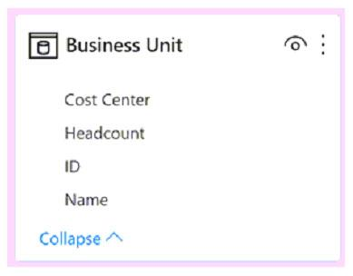  
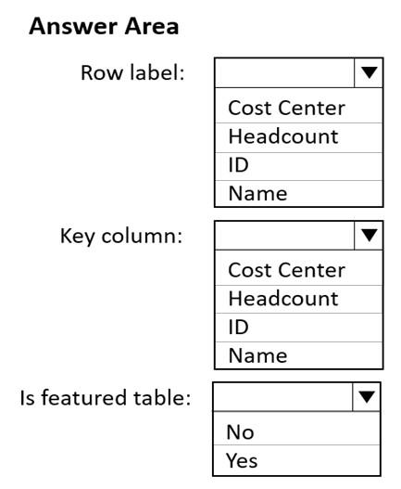

**Answer(s):** A

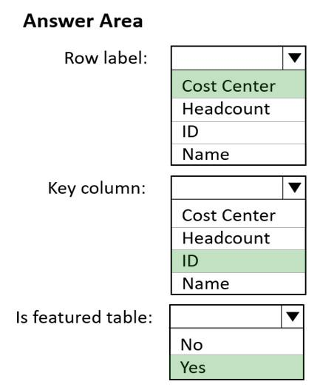

**[QUESTION: 57](https://free-braindumps.com/microsoft/free-pl-300-braindumps/page-16" \l "collapse_171)**

You have the Power BI model shown in the following exhibit.  
A manager can represent only a single country.  
You need to use row-level security (RLS) to meet the following requirements:  
-The managers must only see the data of their respective country.  
-The number of RLS roles must be minimized.  
Which two actions should you perform? Each correct answer presents a complete solution.  
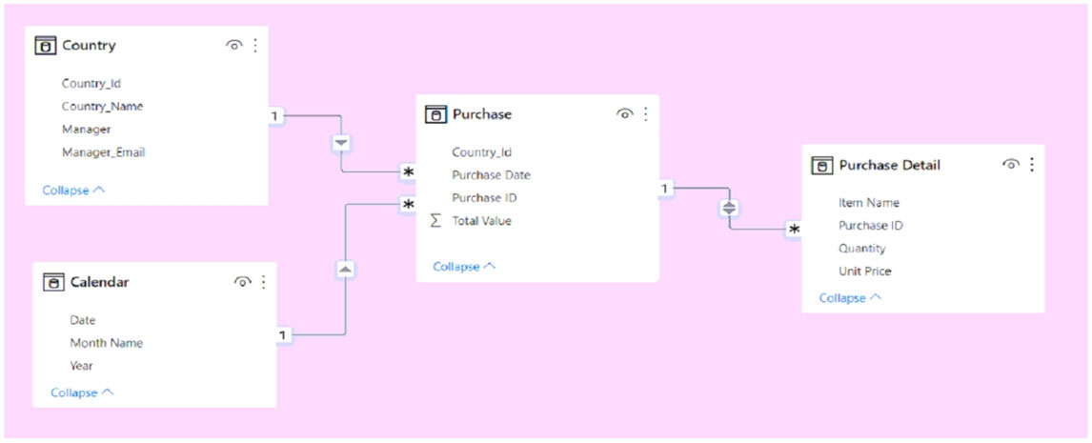NOTE: Each correct selection is worth one point.

1. Create a single role that filters Country[Manager\_Email] by using the USERNAME DAX function.
2. Create a single role that filters Country[Manager\_Email] by using the USEROBJECTID DAX function.
3. For the relationship between Purchase Detail and Purchase, select Apply security filter in both directions.
4. Create one role for each country.
5. For the relationship between Purchase and Purchase Detail, change the Cross filter direction to Single.

**Answer(s):** A,C

**[QUESTION: 58](https://free-braindumps.com/microsoft/free-pl-300-braindumps/page-16" \l "collapse_170)**

HOTSPOT (Drag and Drop is not supported)  
You have a Power BI imported dataset that contains the data model shown in the following exhibit.  
Use the drop-down menus to select the answer choice that completes each statement based on the information presented in the graphic.  
NOTE: Each correct selection is worth one point.  
Hot Area:  
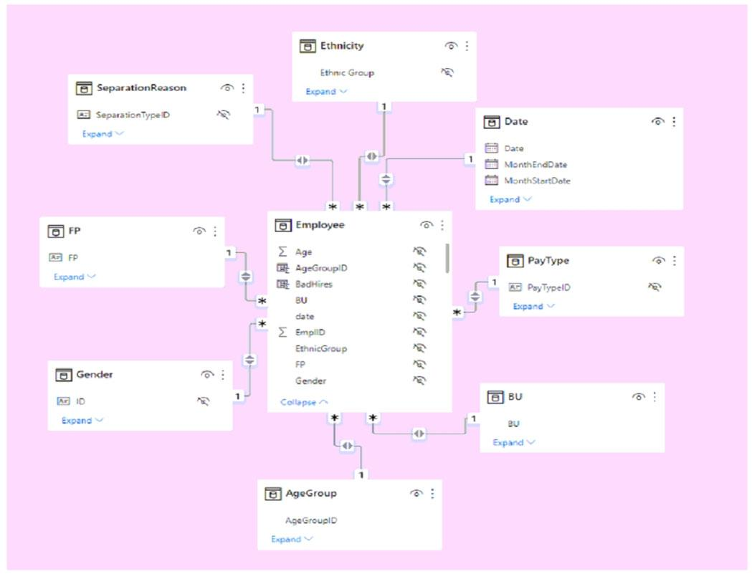  
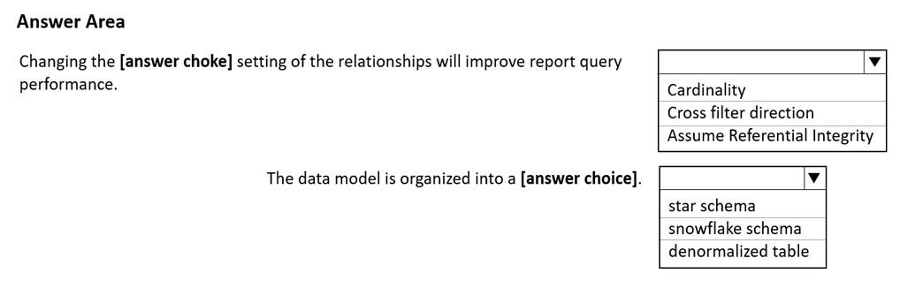

**Answer(s):** A

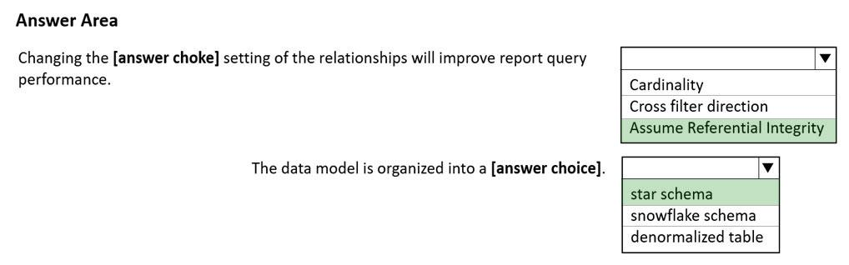

**[QUESTION: 59](https://free-braindumps.com/microsoft/free-pl-300-braindumps/page-16" \l "collapse_169)**

HOTSPOT (Drag and Drop is not supported)  
You have a Power BI model that contains a table named Sales and a related date table. Sales contains a measure named Total Sales.  
You need to create a measure that calculates the total sales from the equivalent month of the previous year.  
How should you complete the calculation? To answer, select the appropriate options in the answer area.  
NOTE: Each correct selection is worth one point.  
Hot Area:

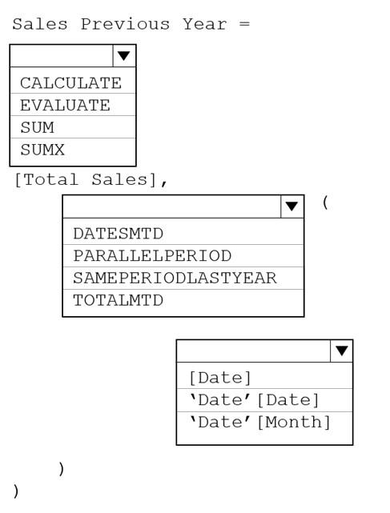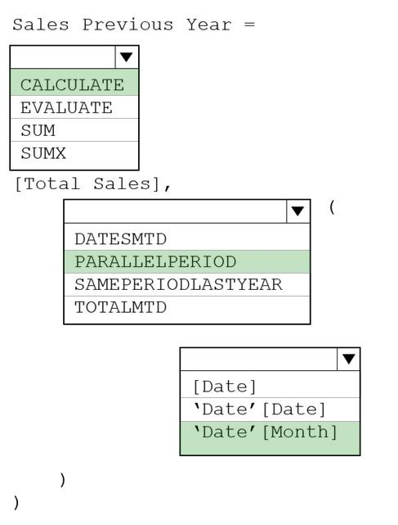

**[QUESTION: 60](https://free-braindumps.com/microsoft/free-pl-300-braindumps/page-16" \l "collapse_176)**

DRAG DROP (Drag and Drop is not supported)  
You plan to create a report that will display sales data from the last year for multiple regions.  
You need to restrict access to individual rows of the data on a per region-basis by using roles.  
Which four actions should you perform in sequence? To answer, move the appropriate actions from the list of actions to the answer area and arrange them in the correct order.  
Select and Place:  
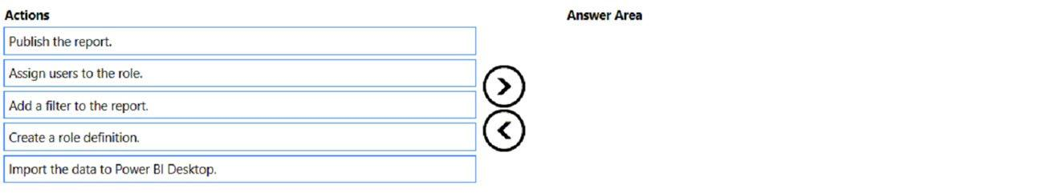

1. See Explanation section for answer.

**Answer(s):** A

**Explanation:**

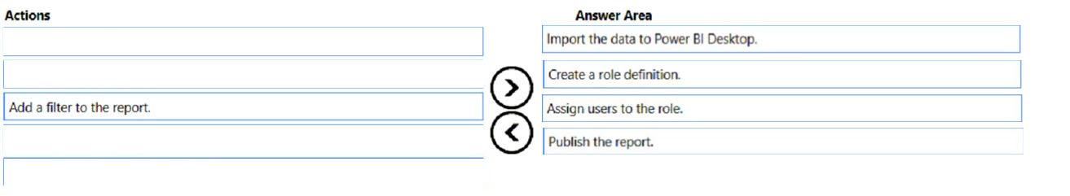

**[QUESTION: 61](https://free-braindumps.com/microsoft/free-pl-300-braindumps/page-17" \l "collapse_186)**

DRAG DROP (Drag and Drop is not supported)  
You create a data model in Power BI.  
Report developers and users provide feedback that the data model is too complex.  
The model contains the following tables.  
The model has the following relationships:  
-There is a one-to-one relationship between Sales\_Region and Region\_Manager.  
-There are more records in Manager than in Region\_Manager, but every record in Region\_Manager has a corresponding record in Manager.  
-There are more records in Sales\_Manager than in Sales\_Region, but every record in Sales\_Region has a corresponding record in Sales\_Manager.  
You need to denormalize the model into a single table. Only managers who are associated to a sales region must be included in the reports.  
Which three actions should you perform in sequence? To answer, move the appropriate actions from the list of actions to the answer area and arrange them in the correct order.  
NOTE: More than one order of answer choices is correct. You will receive credit for any of the correct orders you select.  
Select and Place:  
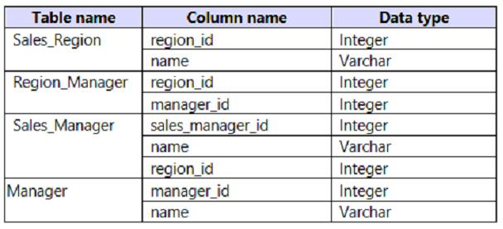  
  
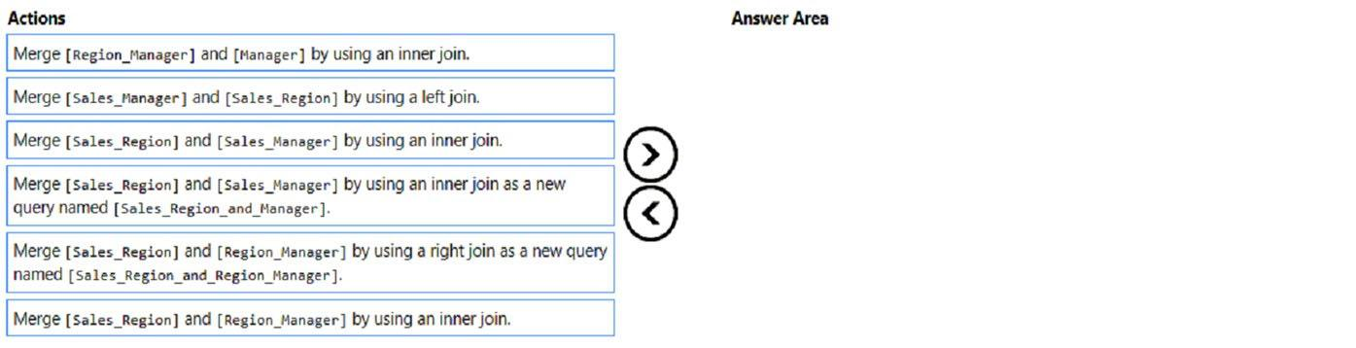

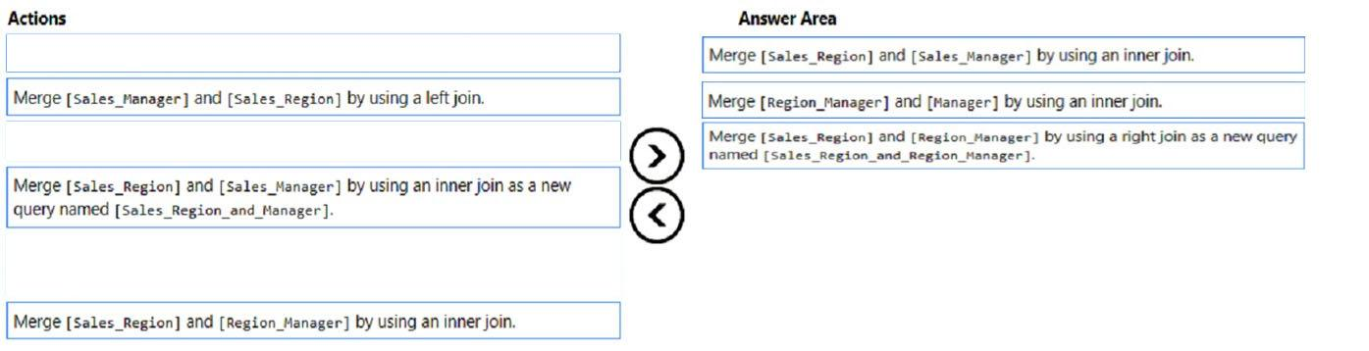

**[QUESTION: 62](https://free-braindumps.com/microsoft/free-pl-300-braindumps/page-17" \l "collapse_187)**

You have a Microsoft Power BI report. The size of PBIX file is 550 MB. The report is accessed by using an App workspace in shared capacity of powerbi.com.  
The report uses an imported dataset that contains one fact table. The fact table contains 12 million rows. The dataset is scheduled to refresh twice a day at 08:00 and 17:00.  
The report is a single page that contains 15 AppSource visuals and 10 default visuals.  
Users say that the report is slow to load the visuals when they access and interact with the report.  
You need to recommend a solution to improve the performance of the report.  
What should you recommend?

1. Change any DAX measures to use iterator functions.
2. Enable visual interactions.
3. Replace the default visuals with AppSource visuals.
4. Split the visuals onto multiple pages.

**[QUESTION: 63](https://free-braindumps.com/microsoft/free-pl-300-braindumps/page-17" \l "collapse_188)**

HOTSPOT (Drag and Drop is not supported)  
You are creating a Microsoft Power BI imported data model to perform basket analysis. The goal of the analysis is to identify which products are usually bought together in the same transaction across and within sales territories.  
You import a fact table named Sales as shown in the exhibit. (Click the Exhibit tab.)  
The related dimension tables are imported into the model.  
Sales contains the data shown in the following table.  
You are evaluating how to optimize the model.  
For each of the following statements, select Yes if the statement is true. Otherwise, select No.  
NOTE: Each correct selection is worth one point.  
Hot Area:  
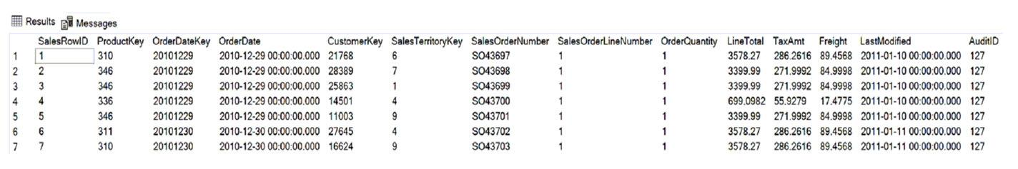  
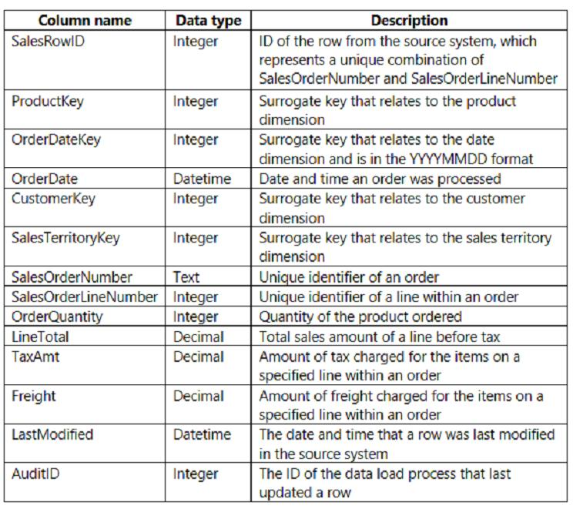  
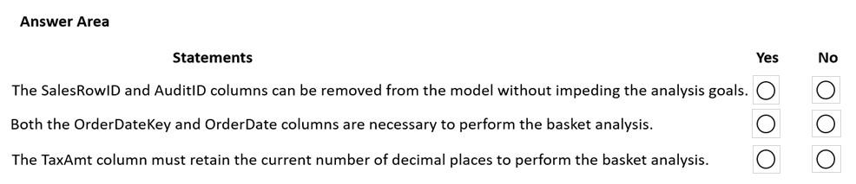

1. See Explanation section for answer.

**Answer(s):** A

**Explanation:**

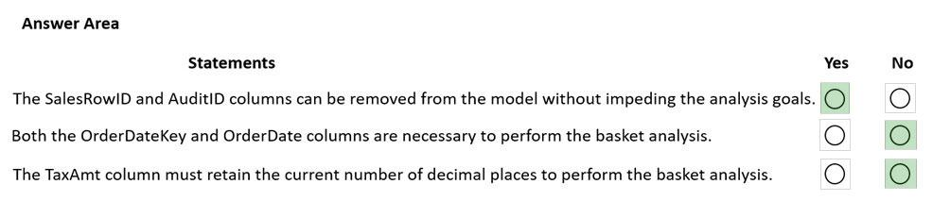

**[QUESTION: 64](https://free-braindumps.com/microsoft/free-pl-300-braindumps/page-17" \l "collapse_205)**

You have a Microsoft Power BI data model that contains three tables named Orders, Date, and City. There is a one-to-many relationship between Date and  
Orders and between City and Orders.  
The model contains two row-level security (RLS) roles named Role1 and Role2. Role1 contains the following filter.  
City[State Province] = "Kentucky"  
Role2 contains the following filter.  
Date[Calendar Year] = 2020  
If a user is a member of both Role1 and Role2, what data will they see in a report that uses the model?

1. The user will see data for which the State Province value is Kentucky or where the Calendar Year is 2020.
2. The user will receive an error and will not be able to see the data in the report.
3. The user will only see data for which the State Province value is Kentucky.
4. The user will only see data for which the State Province value is Kentucky and the Calendar Year is 2020.

**Answer(s):** A

**[QUESTION: 65](https://free-braindumps.com/microsoft/free-pl-300-braindumps/page-18" \l "collapse_204)**

Note: This question is part of a series of questions that present the same scenario. Each question in the series contains a unique solution that might meet the stated goals. Some question sets might have more than one correct solution, while others might not have a correct solution.  
After you answer a question in this section, you will NOT be able to return to it. As a result, these questions will not appear in the review screen.  
You are modeling data by using Microsoft Power BI. Part of the data model is a large Microsoft SQL Server table named Order that has more than 100 million records.  
During the development process, you need to import a sample of the data from the Order table.  
Solution: From Power Query Editor, you import the table and then add a filter step to the query.  
Does this meet the goal?

1. Yes
2. No

**[QUESTION: 66](https://free-braindumps.com/microsoft/free-pl-300-braindumps/page-18" \l "collapse_203)**

Note: This question is part of a series of questions that present the same scenario. Each question in the series contains a unique solution that might meet the stated goals. Some question sets might have more than one correct solution, while others might not have a correct solution.  
After you answer a question in this section, you will NOT be able to return to it. As a result, these questions will not appear in the review screen.  
You are modeling data by using Microsoft Power BI. Part of the data model is a large Microsoft SQL Server table named Order that has more than 100 million records.  
During the development process, you need to import a sample of the data from the Order table.  
Solution: You write a DAX expression that uses the FILTER function.  
Does this meet the goal?

1. Yes
2. No

**[QUESTION: 67](https://free-braindumps.com/microsoft/free-pl-300-braindumps/page-18" \l "collapse_202)**

Note: This question is part of a series of questions that present the same scenario. Each question in the series contains a unique solution that might meet the stated goals. Some question sets might have more than one correct solution, while others might not have a correct solution.  
After you answer a question in this section, you will NOT be able to return to it. As a result, these questions will not appear in the review screen.  
You are modeling data by using Microsoft Power BI. Part of the data model is a large Microsoft SQL Server table named Order that has more than 100 million records.  
During the development process, you need to import a sample of the data from the Order table.  
Solution: You add a WHERE clause to the SQL statement.  
Does this meet the goal?

1. Yes
2. No

**[QUESTION: 68](https://free-braindumps.com/microsoft/free-pl-300-braindumps/page-18" \l "collapse_201)**

DRAG DROP (Drag and Drop is not supported)  
You are preparing a financial report in Power BI.  
You connect to the data stored in a Microsoft Excel spreadsheet by using Power Query Editor as shown in the following exhibit.  
You need to prepare the data to support the following:  
-Visualizations that include all measures in the data over time  
-Year-over-year calculations for all the measures  
Which four actions should you perform in sequence? To answer, move the appropriate actions from the list of actions to the answer area and arrange them in the correct order.  
Select and Place:  
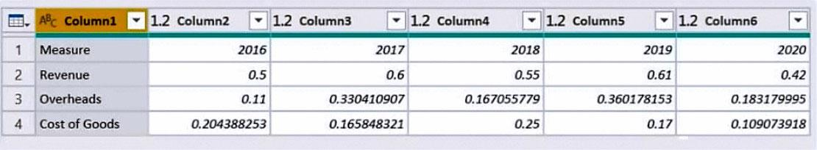  
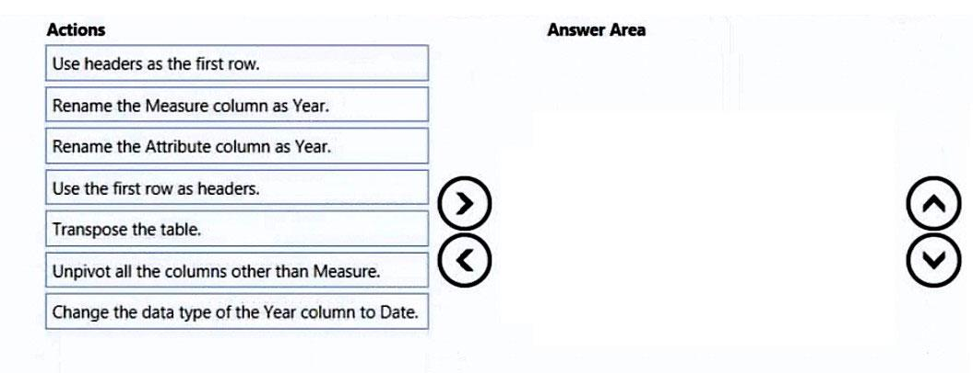

1. See Explanation section for answer.

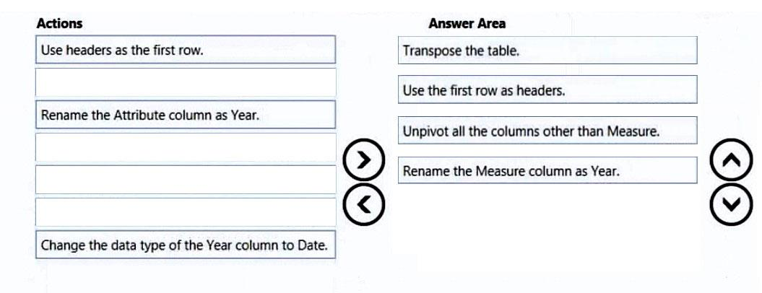

**[QUESTION: 69](https://free-braindumps.com/microsoft/free-pl-300-braindumps/page-19" \l "collapse_200)**

HOTSPOT (Drag and Drop is not supported)  
You are creating an analytics report that will consume data from the tables shown in the following table.  
There is a relationship between the tables.  
There are no reporting requirements on employee\_id and employee\_photo.  
You need to optimize the data model.  
What should you configure for employee\_id and employee\_photo? To answer, select the appropriate options in the answer area.  
NOTE: Each correct selection is worth one point.  
Hot Area:  
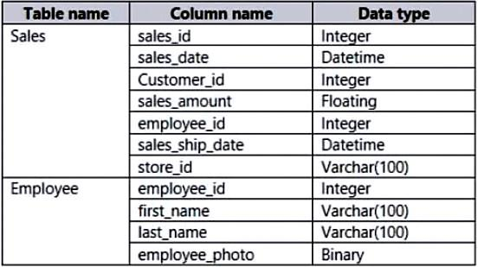  
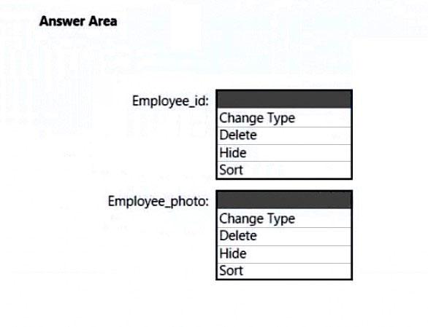

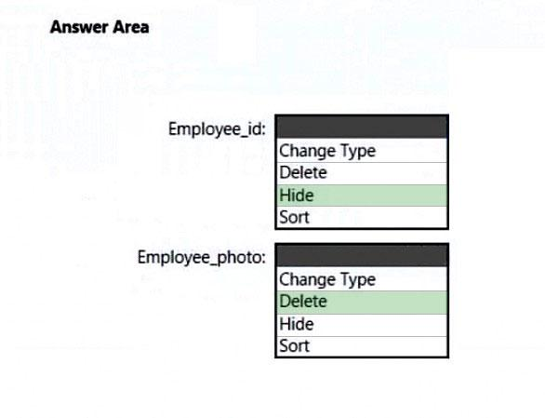

**[QUESTION: 70](https://free-braindumps.com/microsoft/free-pl-300-braindumps/page-19" \l "collapse_199)**

HOTSPOT (Drag and Drop is not supported)  
You plan to create Power BI dataset to analyze attendance at a school. Data will come from two separate views named View1 and View2 in an Azure SQL database.  
View1 contains the columns shown in the following table.  
View2 contains the columns shown in the following table.  
The views can be related based on the Class ID column.  
Class ID is the unique identifier for the specified class, period, teacher, and school year. For example, the same class can be taught by the same teacher during two different periods, but the class will have a different class ID.  
You need to design a star schema data model by using the data in both views. The solution must facilitate the following analysis:  
-The count of classes that occur by period  
-The count of students in attendance by period by day  
-The average number of students attending a class each month  
In which table should you include the Teacher First Name and Period Number fields? To answer, select the appropriate options in the answer area.  
NOTE: Each correct selection is worth one point.  
Hot Area:  
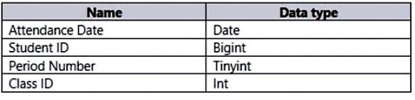  
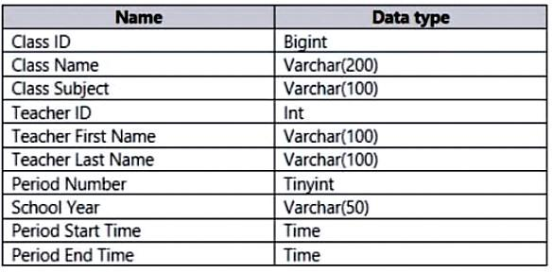  
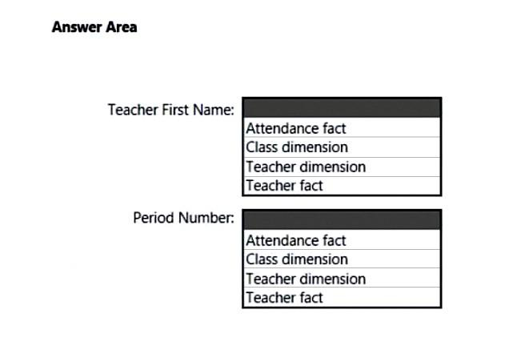

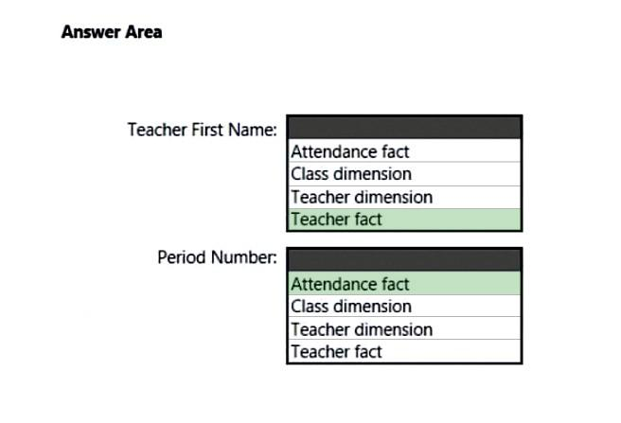

**[QUESTION: 71](https://free-braindumps.com/microsoft/free-pl-300-braindumps/page-19" \l "collapse_198)**

You have the Power BI model shown in the following exhibit.  
There are four departments in the Departments table.  
You need to ensure that users can see the data of their respective department only.  
What should you do?  
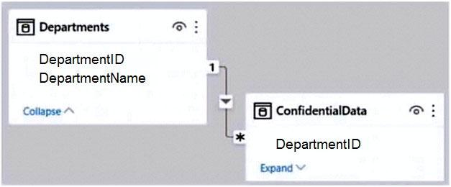

1. Create a slicer that filters Departments based on DepartmentID.
2. Create a row-level security (RLS) role for each department, and then define the membership of the role.
3. Create a DepartmentID parameter to filter the Departments table.
4. To the ConfidentialData table, add a calculated measure that uses the CURRENTGROUP DAX function.

**Answer(s):** B

**[QUESTION: 72](https://free-braindumps.com/microsoft/free-pl-300-braindumps/page-19" \l "collapse_197)**

In Power BI Desktop, you are building a sales report that contains two tables. Both tables have row-level security (RLS) configured.  
You need to create a relationship between the tables. The solution must ensure that bidirectional cross-filtering honors the RLS settings.  
What should you do?

1. Create an inactive relationship between the tables and select Apply security filter in both directions.
2. Create an active relationship between the tables and select Apply security filter in both directions.
3. Create an inactive relationship between the tables and select Assume referential integrity.
4. Create an active relationship between the tables and select Assume referential integrity.

**Answer(s):** B

**[QUESTION: 73](https://free-braindumps.com/microsoft/free-pl-300-braindumps/page-20" \l "collapse_196)**

HOTSPOT (Drag and Drop is not supported)  
You have a column named UnitsInStock as shown in the following exhibit.  
UnitsInStock has 75 non-null values, of which 51 are unique.  
Use the drop-down menus to select the answer choice that completes each statement based on the information presented in the graphic.  
NOTE: Each correct selection is worth one point.  
Hot Area:  
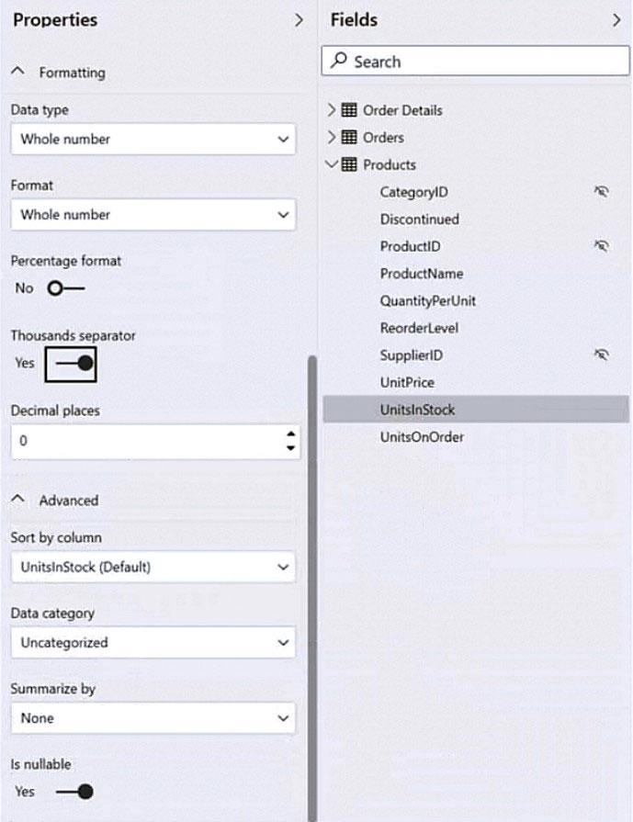  
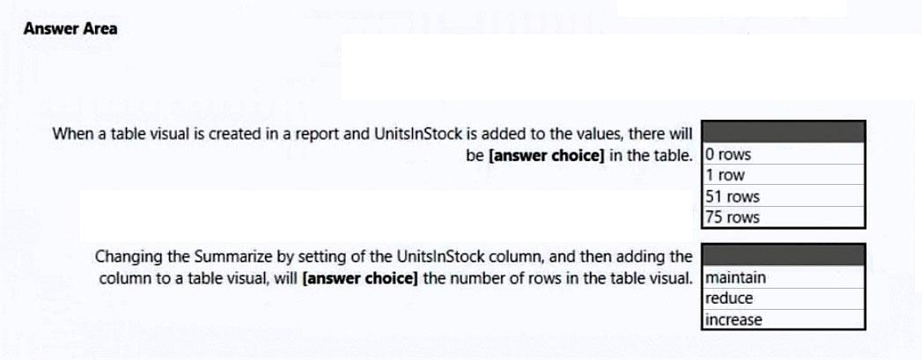

1. See Explanation section for answer.

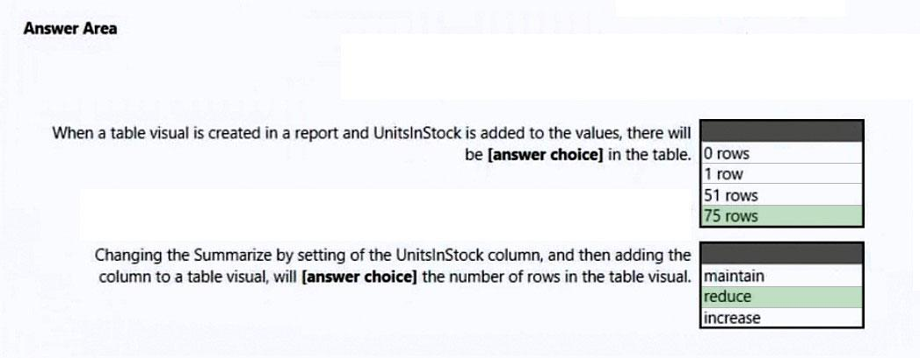

**[QUESTION: 74](https://free-braindumps.com/microsoft/free-pl-300-braindumps/page-20" \l "collapse_195)**

HOTSPOT (Drag and Drop is not supported)  
You have a Power BI report.  
You have the following tables.  
You have the following DAX measure.  
Accounts :=  
CALCULATE (  
DISTINCTCOUNT (Balances[AccountID]),  
LASTDATE ('Date'[Date])  
For each of the following statements, select Yes if the statement is true. Otherwise, select No.  
NOTE: Each correct selection is worth one point.  
Hot Area:  
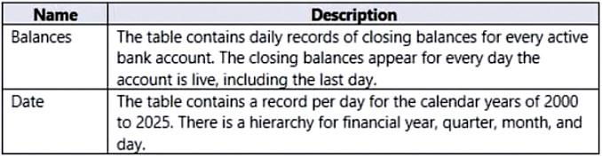  
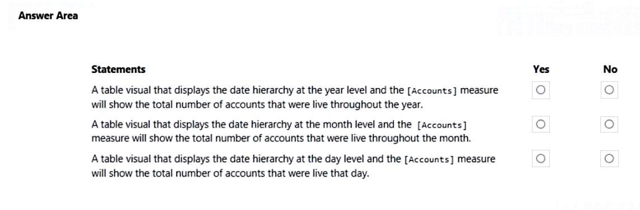

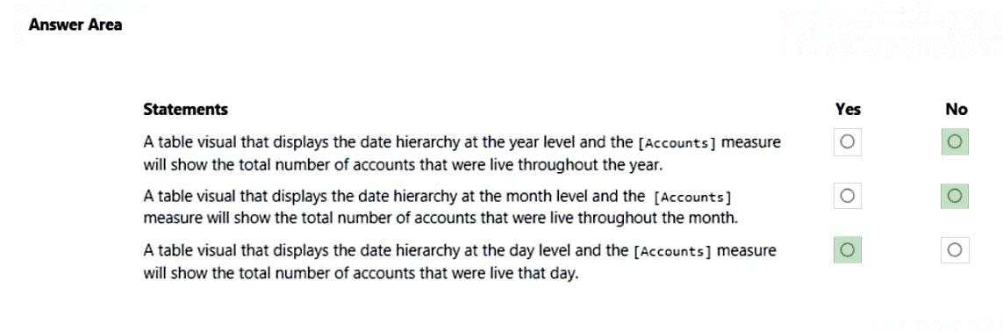

**[QUESTION: 75](https://free-braindumps.com/microsoft/free-pl-300-braindumps/page-20" \l "collapse_194)**

You have the tables shown in the following table.  
The Impressions table contains approximately 30 million records per month.  
You need to create an ad analytics system to meet the following requirements:  
-Present ad impression counts for the day, campaign, and site\_name. The analytics for the last year are required.  
Minimize the data model size.  
Which two actions should you perform? Each correct answer presents part of the solution.  
NOTE: Each correct selection is worth one point.  
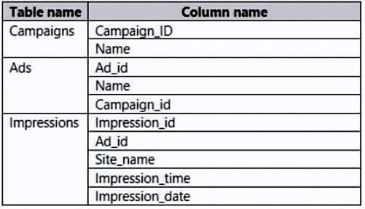

1. Create one-to-many relationships between the tables.
2. Group the Impressions query in Power Query by Ad\_id, Site\_name, and Impression\_date. Aggregate by using the CountRows function.
3. Create a calculated table that contains Ad\_id, Site\_name, and Impression\_date.
4. Create a calculated measure that aggregates by using the COUNTROWS function.

**Answer(s):** A,B

**[QUESTION: 76](https://free-braindumps.com/microsoft/free-pl-300-braindumps/page-20" \l "collapse_193)**

HOTSPOT (Drag and Drop is not supported)  
You are creating a Microsoft Power BI data model that has the tables shown in the following table.  
The Products table is related to the ProductCategory table through the ProductCategoryID column. Each product has one product category.  
You need to ensure that you can analyze sales by product category.  
How should you configure the relationship from ProductCategory to Products? To answer, select the appropriate options in the answer area.  
NOTE: Each correct selection is worth one point.  
Hot Area:  
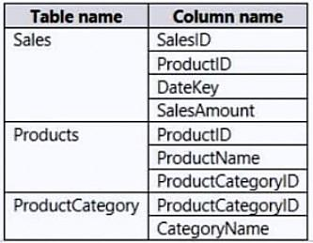  
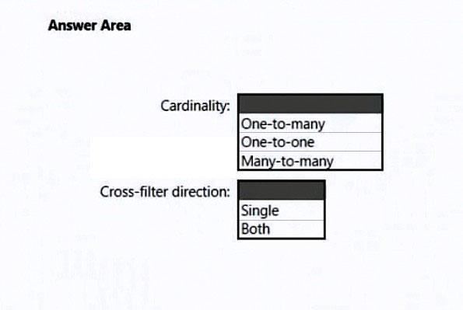

1. See Explanation section for answer.

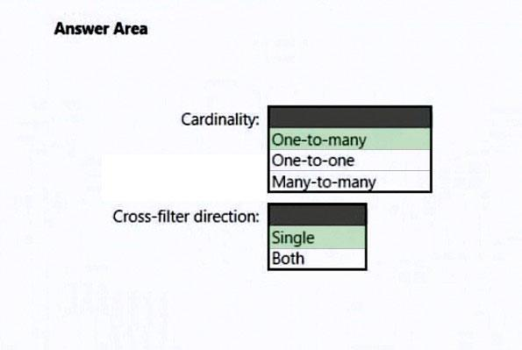

**[QUESTION: 77](https://free-braindumps.com/microsoft/free-pl-300-braindumps/page-21" \l "collapse_192)**

You import a Power BI dataset that contains the following tables:  
-Date  
-Product  
-Product Inventory  
The Product Inventory table contains 25 million rows. A sample of the data is shown in the following table.  
The Product Inventory table relates to the Date table by using the DateKey column. The Product Inventory table relates to the Product table by using the  
ProductKey column.  
You need to reduce the size of the data model without losing information.  
What should you do?  
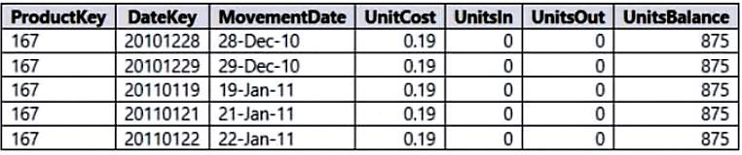

1. Change Summarization for DateKey to Don't Summarize.
2. Remove the relationship between Date and Product Inventory
3. Change the data type of UnitCost to Integer.
4. Remove MovementDate.

**Answer(s):** D

**[QUESTION: 78](https://free-braindumps.com/microsoft/free-pl-300-braindumps/page-21" \l "collapse_191)**

HOTSPOT (Drag and Drop is not supported)  
You are enhancing a Power BI model that has DAX calculations.  
You need to create a measure that returns the year-to-date total sales from the same date of the previous calendar year.  
Which DAX functions should you use? To answer, select the appropriate options in the answer area.  
NOTE: Each correct selection is worth one point.  
Hot Area:  
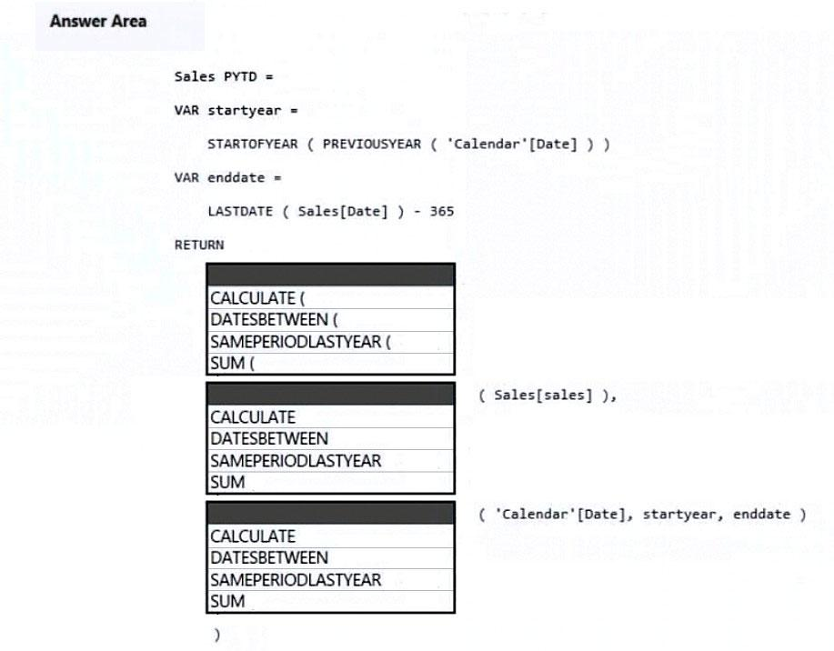

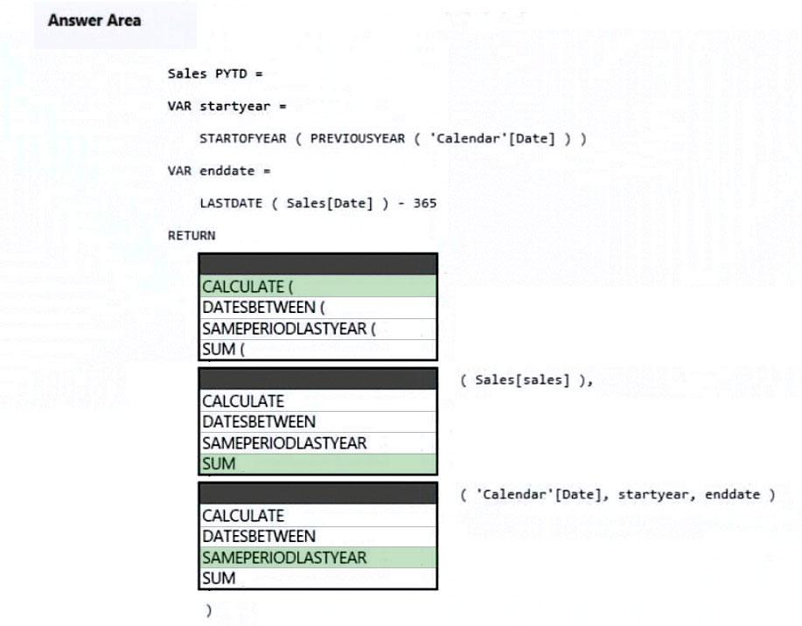

**[QUESTION: 79](https://free-braindumps.com/microsoft/free-pl-300-braindumps/page-21" \l "collapse_190)**

Note: This question is part of a series of questions that present the same scenario. Each question in the series contains a unique solution that might meet the stated goals. Some question sets might have more than one correct solution, while others might not have a correct solution.  
After you answer a question in this section, you will NOT be able to return to it. As a result, these questions will not appear in the review screen.  
You are modeling data by using Microsoft Power BI. Part of the data model is a large Microsoft SQL Server table named Order that has more than 100 million records.  
During the development process, you need to import a sample of the data from the Order table.  
Solution: You add a report-level filter that filters based on the order date.  
Does this meet the goal?

1. Yes
2. No

**Answer(s):** B

**[QUESTION: 80](https://free-braindumps.com/microsoft/free-pl-300-braindumps/page-21" \l "collapse_189)**

Note: This question is part of a series of questions that present the same scenario. Each question in the series contains a unique solution that might meet the stated goals. Some question sets might have more than one correct solution, while others might not have a correct solution.  
After you answer a question in this section, you will NOT be able to return to it. As a result, these questions will not appear in the review screen.  
You have a Power BI report that imports a date table and a sales table from an Azure SQL database data source. The sales table has the following date foreign keys:  
-Due Date  
-Order Date  
-Delivery Date  
You need to support the analysis of sales over time based on all the date foreign keys.  
Solution: For each date foreign key, you add inactive relationships between the sales table and the date table.  
Does this meet the goal?

1. Yes
2. No

**Answer(s):** B

**[QUESTION: 81](https://free-braindumps.com/microsoft/free-pl-300-braindumps/page-22" \l "collapse_228)**

Note: This question is part of a series of questions that present the same scenario. Each question in the series contains a unique solution that might meet the stated goals. Some question sets might have more than one correct solution, while others might not have a correct solution.  
After you answer a question in this section, you will NOT be able to return to it. As a result, these questions will not appear in the review screen.  
You have a Power BI report that imports a date table and a sales table from an Azure SQL database data source. The sales table has the following date foreign keys:  
-Due Date  
-Order Date  
-Delivery Date  
You need to support the analysis of sales over time based on all the date foreign keys.  
Solution: From Power Query Editor, you rename the date query as Due Date. You reference the Due Date query twice to make the queries for Order Date and  
Delivery Date.  
Does this meet the goal?

1. Yes
2. No

**Answer(s):** A

**[QUESTION: 82](https://free-braindumps.com/microsoft/free-pl-300-braindumps/page-22" \l "collapse_249)**

Note: This question is part of a series of questions that present the same scenario. Each question in the series contains a unique solution that might meet the stated goals. Some question sets might have more than one correct solution, while others might not have a correct solution.  
After you answer a question in this section, you will NOT be able to return to it. As a result, these questions will not appear in the review screen.  
You have a Power BI report that imports a date table and a sales table from an Azure SQL database data source. The sales table has the following date foreign keys:  
-Due Date  
-Order Date  
-Delivery Date  
You need to support the analysis of sales over time based on all the date foreign keys.  
Solution: From the Fields pane, you rename the date table as Due Date. You use a DAX expression to create Order Date and Delivery Date as calculated tables.  
Does this meet the goal?

1. Yes
2. No

**[QUESTION: 83](https://free-braindumps.com/microsoft/free-pl-300-braindumps/page-22" \l "collapse_250)**

DRAG DROP (Drag and Drop is not supported)  
You receive revenue data that must be included in Microsoft Power BI reports.  
You preview the data from a Microsoft Excel source in Power Query as shown in the following exhibit.  
You plan to create several visuals from the data, including a visual that shows revenue split by year and product.  
You need to transform the data to ensure that you can build the visuals. The solution must ensure that the columns are named appropriately for the data that they contain.  
Which three actions should you perform in sequence? To answer, move the appropriate actions from the list of actions to the answer area and arrange them in the correct order.  
Select and Place:  
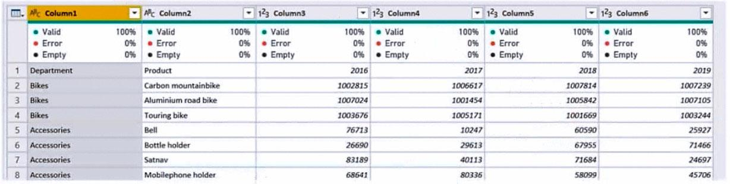  
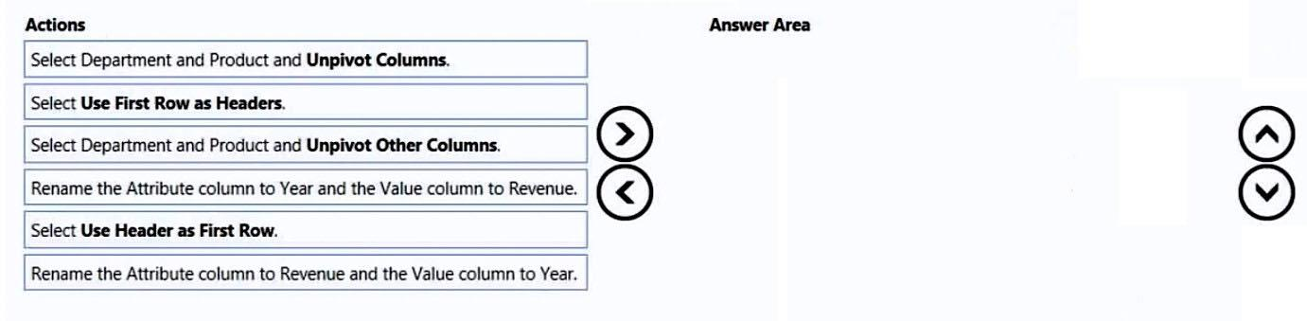

1. See Explanation section for answer.

**Answer(s):** A

**Explanation:**

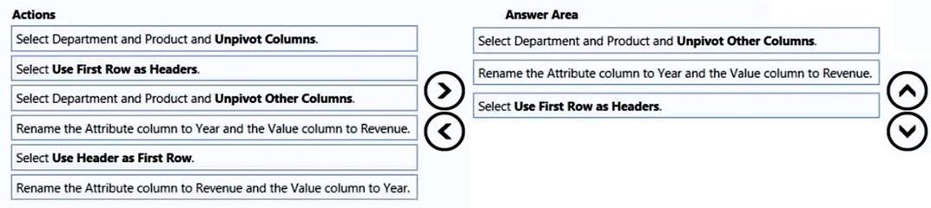

**[QUESTION: 84](https://free-braindumps.com/microsoft/free-pl-300-braindumps/page-22" \l "collapse_251)**

HOTSPOT (Drag and Drop is not supported)  
You have a Power BI report named Orders that supports the following analysis:  
-Total sales over time  
-The count of orders over time  
-New and repeat customer counts  
The data model size is nearing the limit for a dataset in shared capacity.  
The model view for the dataset is shown in the following exhibit.  
The data view for the Orders table is shown in the following exhibit.  
The Orders table relates to the Customers table by using the CustomerID column.  
The Orders table relates to the Date table by using the OrderDate column.  
For each of the following statements, select Yes if the statement is true, Otherwise, select No.  
NOTE: Each correct selection is worth one point.  
  
Hot Area:  
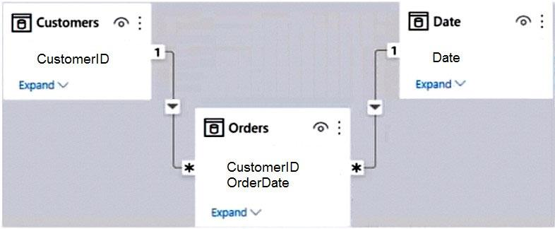  
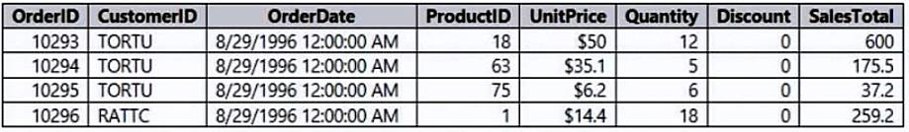  
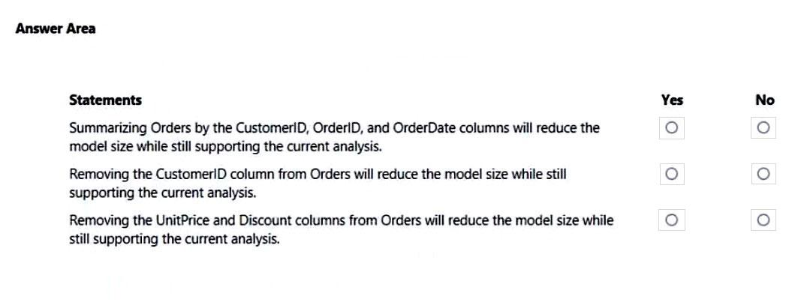

1. See Explanation section for answer.

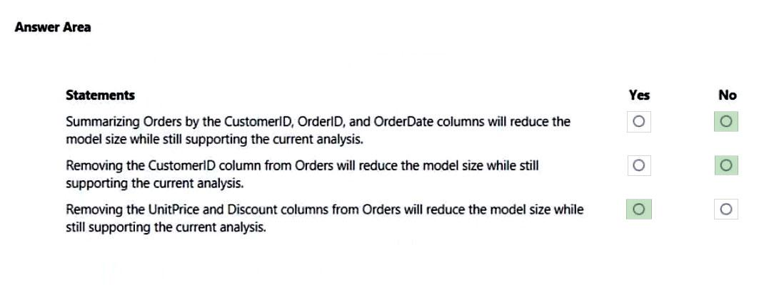

**[QUESTION: 85](https://free-braindumps.com/microsoft/free-pl-300-braindumps/page-23" \l "collapse_310)**

HOTSPOT (Drag and Drop is not supported)  
You are building a financial report by using Power BI.  
You have a table named financials that contains a column named Date and a column named Sales.  
You need to create a measure that calculates the relative change in sales as compared to the previous quarter.  
How should you complete the measure? To answer, select the appropriate options in the answer area.  
NOTE: Each correct selection is worth one point.  
Hot Area:  
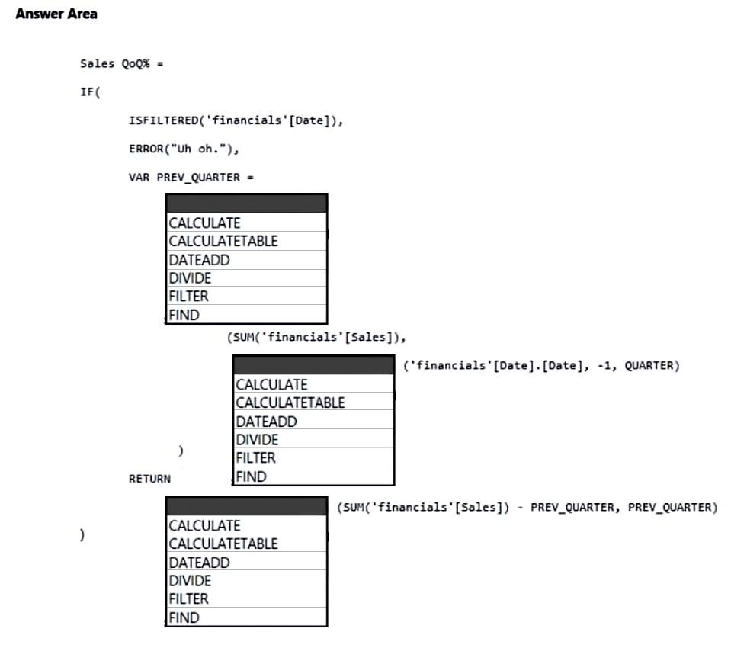

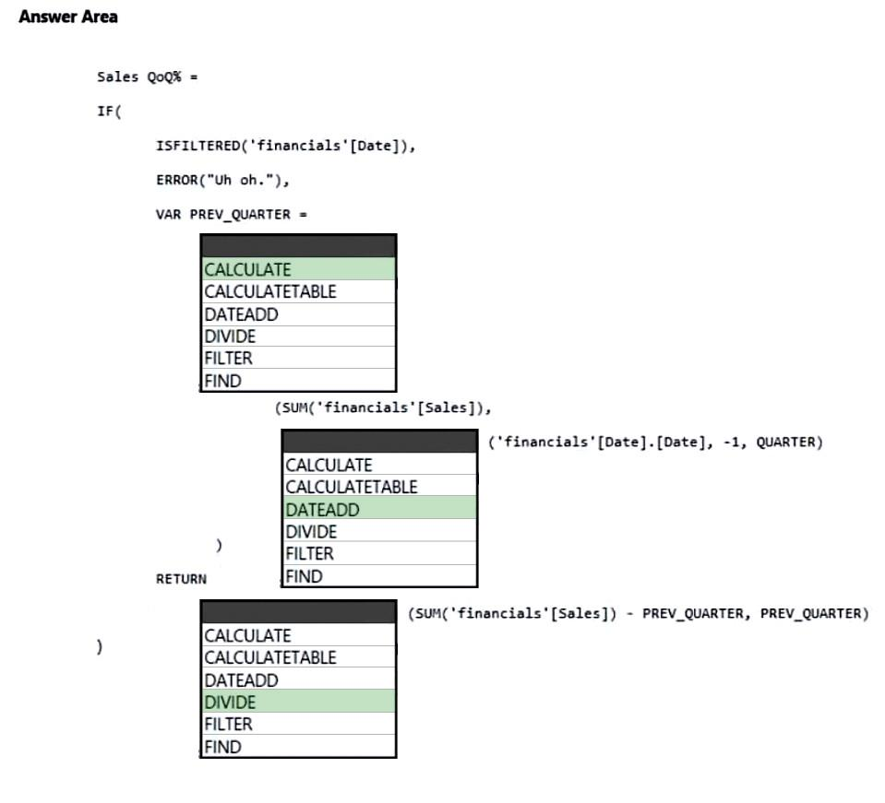

**[QUESTION: 86](https://free-braindumps.com/microsoft/free-pl-300-braindumps/page-23" \l "collapse_309)**

DRAG DROP (Drag and Drop is not supported)  
You are creating a Power BI model and report.  
You have a single table in a data model named Product. Product contains the following fields:  
-ID  
-Name  
-Color  
-Category  
-Total Sales  
You need to create a calculated table that shows only the top eight products based on the highest value in Total Sales.  
How should you complete the DAX expression? To answer, drag the appropriate values to the correct targets. Each value may be used once, more than once, or not at all. You may need to drag the split bar between panes or scroll to view content.  
Select and Place:  
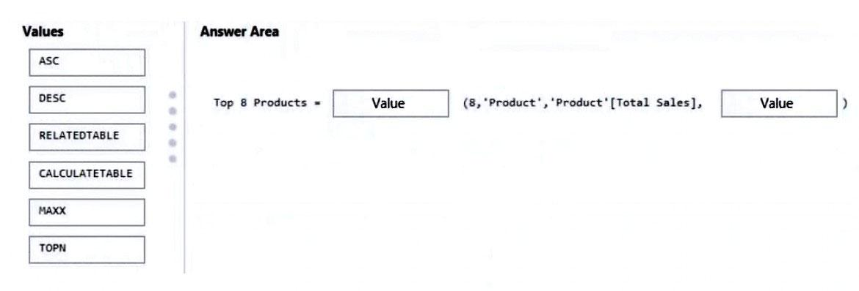

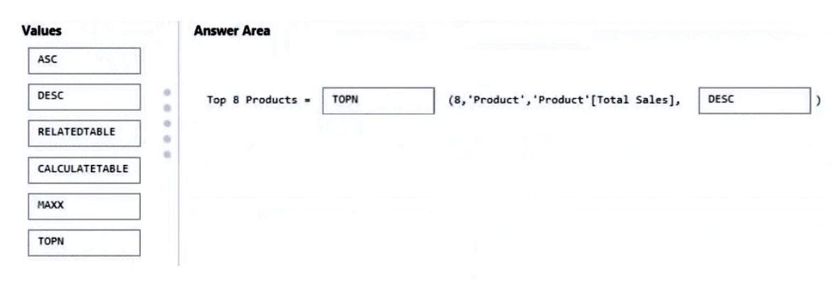

QUESTION: 87

You are creating a sales report in Power BI for the NorthWest region sales territory of your company. Data will come from a view in a Microsoft SQL Server database. A sample of the data is shown in the following table:  
The report will facilitate the following analysis:  
-The count of orders and the sum of total sales by Order Date  
-The count of customers who placed an order  
-The average quantity per order  
You need to reduce data refresh times and report query times.  
Which two actions should you perform? Each correct answer presents part of the solution.  
NOTE: Each correct selection is worth one point.  
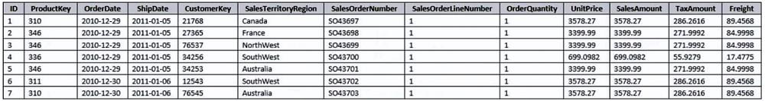

1. Set the data type for SalesOrderNumber to Decimal Number.
2. Remove the CustomerKey and ProductKey columns.
3. Remove the TaxAmt and Freight columns.
4. Filter the data to only the NorthWest region sales territory.

**[QUESTION: 88](https://free-braindumps.com/microsoft/free-pl-300-braindumps/page-23" \l "collapse_307)**

You are creating a Power BI model that contains a table named Store. Store contains the following fields.  
You plan to create a map visual that will show store locations and provide the ability to drill down from Country to State/Province to City.  
What should you do to ensure that the locations are mapped properly?  
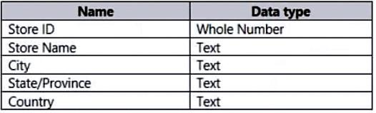

1. Change the data type of City, State/Province, and Country.
2. Set Summarization for City, State/Province, and Country to Don't summarize.
3. Set the data category of City, State/Province, and Country.
4. Create a calculated column that concatenates the values in City, State/Province, and Country

You are building a data model for a Power BI report.  
You have data formatted as shown in the following table.  
You need to create a clustered bar chart as shown in the following exhibit.  
What should you do?  
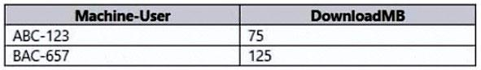  
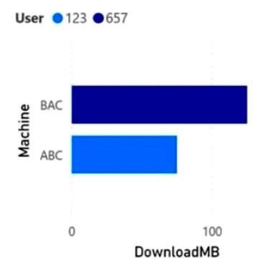

1. From Power Query Editor, split the Machine-User column by using a delimiter.
2. From Power Query Editor, create a column that contains the last three digits of the Machine-User column.
3. In a DAX function, create two calculated columns named Machine and User by using the SUBSTITUTE function.
4. In a DAX function, create two measures named Machine and User by using the SUBSTITUTE function.

**[QUESTION: 90](https://free-braindumps.com/microsoft/free-pl-300-braindumps/page-24" \l "collapse_305)**

DRAG DROP (Drag and Drop is not supported)  
You need create a date table in Power BI that must contain 10 full calendar years, including the current year.  
How should you complete the DAX expression? To answer, select the appropriate options in the answer area.  
NOTE: Each correct selection is worth one point.  
Select and Place:  
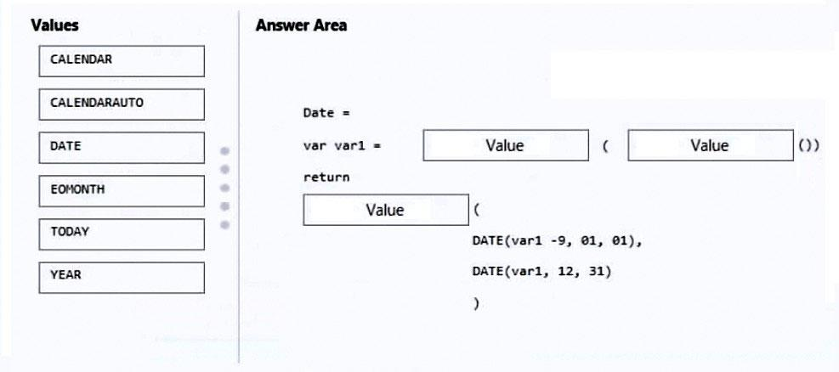

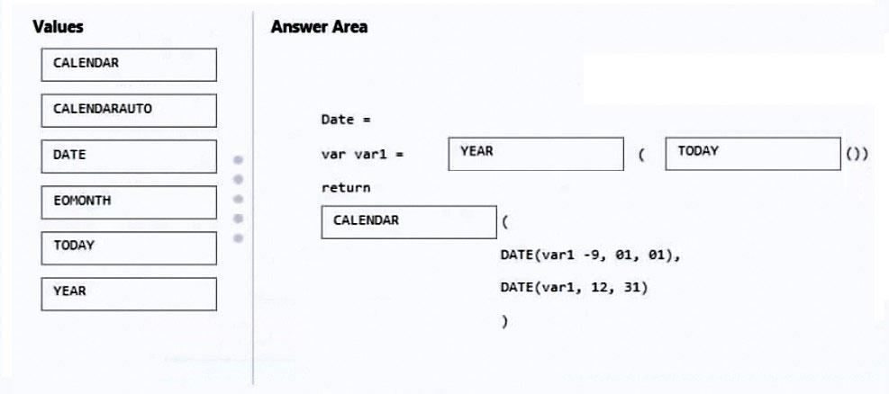

**[QUESTION: 91](https://free-braindumps.com/microsoft/free-pl-300-braindumps/page-24" \l "collapse_304)**

Note: This question is part of a series of questions that present the same scenario. Each question in the series contains a unique solution that might meet the stated goals. Some question sets might have more than one correct solution, while others might not have a correct solution.  
After you answer a question in this section, you will NOT be able to return to it. As a result, these questions will not appear in the review screen.  
You have a Power BI report that imports a date table and a sales table from an Azure SQL database data source. The sales table has the following date foreign keys:  
-Due Date  
-Order Date  
-Delivery Date  
You need to support the analysis of sales over time based on all the date foreign keys.  
Solution: You create measures that use the USERELATIONSHIP DAX function to filter sales on the active relationship between the sales table and the date table.  
Does this meet the goal?

1. Yes
2. No

**[QUESTION: 92](https://free-braindumps.com/microsoft/free-pl-300-braindumps/page-24" \l "collapse_303)**

HOTSPOT (Drag and Drop is not supported)  
You have a Power BI report that contains a measure named Total Sales.  
You need to create a new measure that will return the sum of Total Sales for a year up to a selected date.  
How should you complete the DAX expression? To answer, select the appropriate options in the answer area.  
NOTE: Each correct selection is worth one point.  
Hot Area:  
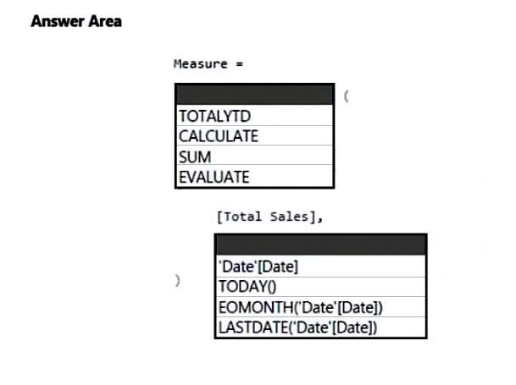

1. See Explanation section for answer.

**Answer(s):** A

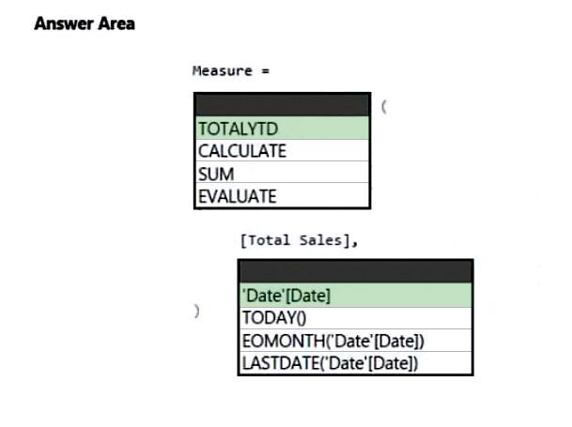

**[QUESTION: 93](https://free-braindumps.com/microsoft/free-pl-300-braindumps/page-25" \l "collapse_302)**

DRAG DROP (Drag and Drop is not supported)  
You are modifying a Power BI model by using Power BI Desktop.  
You have a table named Sales that contains the following fields.  
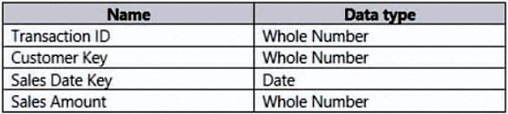  
  
You have a table named Transaction Size that contains the following data.  
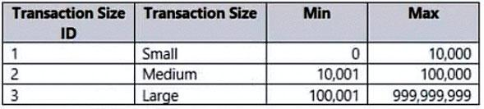  
  
You need to create a calculated column to classify each transaction as small, medium, or large based on the value in Sales Amount.  
How should you complete the code?  
To answer, drag the appropriate values to the correct targets. Each value may be used once, more than once, or not at all.  
You may need to drag the split bar between panes or scroll to view content.  
NOTE: Each correct selection is worth one point.  
Select and Place:  
  
  
  
  
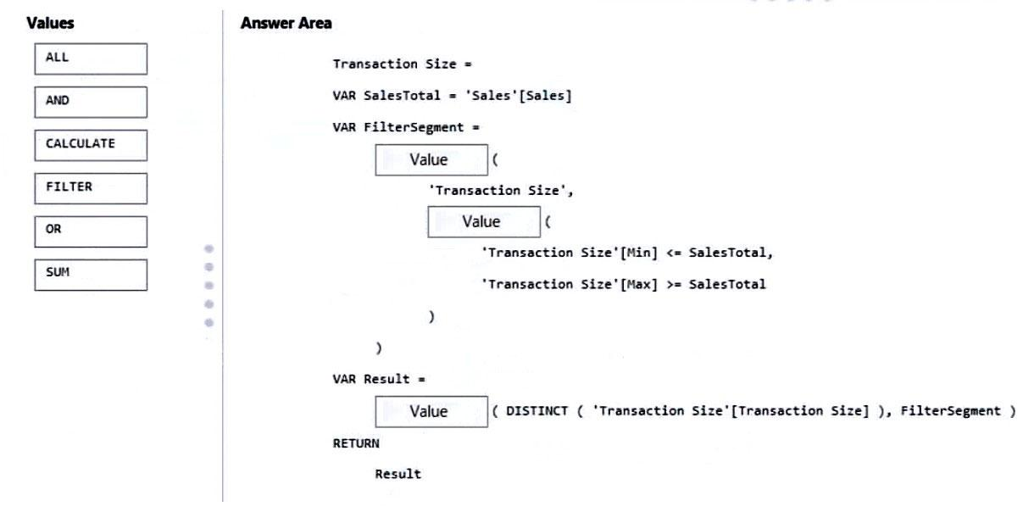

1. See Explanation section for answer.

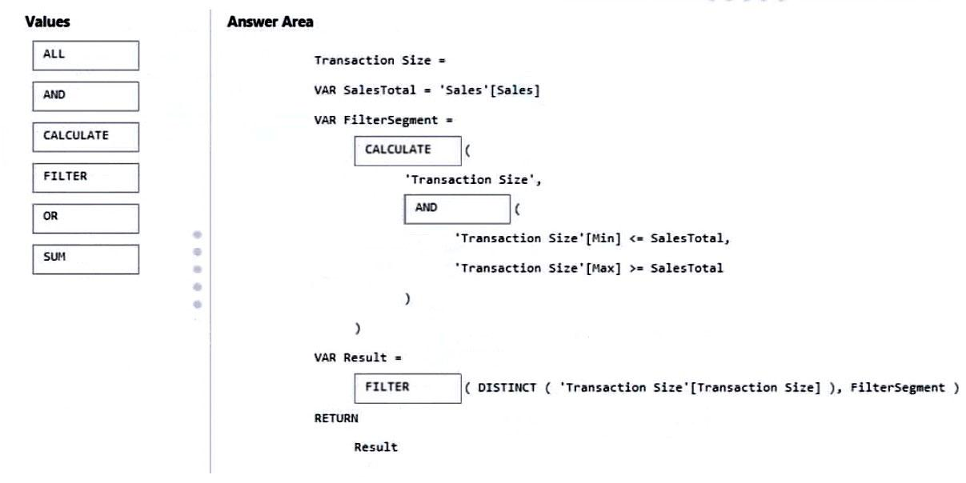

**[QUESTION: 94](https://free-braindumps.com/microsoft/free-pl-300-braindumps/page-25" \l "collapse_301)**

You have a Power BI report for the procurement department. The report contains data from the following tables.  
There is a one-to-many relationship from Suppliers to LineItems that uses the ID and Supplier ID columns.  
The report contains the visuals shown in the following table.  
You need to minimize the size of the dataset without affecting the visuals.  
What should you do?  
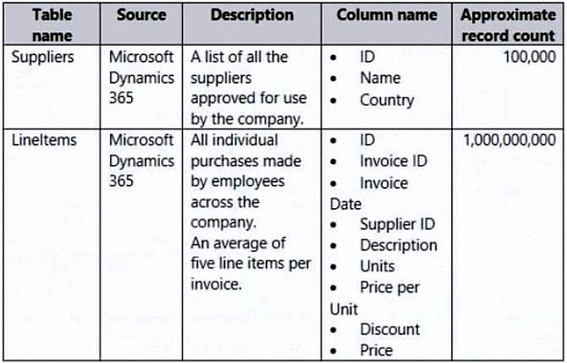  
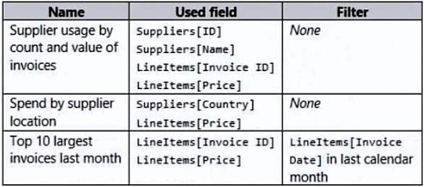

1. Merge Suppliers and LineItems.
2. Remove the LineItems[Description] column.
3. Remove the rows from LineItems where LineItems[Invoice Date] is before the beginning of last month.
4. Group LineItems by LineItems[Invoice ID] and LineItems[Invoice Date] with a sum of LineItems[Price].

**[QUESTION: 95](https://free-braindumps.com/microsoft/free-pl-300-braindumps/page-25" \l "collapse_300)**

You have a Power BI report for the marketing department. The report reports on web traffic to a blog and contains data from the following tables.  
There is a one-to-many relationship from Posts to Traffic that uses the URL and URL Visited columns.  
The report contains the visuals shown in the following table.  
The dataset takes a long time to refresh.  
You need to modify Posts and Traffic queries to reduce load times.  
Which two actions will reduce the load times? Each correct answer presents part of the solution.  
NOTE:  
Each correct selection is worth one point.  
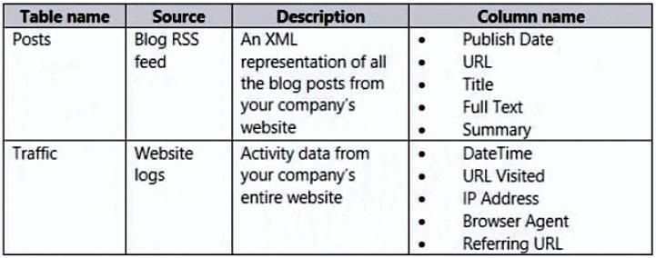  
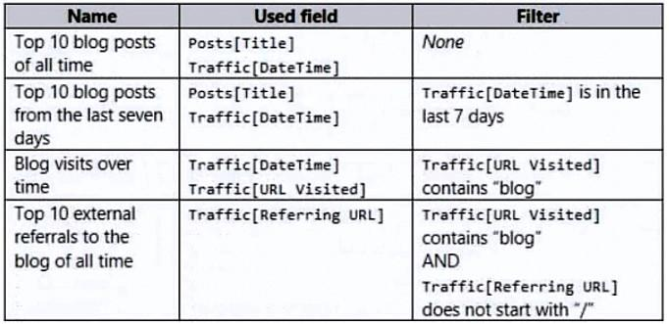

1. Remove the rows in Posts in which Posts[Publish Date] is in the last seven days.
2. Remove the rows in Traffic in which Traffic[URL Visited] does not contain ג€blogג€.
3. Remove Traffic[IP Address], Traffic[Browser Agent], and Traffic[Referring URL].
4. Remove Posts[Full Text] and Posts[Summary].
5. Remove the rows in Traffic in which Traffic[Referring URL] does not start with ג€/ג€.

**[QUESTION: 96](https://free-braindumps.com/microsoft/free-pl-300-braindumps/page-25" \l "collapse_299)**

HOTSPOT (Drag and Drop is not supported)  
You are creating a quick measure as shown in the following exhibit.  
You need to create a monthly rolling average measure for Sales over time.  
How should you configure the quick measure calculation? To answer, select the appropriate options in the answer area.  
NOTE: Each correct selection is worth one point.  
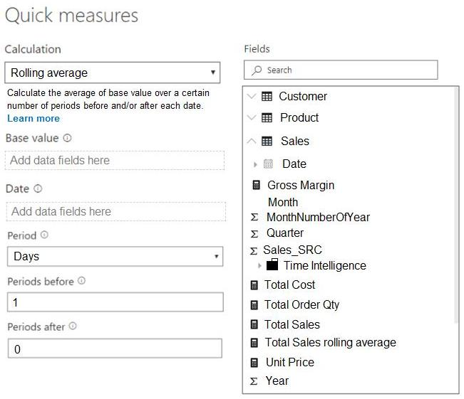  
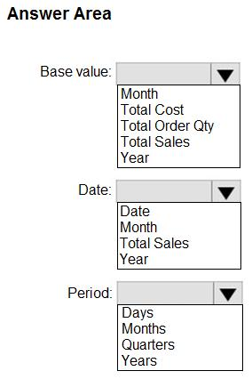

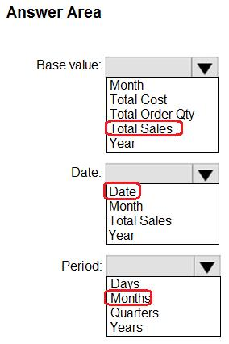

**[QUESTION: 97](https://free-braindumps.com/microsoft/free-pl-300-braindumps/page-26" \l "collapse_298)**

You have the Power BI data model shown in the following exhibit.  
The Sales table contains records of sales by day from the last five years up until today’s date.  
You plan to create a measure to return the total sales of March 2021 when March 2022 is selected.  
Which DAX expression should you use?  
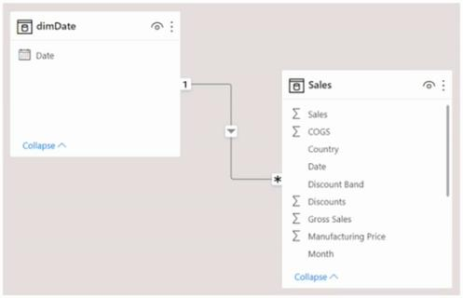

1. Calculate (Sum(Sales[Sales]), PREVIOUSYEAR( dimDate[Date])
2. TOTALYTD (SUM(Sales[Sales]), dimDate[Date] )
3. Calculate (SUM(Sales[Sales]), SAMEPERIODLASTYEAR(dimDate[Date] ))
4. SUM(Sales[Sales])

**Answer(s):** C

**[QUESTION: 98](https://free-braindumps.com/microsoft/free-pl-300-braindumps/page-26" \l "collapse_297)**

You use Power BI Desktop to load data from a Microsoft SQL Server database.  
While waiting for the data to load, you receive the following error.  
You need to resolve the error.  
What are two ways to achieve the goal? Each correct answer presents a complete solution.  
NOTE: Each correct selection is worth one point.  


1. Reduce the number of rows and columns returned by each query.
2. Split log running queries into subsets of columns and use Power Query to merge the queries.
3. Use Power Query to combine log running queries into one query.
4. Disable query folding on long running queries.

**[QUESTION: 99](https://free-braindumps.com/microsoft/free-pl-300-braindumps/page-26" \l "collapse_296)**

Note: This question is part of a series of questions that present the same scenario. Each question in the series contains a unique solution that might meet the stated goals. Some question sets might have more than one correct solution, while others might not have a correct solution.  
After you answer a question in this section, you will NOT be able to return to it. As a result, these questions will not appear in the review screen.  
From Power Query Editor, you profile the data shown in the following exhibit.  
The IoT GUID and IoT ID columns are unique to each row in the query.  
You need to analyze IoT events by the hour and day of the year. The solution must improve dataset performance.  
Solution: You split the IoT DateTime column into a column named Date and a column named Time.  
Does this meet the goal?  
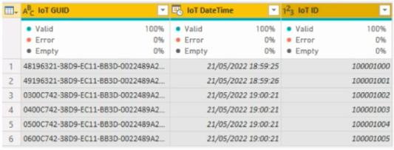

1. Yes
2. No

**[QUESTION: 100](https://free-braindumps.com/microsoft/free-pl-300-braindumps/page-26" \l "collapse_295)**

Note: This question is part of a series of questions that present the same scenario. Each question in the series contains a unique solution that might meet the stated goals. Some question sets might have more than one correct solution, while others might not have a correct solution.  
After you answer a question in this section, you will NOT be able to return to it. As a result, these questions will not appear in the review screen.  
From Power Query Editor, you profile the data shown in the following exhibit.  
The IoT GUID and IoT ID columns are unique to each row in the query.  
You need to analyze IoT events by the hour and day of the year. The solution must improve dataset performance.  
Solution: You remove the IoT GUID column and retain the IoT ID column.  
Does this meet the goal?  


1. Yes
   1. No

**[QUESTION: 101](https://free-braindumps.com/microsoft/free-pl-300-braindumps/page-27" \l "collapse_294)**

Note: This question is part of a series of questions that present the same scenario. Each question in the series contains a unique solution that might meet the stated goals. Some question sets might have more than one correct solution, while others might not have a correct solution.  
After you answer a question in this section, you will NOT be able to return to it. As a result, these questions will not appear in the review screen.  
From Power Query Editor, you profile the data shown in the following exhibit.  
The IoT GUID and IoT ID columns are unique to each row in the query.  
You need to analyze IoT events by the hour and day of the year. The solution must improve dataset performance.  
Solution: You change the IoT DateTime column to the Date data type.  
Does this meet the goal?  


1. Yes
2. No

**[QUESTION: 102](https://free-braindumps.com/microsoft/free-pl-300-braindumps/page-27" \l "collapse_311)**

You have a Microsoft Power BI report. The size of PBIX file is 550 MB. The report is accessed by using an App workspace in shared capacity of powerbi.com.  
The report uses an imported dataset that contains one fact table. The fact table contains 12 million rows. The dataset is scheduled to refresh twice a day at 08:00 and 17:00.  
The report is a single page that contains 15 AppSource visuals and 10 default visuals.  
Users say that the report is slow to load the visuals when they access and interact with the report.  
You need to recommend a solution to improve the performance of the report.  
What should you recommend?

1. Change any DAX measures to use iterator functions.
2. Remove unused columns from tables in the data model.
3. Replace the default visuals with AppSource visuals.
4. Increase the number of times that the dataset is refreshed.

**[QUESTION: 103](https://free-braindumps.com/microsoft/free-pl-300-braindumps/page-27" \l "collapse_313)**

DRAG DROP (Drag and Drop is not supported)  
You have a Power BI data model that contains two tables named Products and Sales.  
A one-to-many relationship exists between the tables.  
You have a report that contains a report-level filter for Products.  
You need to create a measure that will return the percent of total sales for each product. The measure must respect the report-level filter when calculating the total.  
How should you complete the DAX measure? To answer, drag the appropriate DAX functions to the correct targets. Each function may be used once, more than once, or not at all. You may need to drag the split bar between panes or scroll to view content.  
NOTE: Each correct selection is worth one point.  
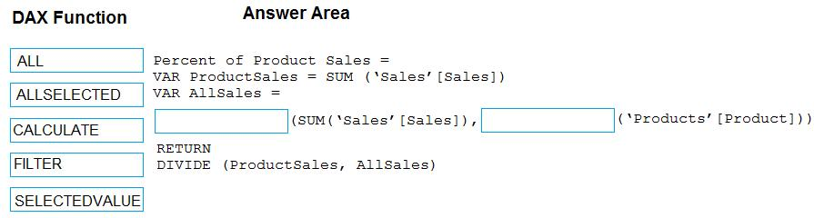

1. See Explanation section for answer.

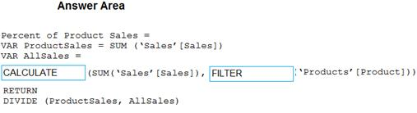

**[QUESTION: 104](https://free-braindumps.com/microsoft/free-pl-300-braindumps/page-27" \l "collapse_332)**

You have a Power BI data model that analyzes product sales over time. The data model contains the following tables.  
A one-to-many relationship exists between the tables.  
The auto date/time option for the data model is enabled.  
You need to reduce the size of the data model while maintaining the ability to analyze product sales by month and quarter.  
Which two actions should you perform? Each correct answer presents part of the solution.  
NOTE: Each correct answer is worth one point.  
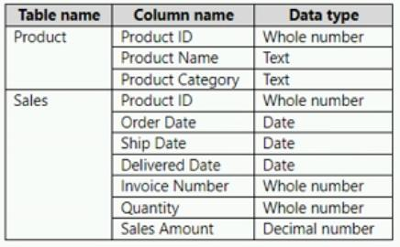

1. Create a relationship between the Date table and the Sales table.
2. Disable the auto date/time option.
3. Create a Date table and select Mark as Date Table.
4. Disable the load on the Date table.
5. Remove the relationship between the Product table and the Sales table.

#### **[QUESTION: 105](https://free-braindumps.com/microsoft/free-pl-300-braindumps/page-28" \l "collapse_314)**

You have a Microsoft Power BI report. The size of PBIX file is 550 MB. The report is accessed by using an App workspace in shared capacity of powerbi.com.  
The report uses an imported dataset that contains one fact table. The fact table contains 12 million rows. The dataset is scheduled to refresh twice a day at 08:00 and 17:00.  
The report is a single page that contains 15 AppSource visuals and 10 default visuals.  
Users say that the report is slow to load the visuals when they access and interact with the report.  
You need to recommend a solution to improve the performance of the report.  
What should you recommend?

1. Implement row-level security (RLS).
2. Remove unused columns from tables in the data model.
3. Replace the default visuals with AppSource visuals.
4. Enable visual interactions.

#### **[QUESTION: 106](https://free-braindumps.com/microsoft/free-pl-300-braindumps/page-28" \l "collapse_331)**

1. HOTSPOT (Drag and Drop is not supported)  
   You have a Power BI data model that contains a table named Stores. The table has the following columns:  
   • Store Name  
   • Open Date  
   • Status  
   • State  
   • City  
   You need to create a calculated column named Active Store Name that meets the following requirements:  
   • When the value of the Status column is “A”, the value in the Store Name column must be returned.  
   • When the value of the Status column is NOT “A”, the value in the Store Name column that is prefixed with "Inactive - " must be returned.  
   How should you complete the DAX expression? To answer, select the appropriate options in the answer area.  
   NOTE: Each correct selection is worth one point.  
   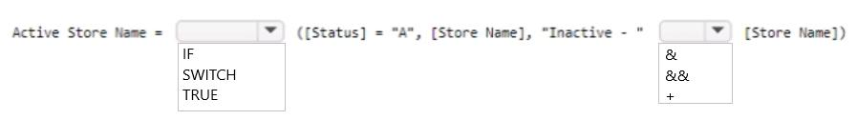

Answer\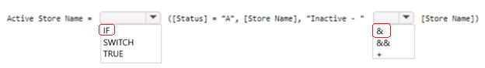

**[QUESTION: 107](https://free-braindumps.com/microsoft/free-pl-300-braindumps/page-28" \l "collapse_330)**

You have a CSV file that contains user complaints. The file contains a column named Logged. Logged contains the date and time each complaint occurred. The data in Logged is in the following format: 2018-12-31 at 08:59.  
You need to be able to analyze the complaints by the logged date and use a built-in date hierarchy.  
What should you do?

1. Apply a transformation to extract the first 11 characters of the logged column.
2. Add a conditional column that outputs 2018 if the Logged column starts with 2018 and set the data type of the new column to Whole Number.
3. Create a column by example that starts with 2018-12-31 and set the data type of the new column to Date.
4. Apply a transformation to extract the last 11 characters of the Logged column and set the data type of the new column to Date.

**[QUESTION: 108](https://free-braindumps.com/microsoft/free-pl-300-braindumps/page-28" \l "collapse_329)**

Note: This question is part of a series of questions that present the same scenario. Each question in the series contains a unique solution that might meet the stated goals. Some question sets might have more than one correct solution, while others might not have a correct solution.  
After you answer a question in this section, you will NOT be able to return to it. As a result, these questions will not appear in the review screen.  
From Power Query Editor, you profile the data shown in the following exhibit.  
The IoT GUID and IoT ID columns are unique to each row in the query.  
You need to analyze IoT events by the hour and day of the year. The solution must improve dataset performance.  
Solution: You create a custom column that concatenates the IoT GUID column and the IoT ID column and then delete the IoT GUID and IoT ID columns.  
Does this meet the goal?  
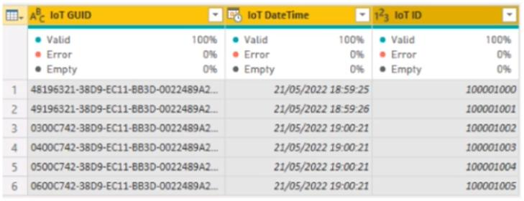

1. Yes
2. No

**[QUESTION: 109](https://free-braindumps.com/microsoft/free-pl-300-braindumps/page-29" \l "collapse_328)**

You have a Power BI model that contains a table named Employee. The table contains the following data.  
Each employee has one manager as shown in the ParentEmployeeID column.  
All reporting paths lead to the CEO at the top of the organizational hierarchy.  
You need to create a calculated column that returns the count of levels from each employee to the CEO.  
Which DAX expression should you use?  
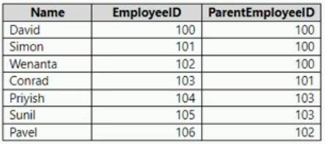

1. PATHLENGTH(PATH(Employee[EmployeeID],Employee[ParentEmployeeID]))
2. PATHITEM(PATH(Employee[EmployeeID],Employee[ParentEmployeeID]),1,INTEGER)
3. PATHCONTAINS(PATH(Employee[EmployeeID],Employee[ParentEmployeeID]),1)
4. PATH(Employee[EmployeeID],Employee[ParentEmployeeID])

**Answer(s):** A

**[QUESTION: 110](https://free-braindumps.com/microsoft/free-pl-300-braindumps/page-29" \l "collapse_327)**

You have a Microsoft Power BI report. The size of PBIX file is 550 MB. The report is accessed by using an App workspace in shared capacity of powerbi.com.  
The report uses an imported dataset that contains one fact table. The fact table contains 12 million rows. The dataset is scheduled to refresh twice a day at 08:00 and 17:00.  
The report is a single page that contains 15 AppSource visuals and 10 default visuals.  
Users say that the report is slow to load the visuals when they access and interact with the report.  
You need to recommend a solution to improve the performance of the report.  
What should you recommend?

1. Replace the default visuals with AppSource visuals.
2. Remove unused columns from tables in the data model.
3. Change the imported dataset to DirectQuery
4. Increase the number of times that the dataset is refreshed.

**[QUESTION: 111](https://free-braindumps.com/microsoft/free-pl-300-braindumps/page-29" \l "collapse_326)**

You use Power Query Editor to preview a query that contains sales order data in the following columns:  
• Tax Amount  
• Sales Order ID  
• Freight Amount  
• Subtotal Amount  
• Total Item Quantity  
The Sales Order ID column uniquely identifies each sales order. The Subtotal Amount and Total Item Quantity columns are always populated, but the Tax Amount and Freight Amount columns are sometimes null when an order has no associated amount.  
You need to query the data to identify the following metrics by month:  
• The average item quantity per order  
• The average freight amount per order  
• The maximum item quantity per order  
How should you modify the query?

1. In the Total Item Quantity column, replace the null values with 0.
2. In the Tax Amount column, remove rows that contain null values.
3. In the Freight Amount column, remove rows that contain null values.
4. In the Freight Amount column, replace the null values with 0.

**[QUESTION: 112](https://free-braindumps.com/microsoft/free-pl-300-braindumps/page-29" \l "collapse_325)**

HOTSPOT (Drag and Drop is not supported)  
You have the Power BI data model shown in the following exhibit.  
You need to create a measure to count the number of product categories that had products sold during a selected period.  
How should you complete the DAX expression? To answer, select the appropriate options in the answer area.  
NOTE: Each correct selection is worth one point.  
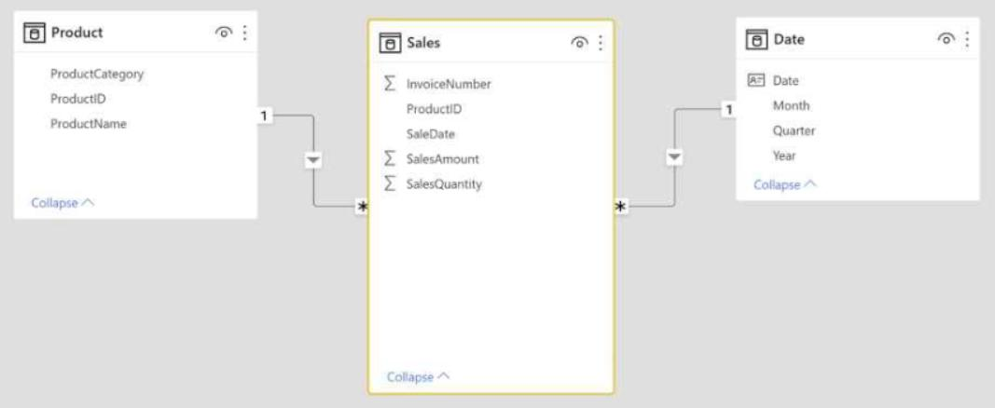  
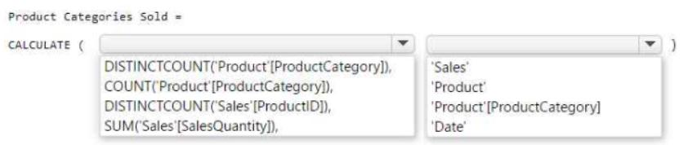

1. See Explanation section for answer.

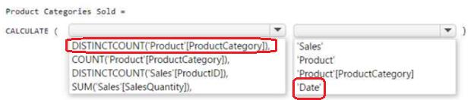

**[QUESTION: 113](https://free-braindumps.com/microsoft/free-pl-300-braindumps/page-30" \l "collapse_324)**

You have a Power BI model that contains a table named Employees. The table contains the following columns:  
• Employee ID  
• First Name  
• Last Name  
• Department  
• Salary  
Each employee is uniquely identified by using Employee ID.  
You need to create a DAX measure that will calculate the average salary of all the employees in the sales department.  
Which DAX expression should you use?

1. DISTINCTCOUNT(‘Employees’[Salary])
2. CALCULATE(DISTINCTCOUNT(‘Employees’[Salary]), ‘Employees’[Department] = “Sales”)
3. CALCULATE(AVERAGE(‘Employees’[Salary]), ‘Employees’[Department] = “Sales”)
4. AVERAGE(‘Employees’[Salary])

**[QUESTION: 114](https://free-braindumps.com/microsoft/free-pl-300-braindumps/page-30" \l "collapse_323)**

HOTSPOT (Drag and Drop is not supported)  
You have the Power BI data model shown in the following exhibit.  
The Sales table has the following columns.  
The data model must support the following analysis:  
• Total sales by product by month in which the order was placed  
• Quantities sold by product by day on which the order was placed  
• Number of sales transactions by quarter in which the order was placed  
For each of the following statements, select Yes if the statement is true. Otherwise, select No.  
NOTE: Each correct selection is worth one point.  
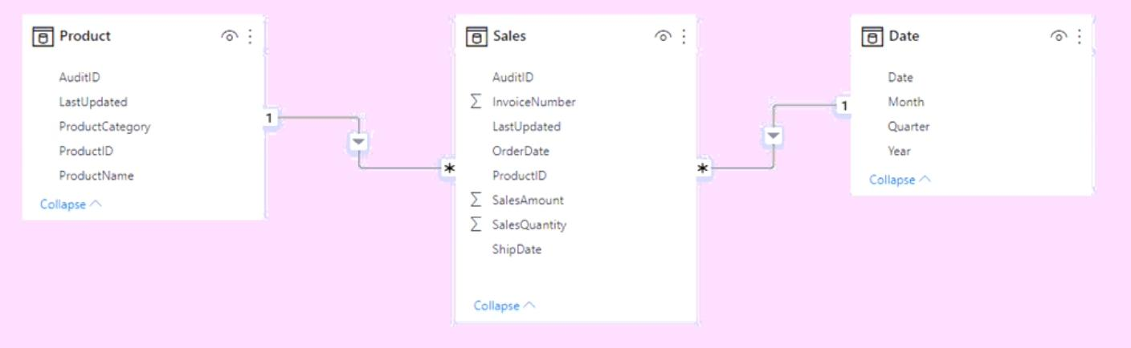  
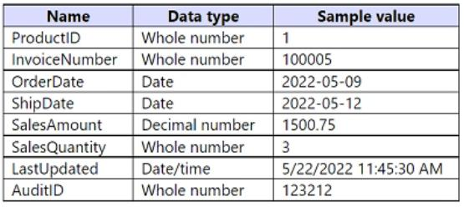  
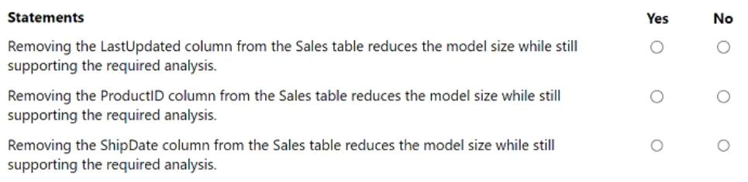

1. See Explanation section for answer.

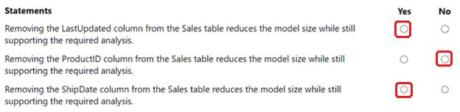

**[QUESTION: 115](https://free-braindumps.com/microsoft/free-pl-300-braindumps/page-30" \l "collapse_322)**

HOTSPOT (Drag and Drop is not supported)  
You have Power BI report that contains the fields shown in the following exhibit.  
Use the drop-down menus to select the answer choice that completes each statement based on the information presented in the graphic.  
NOTE: Each correct selection is worth one point.  
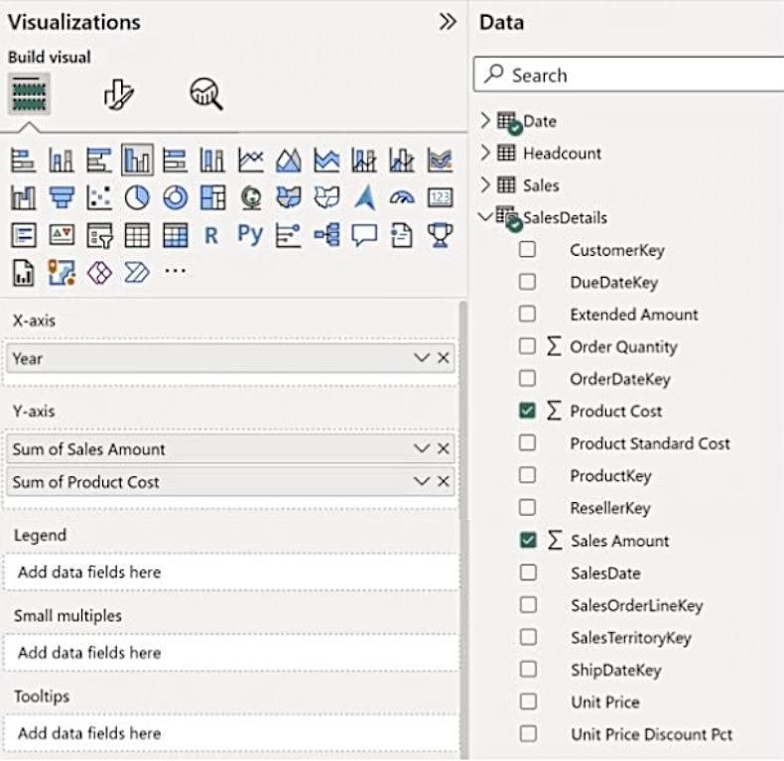  
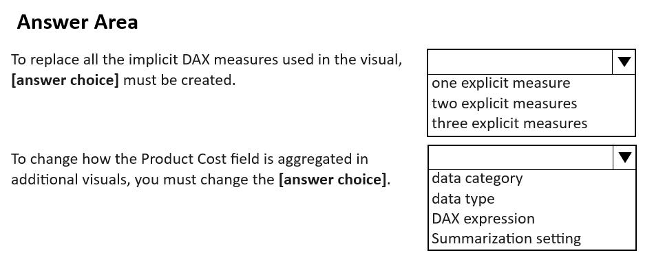

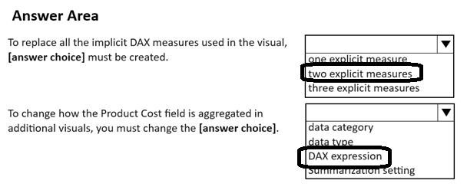

**[QUESTION: 116](https://free-braindumps.com/microsoft/free-pl-300-braindumps/page-30" \l "collapse_321)**

You have a Power BI data model that contains a table named Employees. The table has the following columns:  
• Employee Name  
• Email Address  
• Start Date  
• Job Title  
You are implementing dynamic row-level security (RLS).  
You need to create a table filter to meet the following requirements:  
• Users must see only their own employee data.  
• The DAX expression must work in both Power BI Desktop and the Power BI service.  
Which expression should you use?

1. [Email Address] - USERNAME()
2. [Employee Name] - USERPRINCIPALNAME()
3. [Employee Name] = USERNAME()
4. [Email Address] = USERPRINCIPALNAME()

[Reveal Solution](https://free-braindumps.com/microsoft/free-pl-300-braindumps/page-30#answerQ321) [Next Question](https://free-braindumps.com/microsoft/free-pl-300-braindumps/page-30#collapse_321)

**[QUESTION: 117](https://free-braindumps.com/microsoft/free-pl-300-braindumps/page-31" \l "collapse_320)**

DRAG DROP (Drag and Drop is not supported)  
You have the Power BI data model shown in the following exhibit.  
The Country table contains the following data.  
You create two row-level security (RLS) roles named Manager and CFO.  
You plan to publish the dataset to the Power BI service.  
You need to create DAX expressions for the RLS filters. The solution must meet the following requirements:  
• Each manager must see only the data in the Sales and Human Resources tables for their own country.  
• The CFO must be prevented from seeing the data in the Human Resources table.  
• The CFO must see the sales data of all countries.  
How should you complete the DAX expressions to meet the requirements? To answer, drag the appropriate expressions to the correct targets. Each expression may be used once, more than once, or not at all. You may need to drag the split bar between panes or scroll to view content.  
NOTE: Each correct selection is worth one point.  
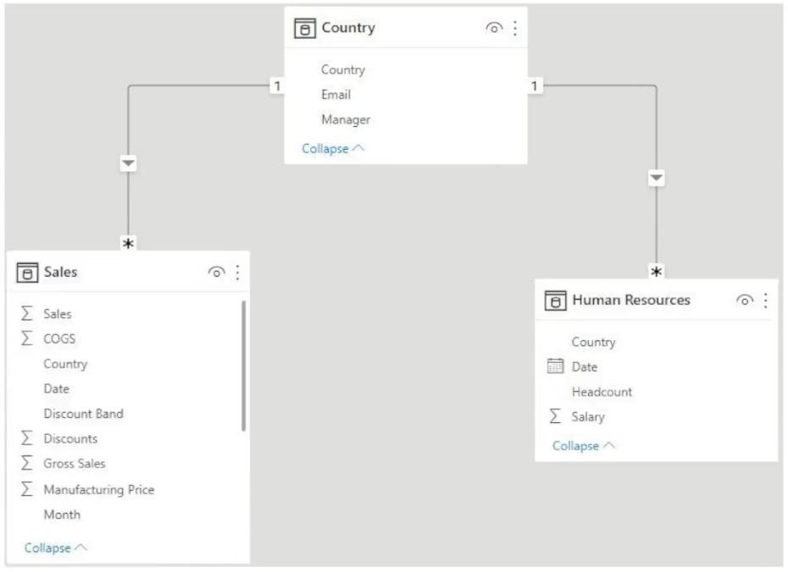  
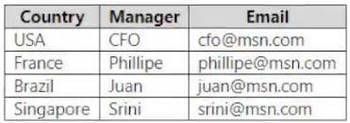  
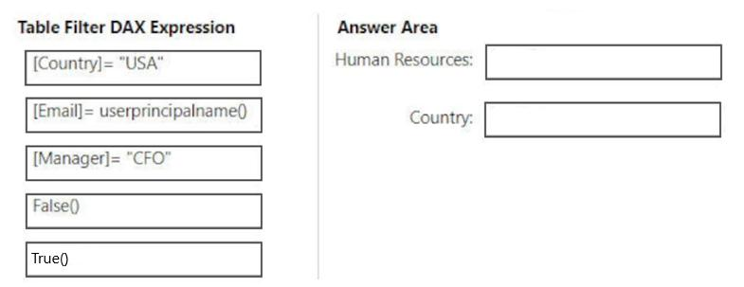

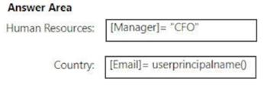

**[QUESTION: 118](https://free-braindumps.com/microsoft/free-pl-300-braindumps/page-31" \l "collapse_319)**

You have a Power BI data model that imports data from a Microsoft Excel spreadsheet.  
You use Power Query to load a query that contains both renamed and custom columns.  
Later, you attempt to reload the query and receive the following error message.  
Expression.Error: The column 'Category' of the table wasn't found.  
What are two possible causes of the error? Each correct answer presents a complete solution.  
NOTE: Each correct selection is worth one point.

1. The column was removed from the source file.
2. The column was renamed in the source file.
3. The file is no longer in the specified location.
4. The data type of the column was changed.

**Answer(s):** A,B

**[QUESTION: 119](https://free-braindumps.com/microsoft/free-pl-300-braindumps/page-31" \l "collapse_318)**

You have a Power BI model that contains a table named Sales. The Sales table contains the following columns:  
• Order Line ID  
• Product ID  
• Unit Price  
• Order ID  
• Quantity  
Orders are uniquely identified by using the order ID and can have multiple order lines. Each order line within an order contains a different product ID.  
You need to write a DAX measure that counts the number of orders.  
Which formula should you use?

1. Count('Sales'[Order ID])
2. CountA('Sales' [Order ID])
3. CountRows('Sales')
4. DistinctCount('Sales' [Order ID])

**Answer(s):** D

**[QUESTION: 120](https://free-braindumps.com/microsoft/free-pl-300-braindumps/page-31" \l "collapse_317)**

HOTSPOT (Drag and Drop is not supported)  
You are creating a Power BI model in Power BI Desktop.  
You need to create a calculated table named Numbers that will contain all the integers from -100 to 100.  
How should you complete the DAX calculation? To answer, select the appropriate options in the answer area.  
NOTE: Each correct selection is worth one point.  
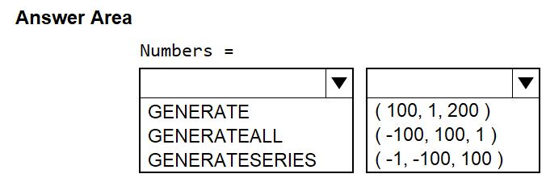

1. See Explanation section for answer.

**Answer(s):** A

**Explanation:**

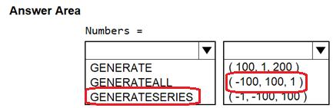

**[QUESTION: 121](https://free-braindumps.com/microsoft/free-pl-300-braindumps/page-32" \l "collapse_316)**

In Power Query Editor, you have a query named Sales Data that contains the following columns.  
You need to create two queries named Product Dimension and Sales Fact based on the Sales Data query. The solution must minimize maintenance effort and the size of the dataset.  
Which two actions should you perform? Each correct answer presents part of the solution.  
NOTE: Each correct selection is worth one point.  
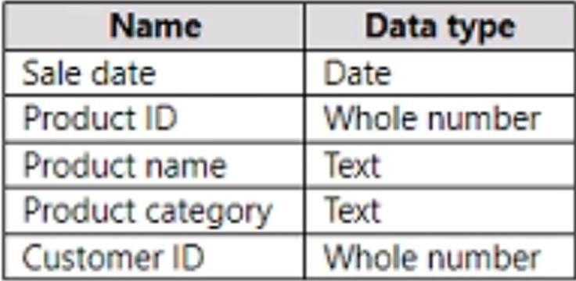

1. Reference the Sales Data query to create the new queries.
2. Disable the load for the Sales Fact query.
3. Duplicate the Sales Data query to create the new queries.
4. Clear Include in report refresh for the Sales Data query.
5. Disable the load for the Sales Data query.

**Answer(s):** A,E

**[QUESTION: 122](https://free-braindumps.com/microsoft/free-pl-300-braindumps/page-32" \l "collapse_315)**

You have a Power BI model that contains a table named Date. The Date table contains the following columns:  
• Date  
• Fiscal Year  
• Fiscal Quarter  
• Month Name  
• Calendar Year  
• Week Number  
• Month Number  
• Calendar Quarter  
You need to create a calculated table based on the Date table. The calculated table must contain only unique combinations of values for Calendar Year, Calendar Quarter, and Calendar Month.  
Which DAX function should you include in the table definition?

1. ADDCOLUMNS
2. CALCULATE
3. SUMMARIZE
4. DATATABLE

**Answer(s):** C

**[QUESTION: 123](https://free-braindumps.com/microsoft/free-pl-300-braindumps/page-32" \l "collapse_293)**

HOTSPOT (Drag and Drop is not supported)  
You have a Power BI model that contains the following data.  
The Date table relates to the Sales table by using the Date columns.  
You need to create a calculated table that will contain the following:  
• A row for each year  
• A column that contains the total sales per year  
How should you complete the DAX calculation? To answer, select the appropriate options in the answer area.  
NOTE: Each correct selection is worth one point.  
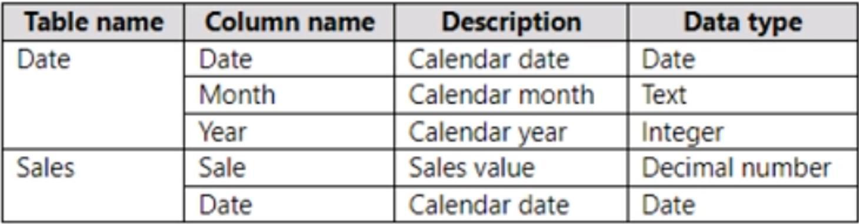  
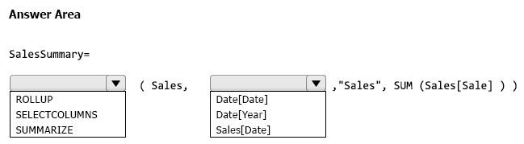

1. See Explanation section for answer.

**Answer(s):** A

**Explanation:**

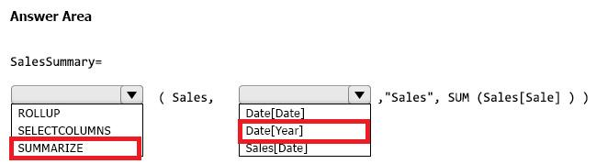

**[QUESTION: 124](https://free-braindumps.com/microsoft/free-pl-300-braindumps/page-32" \l "collapse_312)**

You use Power Query Editor to import and preview sales data from the years 2020 and 2021 in a Microsoft Excel file as shown in the following exhibit.  
You need to shape the query to display the following three columns:  
• Month  
• Sales  
• Year  
What should you select in Power Query Editor?  
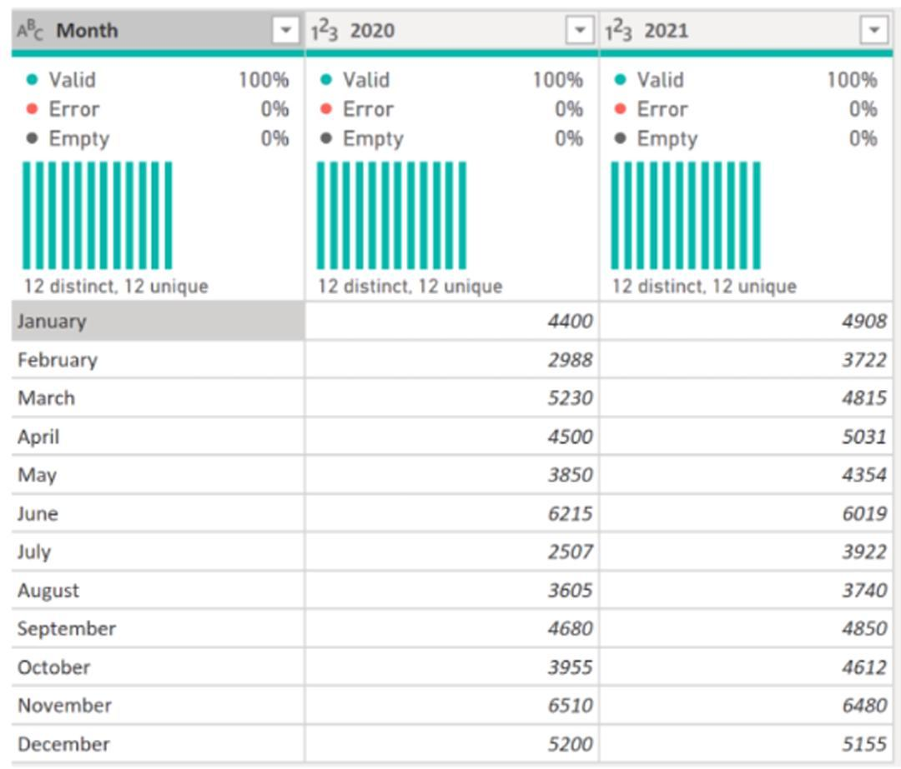

1. Merge columns
2. Transpose
3. Unpivot columns
4. Pivot column

**Answer(s):** C

**[QUESTION: 125](https://free-braindumps.com/microsoft/free-pl-300-braindumps/page-33" \l "collapse_292)**

HOTSPOT (Drag and Drop is not supported)  
You are creating a Power BI model to analyze inventory.  
You load data into three tables named Date, Product, and Inventory. The Inventory table relates to the Date and Product tables by using one-to-many relationships.  
Inventory data is recorded daily with no exceptions. The correct inventory quantity for a given product in a month is the last recorded value for that month.  
You need to write a DAX measure that will show the correct inventory value when a user analyzes inventory by year, month, or date.  
How should you complete the measure? To answer, select the appropriate options in the answer area.  
NOTE: Each correct selection is worth one point.  
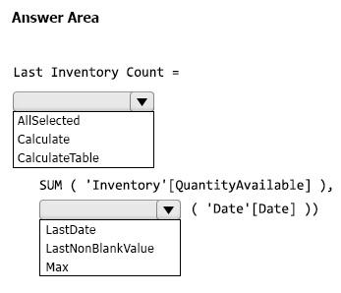

1. See Explanation section for answer.

**Answer(s):** A

**[QUESTION: 126](https://free-braindumps.com/microsoft/free-pl-300-braindumps/page-33" \l "collapse_270)**

**Note: This question is part of a series of questions that present the same scenario. Each question in the series contains a unique solution that might meet the stated goals. Some question sets might have more than one correct solution, while others might not have a correct solution.  
After you answer a question in this section, you will NOT be able to return to it. As a result, these questions will not appear in the review screen.  
You have a Power BI report that imports a date table and a sales table from an Azure SQL database data source. The sales table has the following date foreign keys:  
• Due Date  
• Order Date  
• Delivery Date  
You need to support the analysis of sales over time based on all three dates at the same time.  
Solution: From the Fields pane, you rename the date table as Due Date. You use a DAX expression to create Order Date and Delivery Date as calculated tables. You create active relationships between the sales table and each date table.  
Does this meet the goal?**

1. **Yes**
2. **No**

**Answer(s): A**

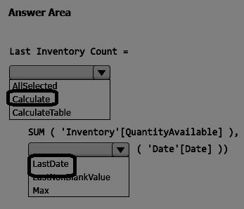

**[QUESTION: 127](https://free-braindumps.com/microsoft/free-pl-300-braindumps/page-33" \l "collapse_268)**

HOTSPOT (Drag and Drop is not supported)  
You are creating a Power BI report that will show the number of current employees over time. The report will use Import storage mode for all tables.  
The employment data will be imported from Azure SQL Database in a monthly snapshot. The data will be stored in a table named Headcount and will contain the following:  
• One row per employee for each month the employee is employed  
• In each row, a date key that shows the first day of the month of each snapshot  
You have a related date table that contains dates for the years 2020 to 2030.  
You need to create a semi-additive DAX measure that will return the count of employees for the last available date in a year, quarter, or month.  
How should you complete the measure? To answer, select the appropriate options in the answer area.  
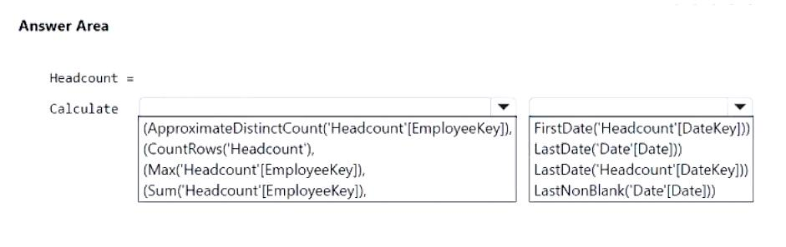

1. See Explanation section for answer.

**Answer(s):** A

**Explanation:**

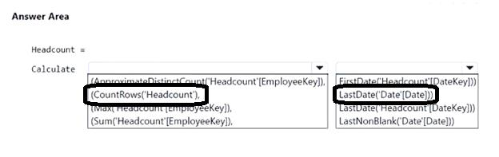

**[QUESTION: 128](https://free-braindumps.com/microsoft/free-pl-300-braindumps/page-33" \l "collapse_267)**

HOTSPOT (Drag and Drop is not supported)  
You have a query named All Sales that imports sales data into a Power BI model.  
You plan to create a star schema by separating columns into separate queries and performing further transformations. The solution must meet the following requirements:  
• Use All Sales as the source for three other queries named Sales Fact, Product Dimension, and Customer Dimension.  
• Minimize maintenance effort.  
What should you do to create the Sales Fact query, and for which query should you clear Enable load? To answer, select the appropriate options in the answer area.  
NOTE: Each correct selection is worth one point.  
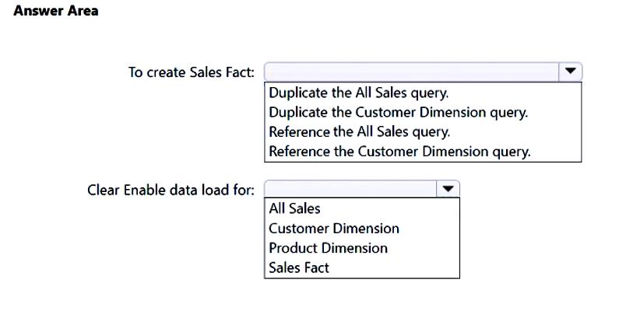

1. See Explanation section for answer.

**Answer(s):** A

**Explanation:**

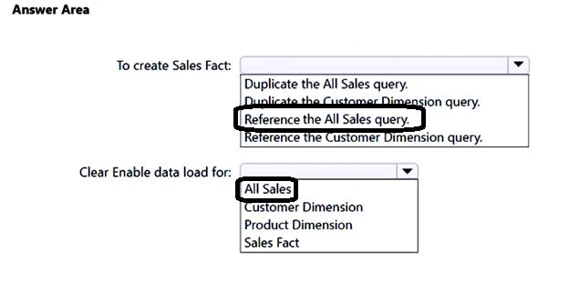

**[QUESTION: 129](https://free-braindumps.com/microsoft/free-pl-300-braindumps/page-34" \l "collapse_266)**

You have a Power BI model that contains the following data.  
The Date table relates to the Sales table by using the Date columns.  
The model contains the following DAX measure.  
Total Sales = SUM(Sales[Sale])  
You need to create another measure named Previous Quarter to display the sales one quarter before the selected period.  
Which DAX calculation should you use?  
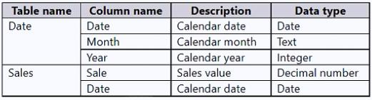

1. CALCULATE ( [Total Sales], DATEADD (Date[Date], -1, QUARTER ) )
2. CALCULATE ( [Total Sales], DATESQTD (Date[Date] ) )
3. TOTALQTD ( [Total Sales], Date[Date] )
4. CALCULATE ( [Total Sales], PARALLELPERIOD (Date[Date], 1, QUARTER ) )

**Answer(s):** A

**[QUESTION: 130](https://free-braindumps.com/microsoft/free-pl-300-braindumps/page-34" \l "collapse_265)**

You have a Power BI data model that contains two tables named Sales and Date. The Sales table contains three measures named Order Quantity, Product Cost, and Sales Amount.  
You need to create the visual shown in the following exhibit.  
In which section of the Fields well should you place the measures?  
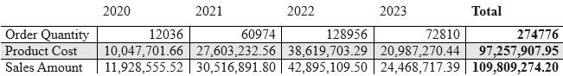

1. Columns
2. Rows
3. Values
4. Drill through

**Answer(s):** C

**[QUESTION: 131](https://free-braindumps.com/microsoft/free-pl-300-braindumps/page-34" \l "collapse_264)**

You are reviewing a Power BI data model.  
You have a calculated table that has the following definition.  
ProductList = INTERSECT ( ProductsGroupA, ProductsGroupB )  
You need to identify the results of the DAX expression.  
Which rows will be returned in ProductList?

1. all the rows in ProductsGroupB that have a matching row in ProductsGroupA
2. all the rows in both tables
3. all the rows in ProductsGroupA that have a matching row in ProductsGroupB
4. all the rows in ProductsGroupA that have no matching row in ProductsGroupB.

**Answer(s):** C

**[QUESTION: 132](https://free-braindumps.com/microsoft/free-pl-300-braindumps/page-34" \l "collapse_263)**

HOTSPOT (Drag and Drop is not supported)  
You have a Power BI tenant that contains a workspace. The workspace contains a dataset named datasetA.  
You need to build a pivot table report in Microsoft Excel. The report must use datasetA as the data source. The solution must meet the following requirements:  
• Ensure that the report can be refreshed to get the latest available data from the Power BI service.  
• Ensure that all the visible data in datasetA is available for use in Excel.  
What should you do to connect Excel to datasetA, and which element in datasetA will be incompatible with the Excel connection? To answer, select the appropriate options in the answer area.  
NOTE: Each correct selection is worth one point.  
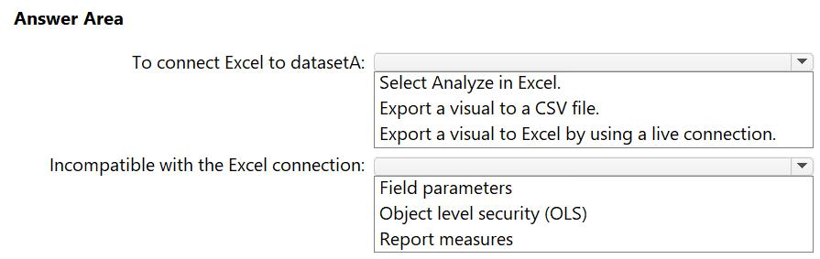

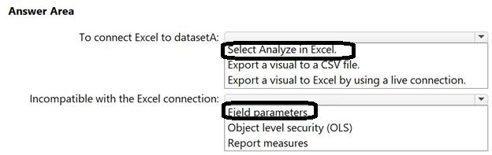

**[QUESTION: 133](https://free-braindumps.com/microsoft/free-pl-300-braindumps/page-35" \l "collapse_262)**

Note: This question is part of a series of questions that present the same scenario. Each question in the series contains a unique solution that might meet the stated goals. Some question sets might have more than one correct solution, while others might not have a correct solution.  
After you answer a question in this section, you will NOT be able to return to it. As a result, these questions will not appear in the review screen.  
You have a Power BI report that imports a date table and a sales table from an Azure SQL database data source. The sales table has the following date foreign keys:  
• Due Date  
• Order Date  
• Delivery Date  
You need to support the analysis of sales over time based on all the date foreign keys.  
Solution: You create measures that use the USERELATIONSHIP DAX function to filter sales on the inactive relationship between the sales table and the date table.  
Does this meet the goal?

1. Yes
2. No

**Answer(s):** A

**[QUESTION: 134](https://free-braindumps.com/microsoft/free-pl-300-braindumps/page-35" \l "collapse_261)**

Note: This question is part of a series of questions that present the same scenario. Each question in the series contains a unique solution that might meet the stated goals. Some question sets might have more than one correct solution, while others might not have a correct solution.  
After you answer a question in this section, you will NOT be able to return to it. As a result, these questions will not appear in the review screen.  
You have a Power BI report that imports a date table and a sales table from an Azure SQL database data source. The sales table has the following date foreign keys:  
• Due Date  
• Order Date  
• Delivery Date  
You need to support the analysis of sales over time based on all the date foreign keys.  
Solution: From the Fields pane, you rename the date table as Due Date. You use a DAX expression to create Order Date and Delivery Date as calculated tables. You create active relationships between the sales table and each date table.  
Does this meet the goal?

1. Yes
2. No

**Answer(s):** A

**[QUESTION: 135](https://free-braindumps.com/microsoft/free-pl-300-braindumps/page-35" \l "collapse_260)**

You have a Power BI semantic model that contains item, price, and country data. The data is displayed in a report that uses filters.  
You need to calculate the average item price for a given country. The solution must support the existing filters.  
Which type of quick measure should you use?

1. Total for category (filters applied)
2. Average per category
3. Rolling average
4. Weighted average per category

**Answer(s):** B

**[QUESTION: 136](https://free-braindumps.com/microsoft/free-pl-300-braindumps/page-35" \l "collapse_259)**

DRAG DROP (Drag and Drop is not supported)  
You use Power Query Editor to import three tables named Customers, Address, and Country.  
In the source system, not every customer has a related address, but every address has a related country.  
You need to merge all the tables into a single query. The solution must optimize query refresh performance.  
Which type of join should you use for each merge operation? To answer, drag the appropriate join types to the correct operations. Each join type may be used once, more than once, or not at all. You may need to drag the split bar between panes or scroll to view content.  
NOTE: Each correct selection is worth one point.  
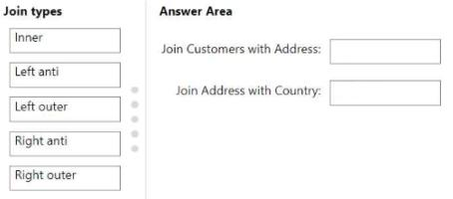

1. See Explanation section for answer.

**Answer(s):** A

**Explanation:**

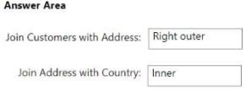

**[QUESTION: 137](https://free-braindumps.com/microsoft/free-pl-300-braindumps/page-36" \l "collapse_258)**

You have a Power BI semantic model that contains four queries named Query 1, Query2. Query3, and Query4.  
Query1 loads customer data into the model and is referenced by the other three queries.  
You discover that data refresh for the model is slow.  
You need to improve the data refresh time. The solution must minimize costs.  
What should you do?

1. Run the Table.buffer function in Query1.
2. Duplicate Query1 to all the other queries.
3. Reconfigure Query1 as a dataflow entity.
4. From the Power BI Admin portal, increase the Capacity settings.

**[QUESTION: 138](https://free-braindumps.com/microsoft/free-pl-300-braindumps/page-36" \l "collapse_257)**

HOTSPOT (Drag and Drop is not supported)  
You have an organization dimension named DimOrganizations.  
You have four related tables as shown in the following exhibit.  
Use the drop-down menus to select the answer choice that completes each statement based on the information presented in the graphic.  
NOTE: Each correct selection is worth one point.  
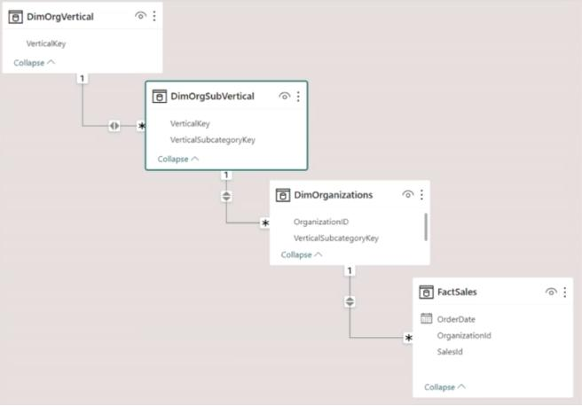  
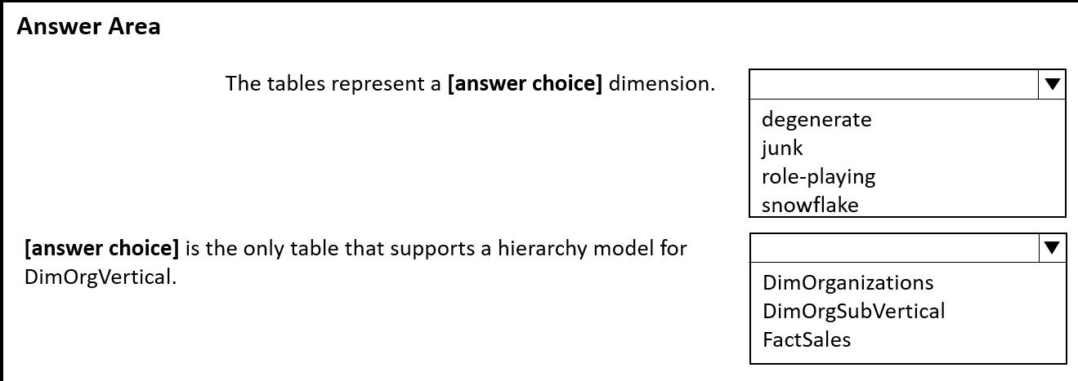

1. See Explanation section for answer.

**Answer(s):** A

**Explanation:**

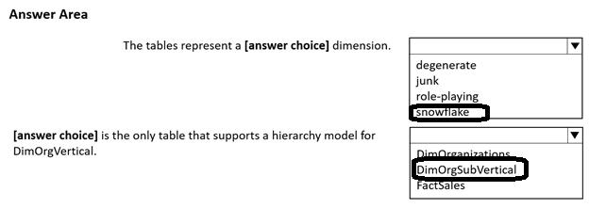

**[QUESTION: 139 not match answer](https://free-braindumps.com/microsoft/free-pl-300-braindumps/page-36" \l "collapse_256)**

HOTSPOT (Drag and Drop is not supported)  
You have a Power BI semantic model that contains a table named Opportunity.  
The Opportunity table contains a column named Qualification. The Qualification column contains values between 0 and 1.  
You need to build a new measure to score the opportunities on a scale of low. medium, and high.  
How should you complete the DAX formula? To answer, select the appropriate options in the answer area.  
NOTE: Each correct selection is worth one point.  
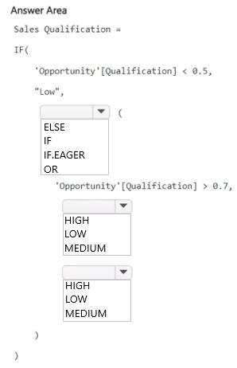

1. See Explanation section for answer.

**Answer(s):** A

**Explanation:**

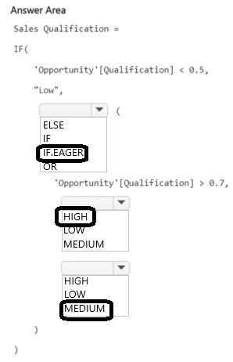

**[QUESTION: 140](https://free-braindumps.com/microsoft/free-pl-300-braindumps/page-36" \l "collapse_255)**

You have a Power BI semantic model that connects to a streaming data source. The data source is updated frequently.  
You need to create a Power BI report that meets the following requirements:  
• Supports real-time analytics  
• Minimizes performance impact on the data source  
• Displays the most recent data without performing a data refresh  
Which connectivity mode should you use for the dataset?

1. DirectQuery mode
2. import mode
3. LiveConnect mode
4. push mode

**Answer(s):** A

**[QUESTION: 141](https://free-braindumps.com/microsoft/free-pl-300-braindumps/page-37" \l "collapse_254)**

HOTSPOT (Drag and Drop is not supported)  
You have a Power BI semantic model that contains a table named Item. The Item table contains a column named Quantity.  
You need to create a DAX query that meets the following requirements:  
• The rank of items must be calculated according to the values in Quantity.  
• Ranking must NOT be skipped if two or more items have the same value in Quantity.  
• If an item is unfiltered, the total of Quantity must display a blank value.  
How should you complete the DAX formula? To answer, select the appropriate options in the answer area.  
NOTE: Each correct selection is worth one point.  
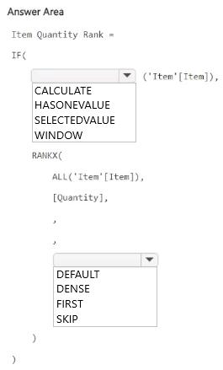

1. See Explanation section for answer.

**Answer(s):** A

**Explanation:**

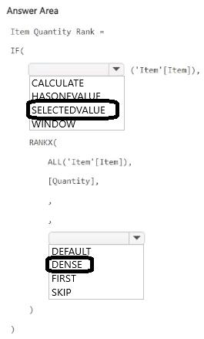

**[QUESTION: 142](https://free-braindumps.com/microsoft/free-pl-300-braindumps/page-37" \l "collapse_253)**

HOTSPOT (Drag and Drop is not supported)  
You use Power Query Editor to pull data from a Microsoft SharePoint Online list.  
You plan to use Advanced Editor to build a Power Query M formula language query.  
You need to create a query that loads the data, expands a column named location, and hides a column named CountryOrRegion from the dataset.  
How should you complete the query? To answer, select the appropriate options in the answer area.  
NOTE: Each correct answer is worth one point.  
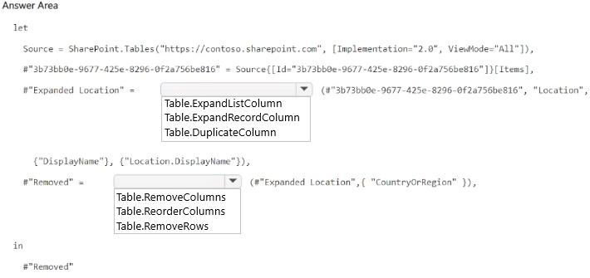

1. See Explanation section for answer.

**Answer(s):** A

**Explanation:**

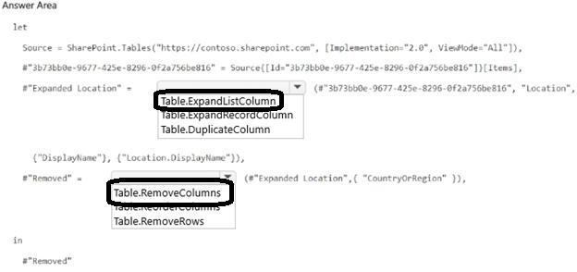

**[QUESTION: 143](https://free-braindumps.com/microsoft/free-pl-300-braindumps/page-37" \l "collapse_252)**

HOTSPOT (Drag and Drop is not supported)  
You have a Power BI semantic model that contains two tables as shown in the following exhibit.  
Use the drop-down menus to select the answer choice that completes each statement based on the information presented in the graphic.  
NOTE: Each correct selection is worth one point.  
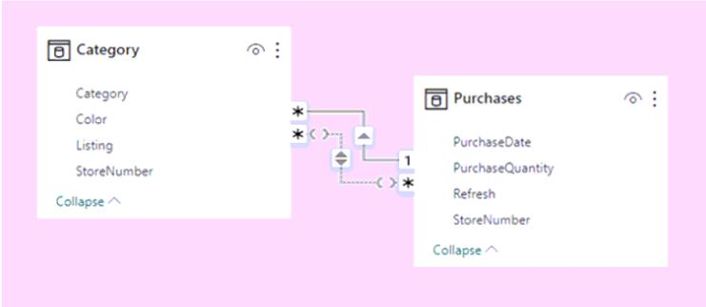  
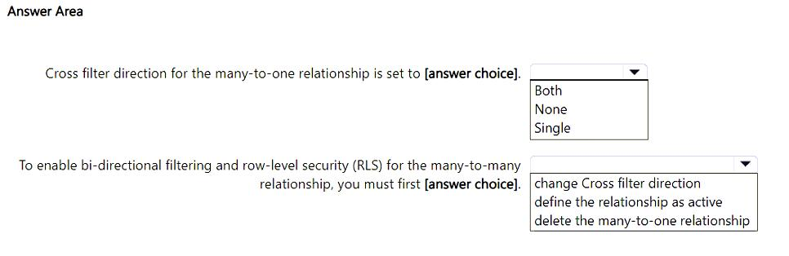

1. See Explanation section for answer.

**Answer(s):** A

**Explanation:**

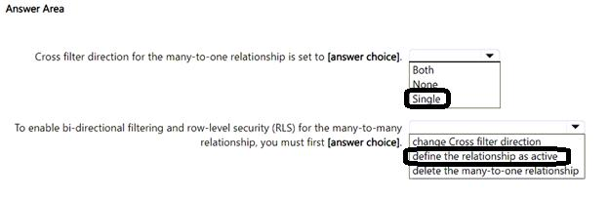

**[QUESTION: 144](https://free-braindumps.com/microsoft/free-pl-300-braindumps/page-37" \l "collapse_269)**

You create a Power BI report named Summary1.  
You discover that Summary1 is slow.  
You run Performance analyzer to identify performance metrics for Summary1.  
Which two metrics display the execution duration in Performance analyzer? Each correct answer present part of the solution.  
NOTE: Each correct answer is worth one point.

1. Top Operations
2. DAX query
3. Server requests
4. Dependencies
5. Visual display

**Answer(s):** B,E

**[QUESTION: 145](https://free-braindumps.com/microsoft/free-pl-300-braindumps/page-38" \l "collapse_271)**

You have a Microsoft 365 subscription that contains the resources shown in the following table.  
You create a new dashboard that uses row-level security (RLS) filters. You define a new role named Consultants.  
To which resource can you assign the Consultants role?  
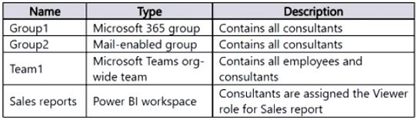

1. Group2
2. Team1
3. Sales reports
4. Group1

**Answer(s):** A

**[QUESTION: 146](https://free-braindumps.com/microsoft/free-pl-300-braindumps/page-38" \l "collapse_290)**

You have a Power BI model that contains two tables named Sales and Date. The Sales table relates to the Date table by using a many-to-one relationship. The Sales table contains the following columns:  
• Date  
• Product  
• SalesAmount  
You need to create a DAX measure for a rolling 31-day sales total that will return the total sales amount for a selected date and the previous 30 days.  
Which DAX expression should you use?

1. CALCULATE(SUM(Sales[SalesAmount]), DATEADD(Date[Date], -30, DAY))
2. CALCULATE(SUM(Sales[SalesAmount]), DATESBETWEEN(Date[Date], Max('Date'[Date])-30, Max('Date'[Date])))
3. CALCULATE(SUM(Sales[SalesAmount]), DATESMTD(Date[Date]))
4. CALCULATE(SUM(Sales[SalesAmount]), DISTINCTCOUNT(Date[Date]) = 31)

**[QUESTION: 147](https://free-braindumps.com/microsoft/free-pl-300-braindumps/page-38" \l "collapse_272)**

You publish a semantic model to the Power BI service. The semantic model contains data from the following data sources:  
• Source1: A Microsoft Excel file stored in Microsoft OneDrive for Business  
• Source2: An Azure SQL database on a virtual network  
• Source3: A public website  
Which data sources require an on-premises data gateway?

1. Source1 only
2. Source2 only
3. Source3 only
4. Source1 and Source2 only
5. Source2 and Source3 only
6. Source1, Source2, and Source3

**Answer(s):** B

**[QUESTION: 148](https://free-braindumps.com/microsoft/free-pl-300-braindumps/page-38" \l "collapse_289)**

HOTSPOT (Drag and Drop is not supported)  
You have a Power BI semantic model named ModelA that contains the following columns:  
All of the columns use the Text data type.  
Based on the model, you create a report named ReportA that contains the following columns:  
• OrderID  
• OrderDate  
• CustomerID  
• ShippingAddress  
ReportA is the only report connected to ModelA.  
You discover that ReportA has performance issues caused by the size of ModelA.  
What should you do to optimize and reduce the size of ModelA? To answer, select the appropriate options in the answer area.  
NOTE: Each correct selection is worth one point.  
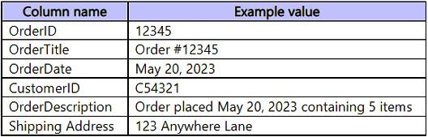  
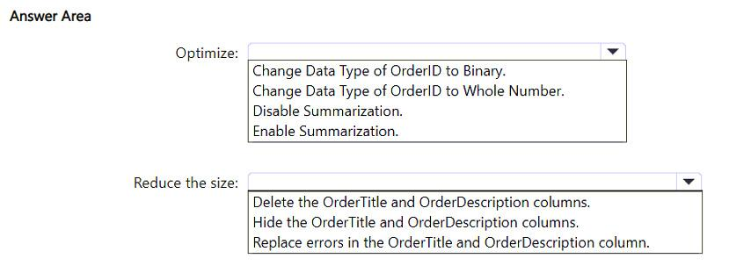

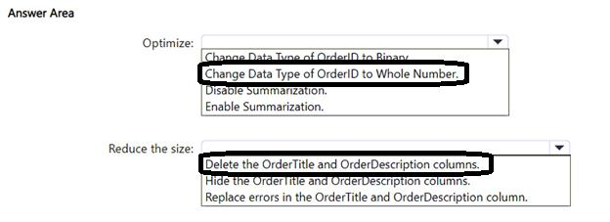

**[QUESTION: 149](https://free-braindumps.com/microsoft/free-pl-300-braindumps/page-39" \l "collapse_288)**

You have a Power BI semantic model that contains two queries.  
You discover that a report based on the model has performance issues.  
You plan to use Power Query to reduce the data loaded to the model.  
Which two actions should you perform? Each correct answer presents part of the solution.  
NOTE: Each correct answer is worth one point.

1. Apply group by and summarize techniques.
2. Combine the queries by using Append.
3. Remove unnecessary columns and rows.
4. Combine the queries by using Merge.
5. Create a new query group.

**Answer(s):** A,C

**[QUESTION: 150](https://free-braindumps.com/microsoft/free-pl-300-braindumps/page-39" \l "collapse_287)**

Note: This question is part of a series of questions that present the same scenario. Each question in the series contains a unique solution that might meet the stated goals. Some question sets might have more than one correct solution, while others might not have a correct solution.  
After you answer a question in this section, you will NOT be able to return to it. As a result, these questions will not appear in the review screen.  
You have an on-premises data gateway.  
You need to reduce the amount of data sent through the gateway by semantic models that run in Import storage mode.  
Solution: You create aggregations to summarize results.  
Does this meet the goal?

1. Yes
2. No

**Answer(s):** B

**[QUESTION: 151](https://free-braindumps.com/microsoft/free-pl-300-braindumps/page-39" \l "collapse_286)**

Note: This question is part of a series of questions that present the same scenario. Each question in the series contains a unique solution that might meet the stated goals. Some question sets might have more than one correct solution, while others might not have a correct solution.  
After you answer a question in this section, you will NOT be able to return to it. As a result, these questions will not appear in the review screen.  
You have an on-premises data gateway.  
You need to reduce the amount of data sent through the gateway by semantic models that run in import storage mode.  
Solution: You increase Automatic page refresh intervals.  
Does this meet the goal?

1. Yes
2. No

**[QUESTION: 152](https://free-braindumps.com/microsoft/free-pl-300-braindumps/page-39" \l "collapse_285)**

Note: This question is part of a series of questions that present the same scenario. Each question in the series contains a unique solution that might meet the stated goals. Some question sets might have more than one correct solution, while others might not have a correct solution.  
After you answer a question in this section, you will NOT be able to return to it. As a result, these questions will not appear in the review screen.  
You have an on-premises data gateway.  
You need to reduce the amount of data sent through the gateway by semantic models that run in import storage mode.  
Solution: You configure incremental refresh.  
Does this meet the goal?

1. Yes
2. No

**[QUESTION: 153](https://free-braindumps.com/microsoft/free-pl-300-braindumps/page-40" \l "collapse_284)**

Note: This question is part of a series of questions that present the same scenario. Each question in the series contains a unique solution that might meet the stated goals. Some question sets might have more than one correct solution, while others might not have a correct solution.  
After you answer a question in this section, you will NOT be able to return to it. As a result, these questions will not appear in the review screen.  
You have an on-premises data gateway.  
You need to reduce the amount of data sent through the gateway by semantic models that run in Import storage mode.  
Solution: You decrease the dashboard cache update frequency.  
Does this meet the goal?

1. Yes
2. No

**Answer(s):** B

**[QUESTION: 154](https://free-braindumps.com/microsoft/free-pl-300-braindumps/page-40" \l "collapse_283)**

HOTSPOT (Drag and Drop is not supported)  
You have a Power BI semantic model named Model1.  
You need to create a measure that will display the sales result for all blue units. The solution must maintain the existing filter context.  
How should you complete the DAX expression? To answer, select the appropriate options in the answer area.  
NOTE: Each correct selection is worth one point.  
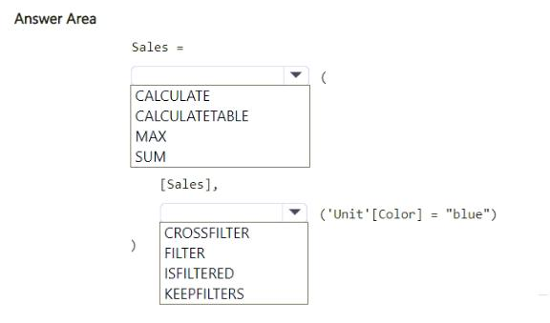

1. See Explanation section for answer.

**Answer(s):** A

**Explanation:**

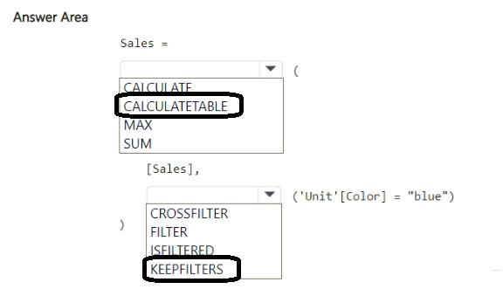

**[QUESTION: 155](https://free-braindumps.com/microsoft/free-pl-300-braindumps/page-40" \l "collapse_282)**

You have a Power BI semantic model named Model1 that runs in Import storage mode.  
You need to reduce the size of Model1. The solution must NOT increase report query response times.  
What should you do?

1. Remove unnecessary columns.
2. Unpivot unnecessary columns.
3. Rename unnecessary columns.
4. Change Model1 to DirectQuery storage mode.

**Answer(s):** A

**[QUESTION: 156](https://free-braindumps.com/microsoft/free-pl-300-braindumps/page-40" \l "collapse_281)**

You have a Power BI semantic model named Model1 that runs in Import storage mode.  
You need to reduce the size of Model1.  
Which two actions should you perform? Each correct answer presents a complete solution.  
NOTE: Each correct selection is worth one point.

1. Summarize the detail data.
2. Upgrade to Power BI premium.
3. Implement row-level security (RLS).
4. Optimize the column data types.
5. Change the active relationships between tables to inactive relationships.

**Answer(s):** A,D

**[QUESTION: 157](https://free-braindumps.com/microsoft/free-pl-300-braindumps/page-41" \l "collapse_280)**

You have a Power BI semantic model that contains the following data.  
You need to create a solution that meets the following requirements:  
• Presents transaction amount totals for each month for the current and prior year  
• Follows the star schema modeling approach  
• Minimizes the data model size  
Which three actions should you perform? Each correct answer presents part of the solution.  
NOTE: Each correct selection is worth one point.  
  
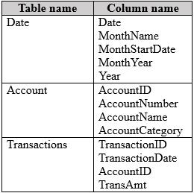

1. Create one-to-many relationships between the tables.
2. In the Transactions query, delete the TransactionID column.
3. In the Date query, group by MonthNumber.
4. In the Transactions query, group by AccountID and MonthStartDate for TransactionDate. Aggregate by summing the TransAmt column.
5. In the Transactions query, add a column that contains the MonthStartDate value for TransactionDate.
6. Create many-to-many relationships between the tables.

**Answer(s):** A,B,D

**[QUESTION: 158](https://free-braindumps.com/microsoft/free-pl-300-braindumps/page-41" \l "collapse_279)**

HOTSPOT (Drag and Drop is not supported)  
You have a Power BI semantic model that contains three tables named Products, OrderHistory, and Date.  
The Products table is a dimension table that contains the following columns:  
• ProductID  
• ProductName  
The OrderHistory table is a fact table that contains the following columns:  
• OrderID  
• ProductID  
• OrderDate  
The Date table is a dimension table that contains the following columns:  
• Year  
• Date  
• Week  
• Month  
You need to define a relationship from Products to OrderHistory and from OrderHistory to Date.  
Which cardinality should you configure? To answer, select the appropriate options in the answer area.  
NOTE: Each correct answer is worth one point.  
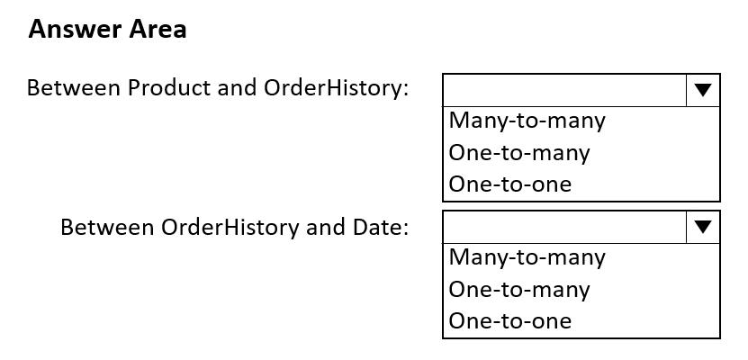

1. See Explanation section for answer.

**Answer(s):** A

**Explanation:**

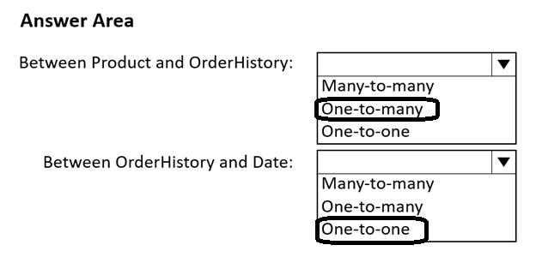

**[QUESTION: 159](https://free-braindumps.com/microsoft/free-pl-300-braindumps/page-41" \l "collapse_278)**

HOTSPOT (Drag and Drop is not supported)  
You use Microsoft Power BI Desktop to review the data shown in the following exhibit.  
Use the drop-down menus to select the answer choice that completes each statement based on the information presented in the graphic.  
NOTE: Each correct selection is worth one point.  
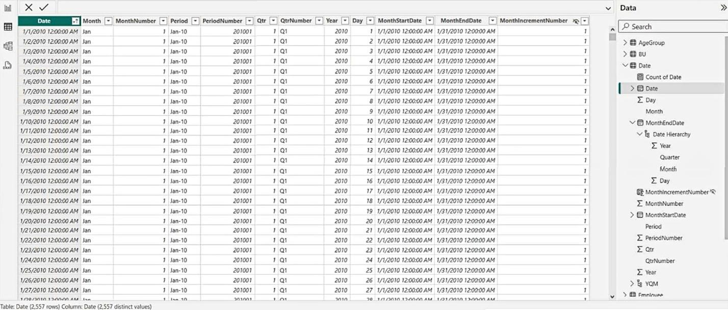  
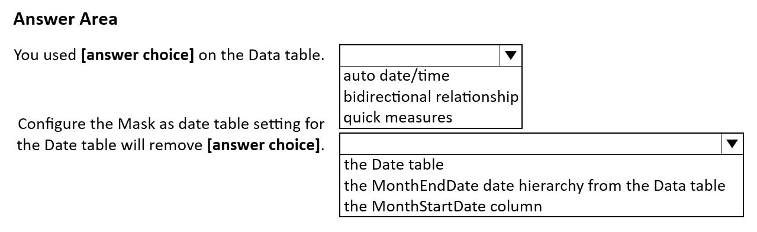

1. See Explanation section for answer.

**Answer(s):** A

**Explanation:**

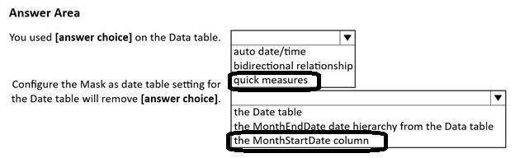

**[QUESTION: 160](https://free-braindumps.com/microsoft/free-pl-300-braindumps/page-41" \l "collapse_277)**

HOTSPOT (Drag and Drop is not supported)  
You have a Power BI semantic model that contains two tables named Sales and Forecast. Both tables contain a date column.  
You need to create a calculated table that will cover the range of dates in both tables.  
How should you complete the DAX expression? To answer, select the appropriate options in the answer area.  
NOTE: Each correct selection is worth one point.  
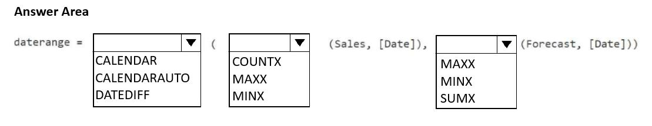

1. See Explanation section for answer.

**Answer(s):** A

**Explanation:**

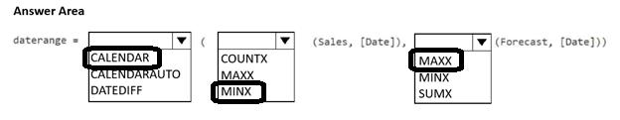

**[QUESTION: 161](https://free-braindumps.com/microsoft/free-pl-300-braindumps/page-42" \l "collapse_276)**

You have a Power BI semantic model named Model1 that contains two tables named DimDate and FactSales. There is an active relationship between DimDate and FactSales. DimDate is marked as the date table. FactSales contains the following data.  
Model1 contains the following measure.  
Previous Year Sales = CALCULATE([Sales Amount], PREVIOUSYEAR('Date'[Date]))  
You have a report that uses Model1. The report has a single report page that has a page level filter set to May 9, 2024. The result of the Previous Year Sales measure is displayed in a card visual.  
Which value will appear in the card visual?  
  
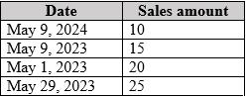

1. 10
2. 15
3. 35
4. 60

**Answer(s):** B

**[QUESTION: 162](https://free-braindumps.com/microsoft/free-pl-300-braindumps/page-42" \l "collapse_275)**

You have a Power BI query named Expenses that imports the following data.  
Users only use the date portion of the TransactionDate value when performing data analysis.  
You need to minimize the model size without affecting the analysis.  
Which two actions should you perform? Each correct answer presents part of the solution.  
NOTE: Each correct selection is worth one point.  
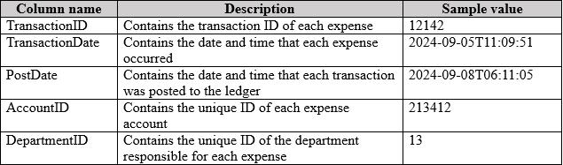

1. Change the data type of the TransactionDate column to Date.
2. Change the data type of the PostDate column to Date.
3. Remove the PostDate column.
4. Remove the TransactionID column.

**Answer(s):** A,C

**[QUESTION: 163](https://free-braindumps.com/microsoft/free-pl-300-braindumps/page-42" \l "collapse_274)**

DRAG DROP (Drag and Drop is not supported)  
You have a Microsoft Excel spreadsheet that contains the data shown in the following table.  
You plan to build a data model for a Power BI report.  
You need to prepare the data so that it is available to the model in the format shown in the following table.  
Which three actions should you perform in sequence in Power Query Editor? To answer, move the appropriate actions from the list of actions to the answer area and arrange them in the correct order.  
Select and Place:  
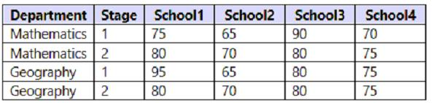  
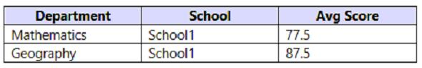  
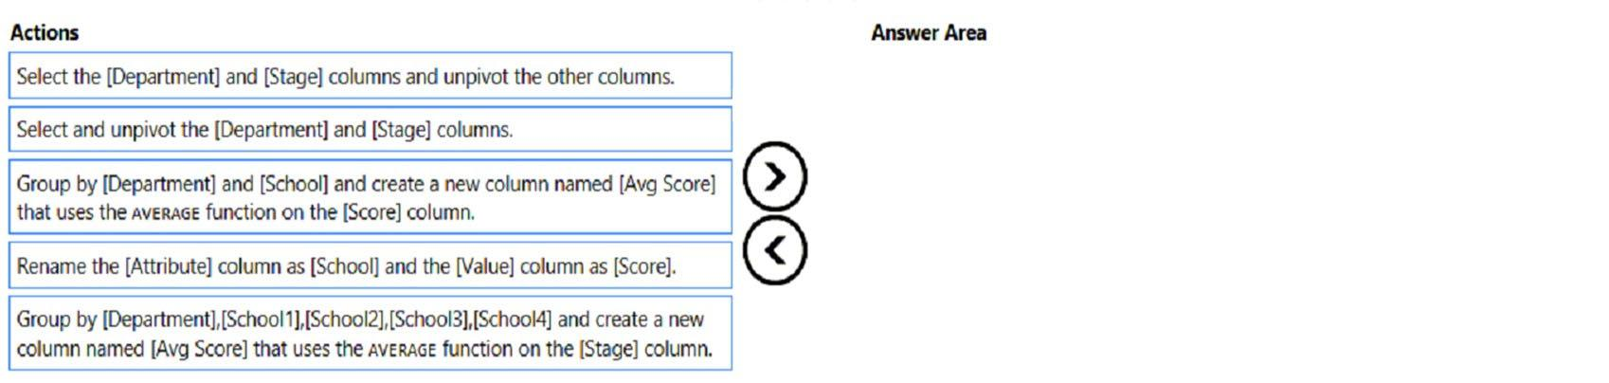

1. See Explanation section for answer.

**Answer(s):** A

**Explanation:**

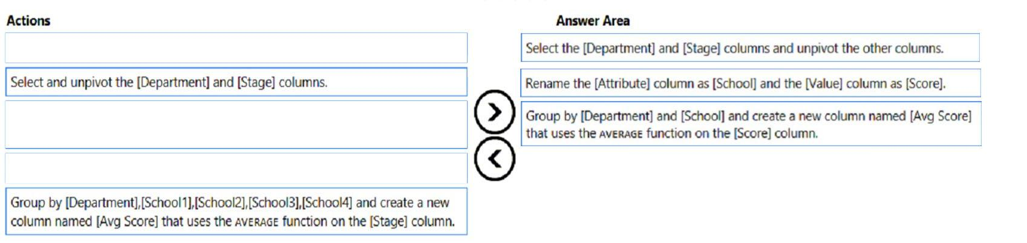

**[QUESTION: 164](https://free-braindumps.com/microsoft/free-pl-300-braindumps/page-42" \l "collapse_273)**

You have a report that contains a bar chart and a column chart. The bar chart shows customer count by customer segment. The column chart shows sales by month.  
You need to ensure that when a segment is selected in the bar chart, you see which portion of the total sales for the month belongs to the customer segment.  
How should the visual interactions be set on the column chart when the bar chart is selected?

1. highlight
2. filter
3. no impact

**Answer(s):** A

A user creates a Power BI report named ReportA that uses a custom theme.  
You create a dashboard named DashboardA.  
You need to ensure that DashboardA uses the custom theme. The solution must minimize development effort.  
Which two actions should you perform? Each correct answer presents part of the solution.  
NOTE: Each correct selection is worth one point.

1. Publish ReportA to Power BI.
2. From ReportA save the current theme.
3. Publish ReportA to the Microsoft Power BI Community theme gallery.
4. From DashboardA, create a custom theme.
5. From DashboardA, upload a JSON theme.

**Answer(s):** B,E

**[QUESTION: 166](https://free-braindumps.com/microsoft/free-pl-300-braindumps/page-43" \l "collapse_291)**

You need to create a visualization that compares revenue and cost over time.  
Which type of visualization should you use?

1. waterfall chart
2. stacked area chart
3. line chart
4. donut chart

**Answer(s):** C

**[QUESTION: 167](https://free-braindumps.com/microsoft/free-pl-300-braindumps/page-43" \l "collapse_167)**

HOTSPOT (Drag and Drop is not supported)  
You have a report in Power BI Desktop.  
You add a key influencers visual as shown in the exhibit. (Click the Exhibit tab.)  
Use the drop-down menus to select the answer choice that completes each statement based on the information presented in the graphic.  
NOTE: Each correct selection is worth one point.  
Hot Area:  
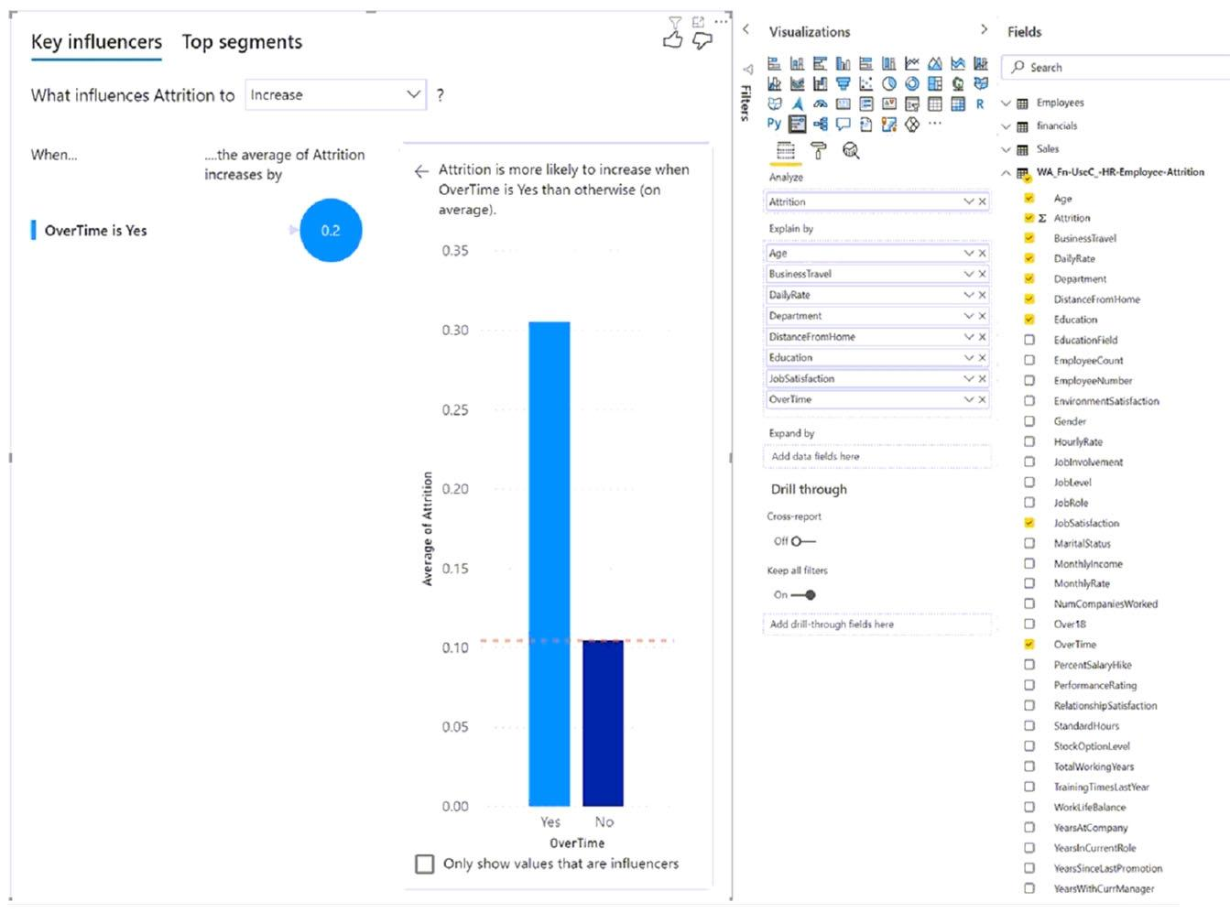  
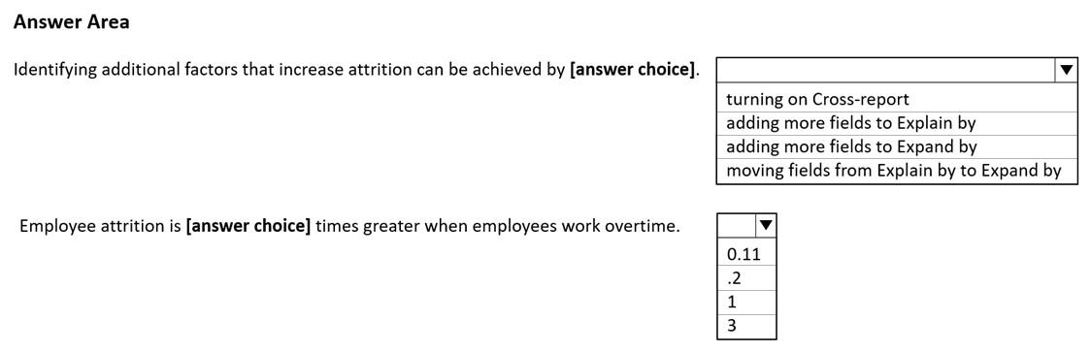

1. See Explanation section for answer.

**Answer(s):** A

**Explanation:**

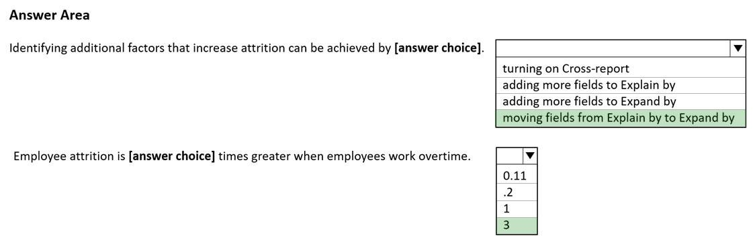

**[QUESTION: 168](https://free-braindumps.com/microsoft/free-pl-300-braindumps/page-43" \l "collapse_124)**

You build a report to help the sales team understand its performance and the drivers of sales.  
The team needs to have a single visualization to identify which factors affect success.  
Which type of visualization should you use?

1. Key influencers
2. Line and clustered column chart
3. Q&A
4. Funnel chart

**Answer(s):** A

**[QUESTION: 169](https://free-braindumps.com/microsoft/free-pl-300-braindumps/page-44" \l "collapse_59)**

HOTSPOT (Drag and Drop is not supported)  
You have a table that contains the following three columns:  
City  
-Total Sales  
-Occupation  
You need to create a key influencers visualization as shown in the exhibit. (Click the Exhibit tab.)  
How should you configure the visualization? To answer, select the appropriate options in the answer area.  
NOTE: Each correct selection is worth one point.  
Hot Area:  
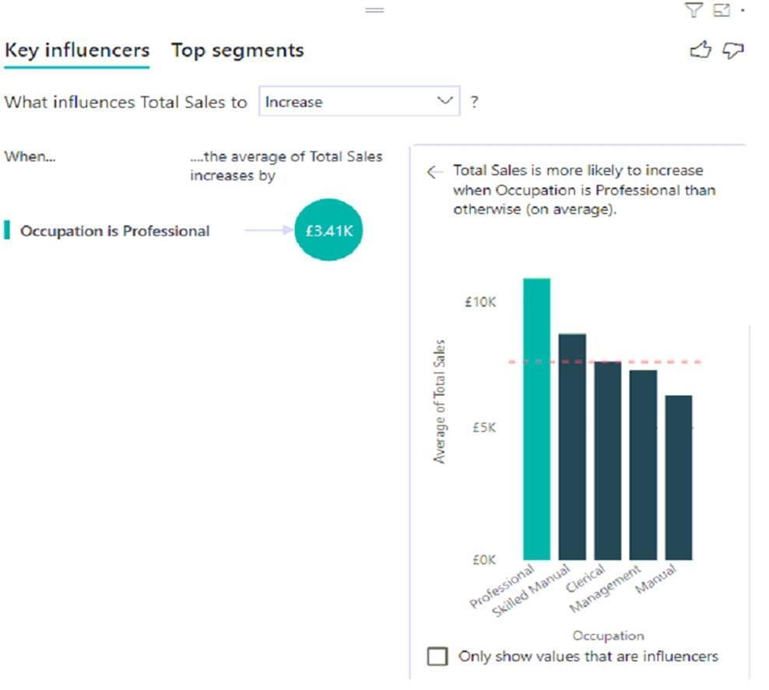  
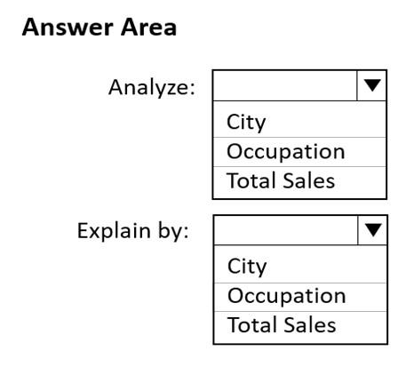

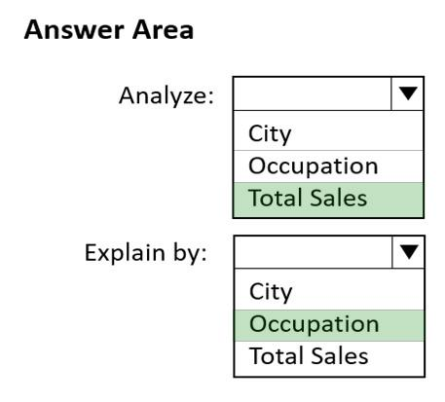

**[QUESTION: 170](https://free-braindumps.com/microsoft/free-pl-300-braindumps/page-44" \l "collapse_58)**

You are using the key influencers visual to identify which factors affect the quantity of items sold in an order.  
You add the following fields to the Explain By field:  
-Customer Country  
-Product Category  
-Supplier Country  
-Sales Employee  
-Supplier Name  
-Product Name  
-Customer City  
The key influencers visual returns the results shown in the following exhibit.  
What can you identify from the visual?  
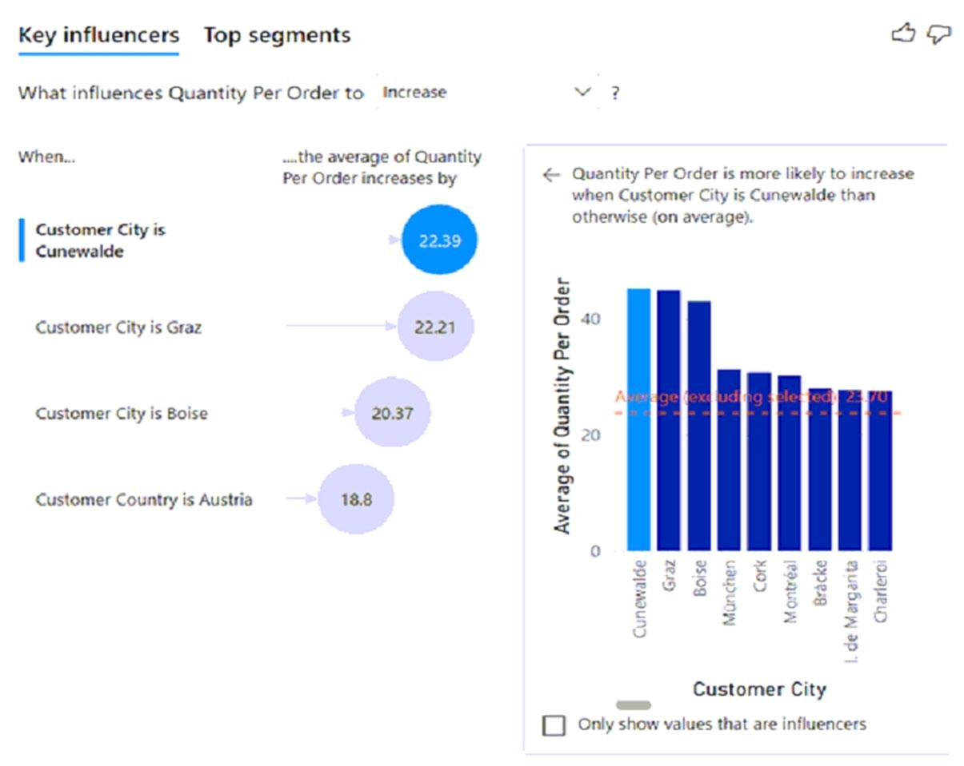

1. Customers in Austria order 18.8 more units than the average order quantity.
2. Customers in Boise order 20.37 percent more than the average order quantity.
3. Product Category positively influences the quantity per order.
4. Customers in Cork order lower quantities than average.

**Answer(s):** A

**[QUESTION: 171](https://free-braindumps.com/microsoft/free-pl-300-braindumps/page-44" \l "collapse_57)**

You have a report that contains four pages. Each page contains slicers for the same four fields.  
Users report that when they select values in a slicer on one page, the selections are not persisted on other pages.  
You need to recommend a solution to ensure that users can select a value once to filter the results on all the pages.  
What are two possible recommendations to achieve this goal? Each correct answer presents a complete solution.  
NOTE: Each correct selection is worth one point.

1. Create a bookmark for each slicer value.
2. Replace the slicers with report-level filters.
3. Sync the slicers across the pages.
4. Replace the slicers with page-level filters.
5. Replace the slicers with visual-level filters.

**Answer(s):** B,C

**[QUESTION: 172](https://free-braindumps.com/microsoft/free-pl-300-braindumps/page-44" \l "collapse_56)**

You have a report that includes a card visualization.  
You need to apply the following conditional formatting to the card while minimizing design effort:  
-For values that are greater than or equal to 100, the font of the data label must be dark red.  
-For values that are less than 100, the font of the data label must be dark gray.  
Which type of format should you use?

1. Color scale
2. Rules
3. Field value

**Answer(s):** B

**[QUESTION: 173](https://free-braindumps.com/microsoft/free-pl-300-braindumps/page-45" \l "collapse_55)**

DRAG DROP (Drag and Drop is not supported)  
You have a Power BI dashboard named DashboardA that contains a tile named TileA. TileA contains a treemap visual from a report named ReportA.  
You need to provide the users of DashboardA with additional tiles that relate to the contents of TileA.  
Which three actions should you perform in sequence? To answer, move the appropriate actions from the list of actions to the answer area and arrange them in the correct order.  
Select and Place:  
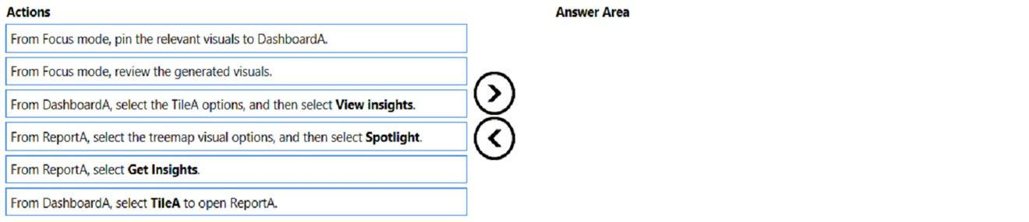

1. See Explanation section for answer.

**Answer(s):** A

**Explanation:**

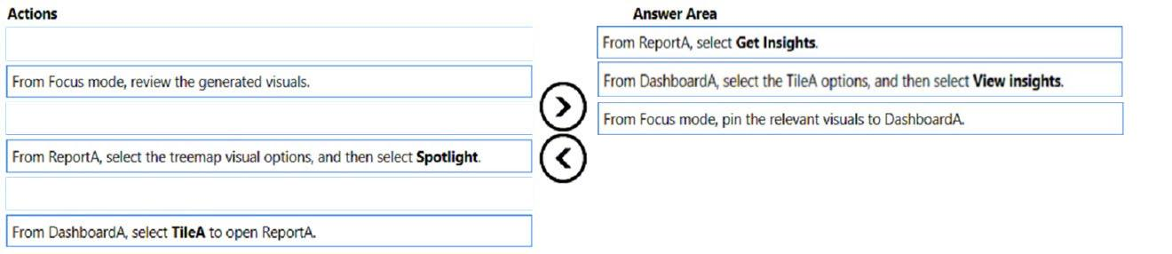

**[QUESTION: 174](https://free-braindumps.com/microsoft/free-pl-300-braindumps/page-45" \l "collapse_54)**

You are creating a dashboard by using the Power BI service.  
You have an existing report page that contains three charts.  
You need to add the charts to the dashboard while maintaining the interactivity between the charts.  
What should you do?

1. Edit interactions in the report and set all interactions to Filter.
2. Pin each chart as a tile.
3. Edit the dashboard theme and pin each chart as a tile.
4. Pin the report page as a live title

**Answer(s):** D

**[QUESTION: 175](https://free-braindumps.com/microsoft/free-pl-300-braindumps/page-45" \l "collapse_53)**

HOTSPOT (Drag and Drop is not supported)  
You need to create a visual as shown in the following exhibit.  
The indicator color for Total Sales will be based on % Growth to Last Year.  
The solution must use the existing calculations only.  
How should you configure the visual? To answer, select the appropriate options in the answer area.  
NOTE: Each correct selection is worth one point.  
Hot Area:  
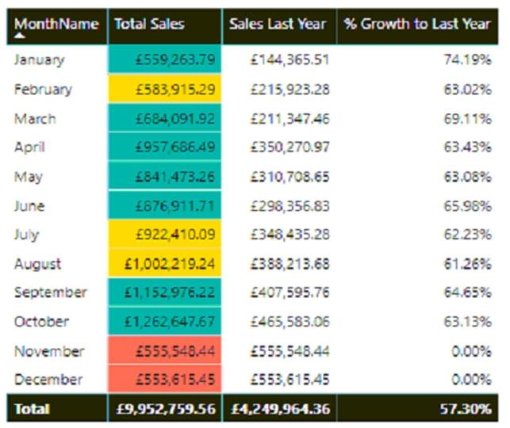  
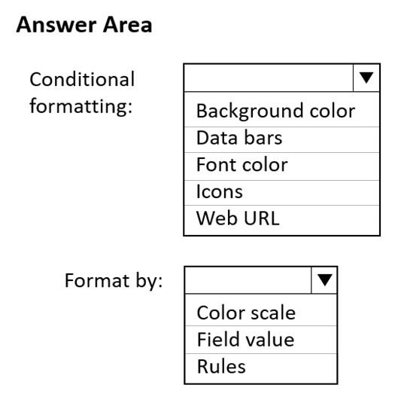

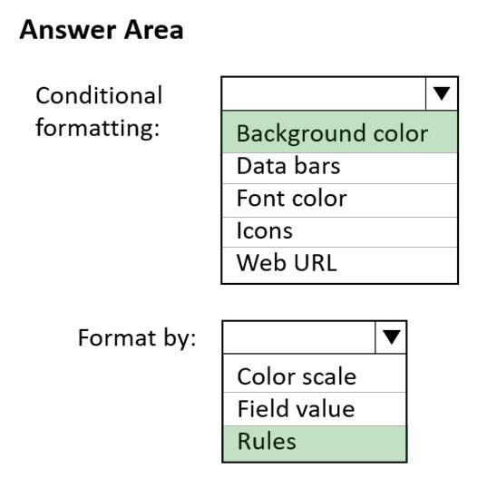

**[QUESTION: 176](https://free-braindumps.com/microsoft/free-pl-300-braindumps/page-45" \l "collapse_52)**

DRAG DROP (Drag and Drop is not supported)  
You are using existing reports to build a dashboard that will be viewed frequently in portrait mode on mobile phones.  
You need to build the dashboard.  
Which four actions should you perform in sequence? To answer, move the appropriate actions from the list of actions to the answer area and arrange them in the correct order.  
Select and Place:  
